Merton’s Climate Delivery Plan for Year 4 - Workstream 8 - Summary 2024

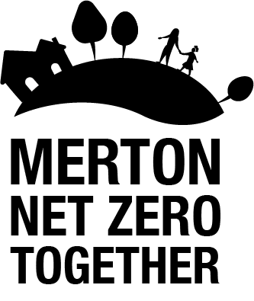

WS 8: Communication, outreach and LBM corporate procedure: Successfully delivering this work stream involves raising climate awareness in Merton and empowering residents, businesses, organisations, council staff and councillors to act to reduce emissions and adapt to the impacts of climate change.
Key areas of progress in 2023:
- Launched Merton’s new Green Schools Network and Charter.
- Published Merton’s first Climate Delivery Plan Summary Report and engagement leaflet for residents.
- Produced regular digital communications through social media and monthly editions of Merton’s Climate Action Newsletter to provide updates on climate action in Merton.
- Organised and attended a range of climate engagement activities and events (including Clean Air Day events, a Black History Month Climate Event, Green Libraries Week and much more).
- Supported Merton’s Climate Action Group and/or delivery partners with ongoing NCIL funded projects (Merton Garden Streets 2022, Energy Matters and the Wheel) and the development of climate case studies to showcase local climate action.
- Enabled wider community climate action by launching the first phase of Merton’s new Community Climate Action Fund.
- Started a Merton Climate Stories video series to showcase those taking action to reduce carbon emissions and adapt to climate change.
- Consulted with local community groups and organisations on Merton’s draft Climate Engagement Strategy in Autumn 2023.
- Delivered the first phase of Merton’s carbon literacy training for councillors, senior staff and volunteer officers, and securing a Bronze Carbon Literacy Award for Merton Council.
- Updated Merton’s Greenhouse Gas inventory.

Key priorities for 2024:
- Publish the second resident summary report of the climate delivery plan and leaflet for year 4.
- Finalise and adopt Merton’s Climate Engagement Strategy.
- Deliver the second phase of Merton’s carbon literacy training.
- Continue to support the development and delivery of community-led climate action projects and seeking wider engagement.
- Confirm the winning bidders for the first phase of the Community Climate Action Fund.
- Launch the second phase of the Community Climate Action Fund.
- Deliver climate engagement and communications activities in line with Merton’s Climate Engagement Strategy.
- Increase engagement with business stakeholders in Merton.

Acronyms

- CDP – Climate Delivery Plan
- ECO – Energy Company Obligation
- EV – Electric Vehicle
- FY – Financial Year
- GLA – Greater London Authority
- LBM – London Borough of Merton
- LED – Light Emitting Diode
- MEES – Minimum Energy Efficiency Standards
- PPA – Power Purchase Agreement
- SLP – South London Partnership
- SuDS – Sustainable Urban Drainage Systems
- TFL – Transport for London

