Merton’s Climate Delivery Plan for Year 4 - Workstream 7 - Summary 2024

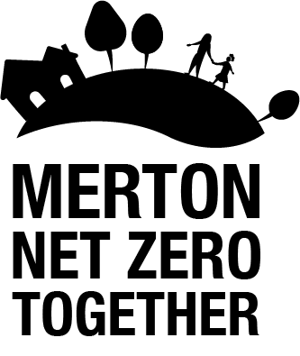

WS 7: LBM Procurements and investments: Successfully delivering this work stream will require the reduction of greenhouse gas emissions from Merton’s procurements and pension investments, whilst balancing the need to reduce emissions with the potential additional costs of services.
Key areas of progress in 2023:
- Reviewed Merton’s procurement process and tender documents to further embed carbon reduction in our requirements for new contracts.
- Engaged with contract managers to embed carbon reduction in Merton’s existing and new contracts (e.g. waste contract review).
- Implemented Merton’s new Contract Standing Orders (CSO) which require Responsible Officers to give due consideration to the Climate Emergency.
- Investigated options for developing or commissioning a tool to support officers in embedding carbon reduction in all council decisions including procurement.
- Incorporated climate considerations in the CSO training and Procurement Toolkit provided to officers.
- Continued the decarbonisation of Merton’s pension investments.

Key priorities for 2024:
- Recruit a new member of staff to lead on the decarbonisation of Merton’s procured services, and support contract managers and commissioners across the Council in engaging with suppliers to measure and reduce emissions from Merton’s new and existing contracts.
- Develop and deliver bespoke training to empower contract managers and commissioners to consider carbon at all stages of procurement, alongside wider carbon literacy training for all staff.
- Pilot a tool to embed carbon reduction in all council decision making including procurement.
- Continuing to engage with suppliers to trial low carbon technologies in Merton’s contracts where appropriate.

Acronyms

- CDP – Climate Delivery Plan
- ECO – Energy Company Obligation
- EV – Electric Vehicle
- FY – Financial Year
- GLA – Greater London Authority
- LBM – London Borough of Merton
- LED – Light Emitting Diode
- MEES – Minimum Energy Efficiency Standards
- PPA – Power Purchase Agreement
- SLP – South London Partnership
- SuDS – Sustainable Urban Drainage Systems
- TFL – Transport for London

