Merton’s Climate Delivery Plan for Year 4 - Workstream 5 - Summary 2024

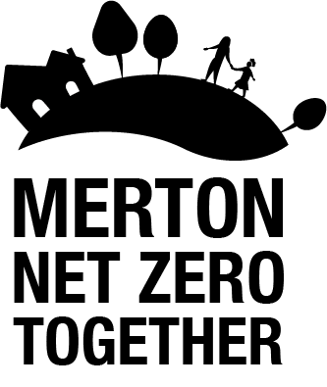

WS 5: Green infrastructure: Successfully delivering this work stream will require increased tree planting and green infrastructure projects by the council and private landowners, and increased public participation in community planting.
Key areas of progress in 2023:
- Adopted Merton’s Tree Strategy 2023-2029 which sets out the way the council will manage and enhance trees in the borough.
- Planted 6,000 whips and 12 standard trees as part of Cranmer Green Community Woodland Scheme.
- Planted 20 disease resistant Elm Trees during the Queens Green Canopy Commemorative Tree Planting programme; one for each Merton Ward.
- Joined the Trees for Streets Street Tree Sponsorship Scheme and receiving over 85 requests to adopt a street tree. This equates to £17K investment in new street tree planting with a priority to planting trees in low canopy wards.
- Achieved new Green Flag Award Status for Cannizaro Park.
- Constructed a large green infrastructure Sustainable urban Drainage System (SuDS) solution for Raynes Park Town Centre on Pepys Road.
- Designed a SuDs pocket park improvement scheme at Home Park Road and Kenilworth Green and installed a SuDS raingarden at Madeira Road.
- Supported the examination of Merton’s draft Local Plan which includes several Green and Blue Infrastructure policies.
- Proactively engaging with the Independent Merton Greenspace Forum and Merton’s existing Friends of Parks network to share knowledge and experience as well as encourage new groups to form.
- Supported and funded the third year of the Climate Action Group’s Merton Garden Streets initiative run by Sustainable Merton, with 129 streets signed-up in 2023.

Key priorities for 2024:

- Scope Phase 2 of Merton’s Tree Strategy for the management of trees on private land.
- Plant 2500 whips at Morden Park Lower Field with Trees for Cities and 2500 whips at Hillcross Avenue perimeter with Merton Friends of the Earth.
- Apply for new Green Flag Award Status for Canons House and Grounds, Haydons Road Rec, and Holland Gardens.
- Deliver a large flood alleviation and river restoration scheme in Derwent Road Flood Wash, in Lower Morden.
- Deliver a Green Infrastructure SuDS scheme in Mitcham town centre.
- Adopt Merton’s new Green Infrastructure policies.

Acronyms

- CDP – Climate Delivery Plan
- ECO – Energy Company Obligation
- EV – Electric Vehicle
- FY – Financial Year
- GLA – Greater London Authority
- LBM – London Borough of Merton
- LED – Light Emitting Diode
- MEES – Minimum Energy Efficiency Standards
- PPA – Power Purchase Agreement
- SLP – South London Partnership
- SuDS – Sustainable Urban Drainage Systems
- TFL – Transport for London

