Merton’s Climate Delivery Plan for Year 4 - Workstream 1 - Summary 2024

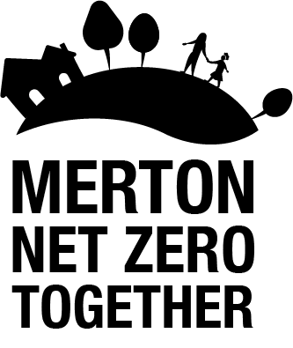

WS1: Sustainable consumption and low carbon economy:
Successfully delivering this work stream will require significant behaviour changes from Merton’s residents, businesses and organisations, to drive sustainable consumption habits and enable a transition to a low carbon economy.
Key areas of progress in 2023:
- Launched the first round of Merton’s new Community Climate Action Fund to support local community-led climate action projects.
- Provided workspace to establish and launch the Preloved Studio at Canons House and Grounds for textile reuse and repair.
- Investigated how SMEs on our highstreets can aggregate and reduce waste and become more resource efficient with UCL and Sustainable Merton through the Net Zero Innovation Programme.
- Developing and delivering green skills training opportunities and employment pathways through Merton’s Towards Employment programme.
- Continuing to roll-out Merton’s adult education programme for green skills.
- Working with partners to support the development of green jobs and skills through several events in Merton and South London (e.g. Green Skills Event at Merton College on 15th June 2023, South London Green Careers Summit on 7th November 2023, BIG South London Innovation Summit on 10th November 2023 etc).
- Ran a workshop with partner organisations (including business improvement districts) in September 2023 to investigate the challenges and opportunities for decarbonising businesses in Merton,
- Participated in the pan-London Eat Like a Londoner campaign to help residents eat better, save money and reduce food waste.
- Part funded a sustainability workshop for local businesses on 12th September 2023 as part of a Business Masterclass Series delivered by Love Wimbledon and Merton Chamber of Commerce.

Key priorities for 2024:

- Recruit a new member of staff to lead on the development of a low carbon economy, by promoting low carbon business, helping maximise green skills and jobs opportunities, and promoting a circular economy.
- Confirm winning bidders for the first round of Merton’s Community Climate Action Fund to support community-led climate action projects.
- Launch the second round of Merton’s Community Climate Action Fund.
- Finalise and adopt Merton’s Climate Engagement Strategy to maximise the impact of Merton’s climate engagement.

Acronyms

- CDP – Climate Delivery Plan
- ECO – Energy Company Obligation
- EV – Electric Vehicle
- FY – Financial Year
- GLA – Greater London Authority
- LBM – London Borough of Merton
- LED – Light Emitting Diode
- MEES – Minimum Energy Efficiency Standards
- PPA – Power Purchase Agreement
- SLP – South London Partnership
- SuDS – Sustainable Urban Drainage Systems
- TFL – Transport for London

