Membership Form

By filling in this membership form, you agree to become a Merton Under 18’s COVID Community Champion with the responsibilities as detailed in this video: https://www.youtube.com/watch?v=xc7yba_ealg (The process and benefits of becoming an Under 18’s COVID Community Champion).
Your details will only be used for your involvement with this group and stored confidentially, and not shared any wider. Your address will only be used to send you your member resources, e.g. Certificate, face mask and badge. Your phone contact will be only used to share key group information with you!
Name: …………………………………………………….
School and Year Group: ………………………………………..
Are you a member of your Youth Council or and MYP?.........………………………………………………
Were you recruited by an Under-18 COVID Community Champion Leader? .............................................
If ‘Yes’, please write their name:……………………………….
Home Address: ………………………………………………..
Your school email address: ……………………………………….
Your phone number (Optional): ………………………………………
Contact email (for those who go to school outside the borough, this can be your parents/ carer): …………………………………………………………………….
Name of parent: ………………………………………………………………..
Email: ………………………………………………………………………………
Phone contact: ……………………………………………………………………

Below please fill in the boxes below as we want to get to know you a bit more 😊
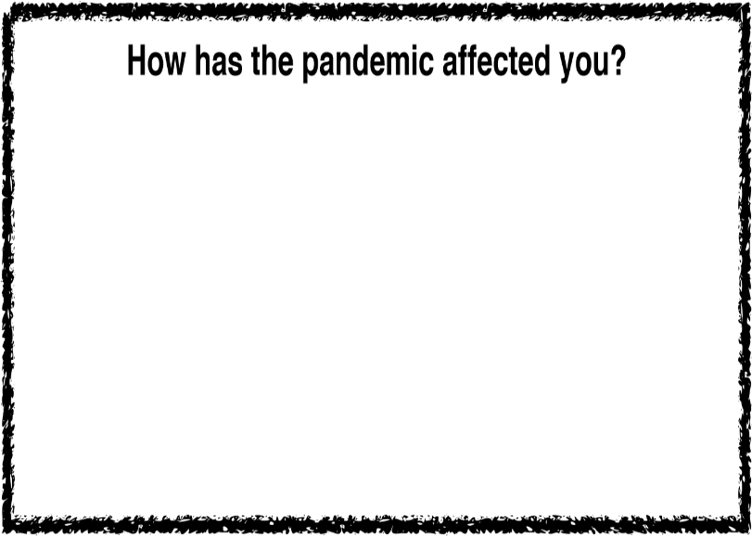
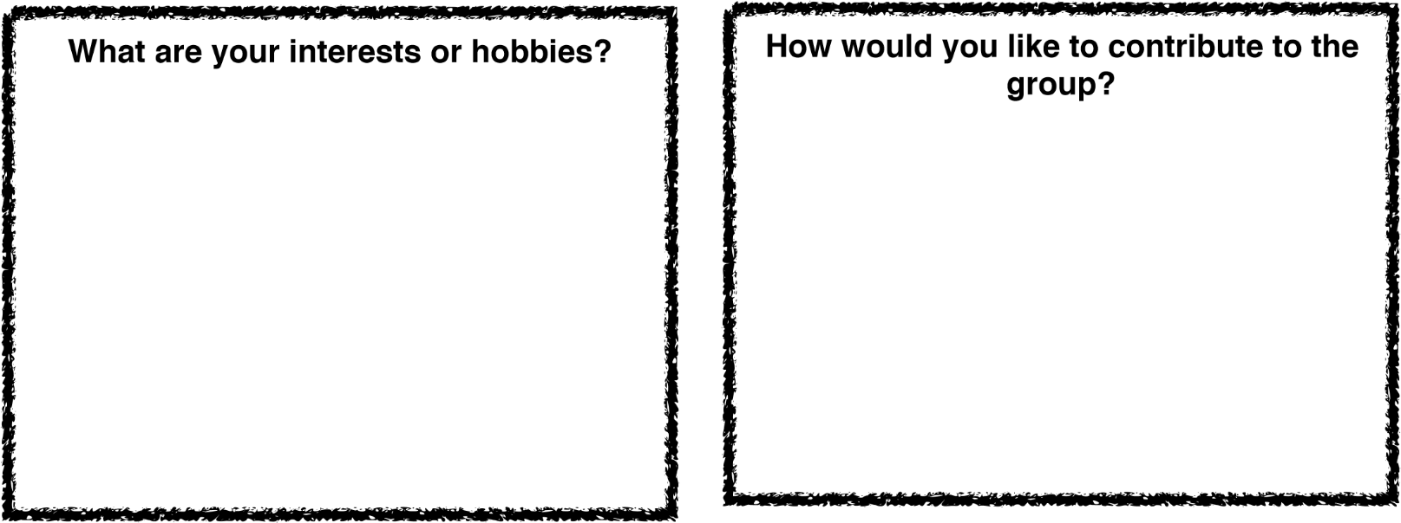

Thank you for your time!
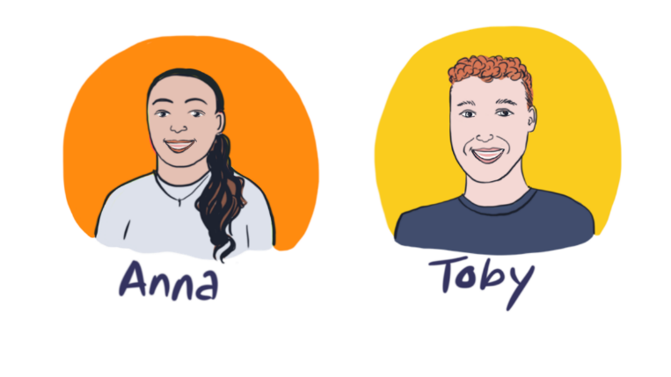
Anna and Toby

