London Borough of Merton

STATEMENT OF PRINCIPLES
under the Gambling Act 2005

From January 2022 to January 2025
INDEX

Section | Title | Page No.
 | Glossary of Terms | 3
1 | Introduction | 5
2 | Profile of the Borough | 5
3 | Licensing Objectives | 6
4 | Licensable Premises and Permits | 7
5 | General Principles | 7
6 | Consultation | 9
7 | Information Exchange | 9
8 | Duplication with other Regulatory Regimes | 10
9 | Decision Making | 10
10 | Responsible Authorities and Interested Parties | 11
11 | Enforcement | 14
12 | Premises Licences | 15
13 | Casinos | 24
14 | Travelling Fairs | 24
15 | Provisional Statements | 24
16 | Reviews | 25
17 | Complaints against Licensed Premises | 26
18 | Permits | 26
19 | Temporary Use Notices | 30
20 | Occasional Use Notices | 30
21 | Small Society Lotteries | 30
 | Further Information | 31
Appendix A | Delegation of Licensing Functions | 33
Appendix B | Risk Assessment Guidance | 35
Appendix C | Local Are Profile Maps | 39
Appendix D | Definitions | 48
Appendix E | Responsible Authorities | 53

GLOSSARY OF TERMS

Within this Statement of Policy, the following words and terms are defined as stated:

Licensing Objectives | As defined in section 3.1 below
Licensing Authority | London Borough of Merton
Licences | As stated in section 4.1 below
Applications | Applications for licences and permits as defined in Section 4.1 below
Notifications | Means notification of temporary and occasional use notices
Act | The Gambling Act 2005 (as amended)
Regulations | Regulations made under the Gambling Act 2005
Premises | Any place, including a vehicle, vessel or moveable structure
Code of Practice | Means any relevant code of practice made under section 24 of the Gambling Act 2005
Mandatory Condition | Means a specified condition provided by regulations to be attached to a licence
Default Condition | Means a specified condition provided by regulations to be attached to a licence, unless excluded by the Council
Provisional Statement | Means an application made prior to construction or extensive building work is undertaken to ascertain whether the grant of a licence is likely.
Responsible Authority | For the purposes of this Act, the following are responsible authorities in relation to premises:  1. The London Borough Of Merton;  2. The Gambling Commission;  3. Metropolitan Police  4. Planning Department  5. Environmental Protection (the authority which has functions in relation to pollution of the environment or harm to human health)  6. Merton Local Safeguarding Children Board (LSCB) &  LBM’s Safeguarding Adults Service;  7. HM Revenue and Customs;  8. The London Fire Authority; and  9. Any other person prescribed in regulations made by the  Secretary of State
Interested Party | For the purposes of this Act, a person is an interested party in relation to a premises licence if, in the opinion of the Licensing Authority which issues the licence or to which the application is made, that person:  a) Lives sufficiently close to the premises to be likely to be affected by the authorised activities;  b) Has business interests that might be affected by the authorised activities;  c) Represents persons who satisfy a) or b) above.
Local Area Profile | Operators of gambling premises are required to assess the local risks to the licensing objectives posed by the provisions of gambling facilities at each of their premises and have policies, procedures and control measures to mitigate those risks. In order to assist operators in drawing up their risk assessments Licensing Authorities can provide information on the profile of their borough including location of e.g. schools, addiction rehabilitation centres, money lenders and pawn shops, gambling premises as well as deprivation indices and crime figures for the borough broken down by area. The Local Area Profile document is designed to assist operators when completing their risk assessments to allow them to address identified local risks.

STATEMENT OF PRINCIPLES UNDER THE GAMBLING ACT 2005

1. Introduction

1.1 The London Borough of Merton is the Licensing Authority under the Gambling Act 2005 (the “Act”), responsible for issuing premises licences, permits, lottery registrations and temporary and occasional use notices for Gambling activities within the Borough.

1.2 The Gambling Act 2005 requires the Licensing Authority to prepare and publish a “Statement of Principles” that sets out the principles that the Licensing Authority will apply when making decisions on applications made under the Act.

1.3 In producing its statement, this Licensing Authority declares that it has had regard to the licensing objectives under the Act, the guidance issued by the Gambling Commission (published 1 April 2021) and the responses from those consulted on the statement.

1.4 Once adopted, the Statement of Principles will be made available on Merton’s website at www.merton.gov.uk

1.5 The first Statement of Principles was published in January 2007. This is the 6th Statement published by this Authority and is for the period 2022-2025. It came into effect on 31 January 2022. The Policy will be reviewed as necessary, and at least every three years from the date of its adoption.

1.6 A consultation on this policy took place take place between 19 July and 27 September 2021 (10 weeks).

1.7 Notwithstanding this statement of intent, each application received will be considered on its own merits, subject to the provisions of the Act, associated and subordinate legislation and common law.

2. Profile of the Borough

2.1 The London Borough of Merton is an outer London borough situated to the south west of central London, neighbouring the boroughs of Croydon, Kingston, Lambeth, Sutton and Wandsworth. Comprising of 20 wards, the borough of Merton covers an area of approximately 14.7 square miles and has a population, at 2018, of just over 209,000 residents, projected to increase to 222,717 by 2025 and 232,473 by 2030. Merton is well connected with both central London and neighbouring boroughs,

2.2 The Borough is predominantly a residential area. Its properties are both wide ranging in character and often of a high quality. The borough has five main commercial centres; Colliers Wood, Mitcham, Morden, Raynes Park and Wimbledon. The busiest of these areas is Wimbledon which has the highest density of leisure and entertainment venues in the Borough. Merton’s economy is heavily reliant on leisure and service industries which form almost 60% of total employment within the borough.

2.3 Merton is densely populated but also has one of the highest proportions of parks and open spaces within the London area, some one third of them being green field sites
2.4 At the time of writing this Statement of Principles there are no casinos or licensed bingo halls in the borough. There are 32 licensed betting shops and 1 adult gaming centre.

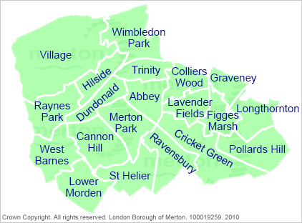
London Borough of Merton Ward Boundaries

3. Licensing Objectives

3.1 The Act requires the Licensing Authority to carry out its various licensing functions so as to be reasonably consistent with the following three licensing objectives:
• preventing gambling from being a source of crime or disorder, being
associated with crime or disorder or being used to support crime;
• ensuring that gambling is conducted in a fair and open way;
• protecting children and other vulnerable persons from being harmed or
exploited by gambling.
3.2 Merton Council as Licensing Authority is aware that, as per Section 153 of the Act, in carrying out its licensing functions under the Act, particularly with regard to premises licences, it should aim to permit the use of premises for gambling in so far as it thinks it is;
• in accordance with any relevant code of practice issued by the Gambling
Commission;
• in accordance with any relevant guidance issued by the Gambling
Commission;
• reasonably consistent with the licensing objectives; and
• in accordance with the authority’s Statement of Policy and Principles.
3.3 The Licensing Authority is under a duty to act fairly and rationally but cannot grant an application that does not satisfy the requirements of the preceding paragraph. Where there is conflict, the Gambling Commission Code of Practice and Guidance take precedence.
3.4 Nothing in this Statement will override the right of any person to make an application under this Act and have that application considered on its individual merits. Equally nothing in the Statement will undermine the right of any person to make representations to an application or seek a review of a licence where there is a legal power to do so. However, any application received by the Licensing Authority for a casino premises licence shall be returned on the basis that the Licensing Authority has passed a resolution not to issue casino premises licences (subject to a new resolution being approved in 2021)
4. Licensable Premises and Permits

4.1 This document sets out the policies that this Authority will apply when making decisions upon applications or notifications made for:

• Premises licences (in respect of casinos, bingo premises, betting premises,
tracks, adult gaming centres, family entertainment centres);
• Provisional Statements where premises are intended to provide gambling
activities;
• Club Gaming permits and/or Club Machine Permits;
• Permits for the use of certain lower stake gaming machines at unlicensed
Family Entertainment Centres;
• Notifications for the use of gaming machines in alcohol licensed premises for
the use of two or fewer gaming machines;
• Gaming Machine Permits for premises licensed to sell/supply alcohol for
consumption on the licensed premises, under the Licensing Act 2003, where
there are more than two machines.
• Registration of small society lotteries below prescribed thresholds;
• Prize Gaming Permits;
• Temporary Use Notices;
• Occasional Use Notices;

4.2 Local licensing authorities are not involved in licensing remote gambling (e.g. internet gambling). This will fall to the Gambling Commission. Neither are they involved in licensing the National Lottery nor in regulating spread betting.

5. General Principles

5.1 The starting point in determining applications will be to grant the application without conditions, other than the mandatory conditions or default conditions laid down by the Secretary of State, subject to the applicant having identified any risks and offering any suitable control measure required to address the Borough’s Local Area Profile. Default conditions will only be amended and additional conditions added where they are needed to meet the requirements of the licensing objectives, and any conditions applied will be proportionate. Conditions will be considered unnecessary if they are already adequately covered by other legislation or in the Default or Mandatory Conditions.

5.2 When determining an application to grant a Premises Licence or review a Premises Licence, the Licensing Authority will have regard to the proximity of the premises to schools, vulnerable adult centres and residential areas where there may be a high concentration of families with children or in areas of social deprivation or where there are high crime rates. The proximity of premises taken into consideration will vary depending on the size and scope of the gambling premises concerned. Each case will be considered on its merits. This Authority would expect the applicant to effectively demonstrate how they might promote the licensing objectives, address any relevant guidance issued by the Gambling Commission under section 25 of the Act and be in accordance with any relevant code of practice issued under section 24 of the Act. We would therefore expect a premises risk assessment to take into consideration the locality where the premises are situated.

5.3 When considering any conditions to be attached to a licence, the Licensing Authority will primarily focus on the impact of the authorised activities taking place at licensed premises on interested parties and/or in the context of the Licensing Objectives.

5.4 In determining any application the Licensing Authority may not have regard to the expected demand for the facilities, which it is proposed that the premises intend to provide.

5.5 The Licensing Authority recognises that, apart from the licensing function, there are a number of other mechanisms available for addressing issues that can occur away from licensed premises that may give rise to objections including:

1. Planning controls;
2. Ongoing measures to create a safe and clean environment in these areas in partnership with local businesses, transport operators and other Council departments;
3. Regular liaison with the Police on law enforcement issues regarding disorder and anti-social behaviour;
4. The power of the Police, other responsible authorities or local residents and businesses to seek a review of the licence.

5.6 Objectors will be required to relate their objection to one or more of the Licensing Objectives for Gambling, listed at 3.1 above, before the Licensing Authority will be able to consider it. An application for a review of a licence must be made on the prescribed form but must also relate to the three Licensing Objectives for Gambling, listed at 3.1 above.

5.7 The Licensing Authority, in undertaking its licensing function, will have due regard to the need to eliminate unlawful discrimination and to promote equality and good relations between persons of different racial groups and to promote equality of opportunity for people with disabilities.

6. Consultation

6.1 Under the Act, the Licensing Authority is required to consult with the following parties on its proposed Statement of Principles
- The Chief Officer of Police;
- One or more persons who appear to the authority to represent the interests of persons carrying on gambling businesses in the authority’s area; and
- One or more persons who appear to the authority to represent the interests of persons who are likely to be affected by the exercise of the authority’s functions under the Gambling Act 2005.

6.2 The Licensing Authority consulted:
- The Responsible Authorities namely:
the Chief Officer of Police;
the Gambling Commission;
the London Fire Authority;
the Local Planning Authority;
Environmental Services in its capacity as the body responsible for the
prevention of pollution to the environment and protection of public health;
the Council’s Children Services; and
HM Revenue & Customs;
- The Council’s Adult Social Care Services
- Trade associations
- Businesses or their representatives involved in gambling
- Ward Councillors and local Members of Parliament
- Faith groups
- Residents Associations
- Voluntary and Community Organisations working with children and vulnerable adults
- Wimbledon Civic Trust
- Advocacy Groups (e.g.Citizens Advice)
- Organisations working with people who are problem gamblers
- The Director of Public Health
- Community Safety Partnership
6.3 A copy of the draft statement was also be published on the Council’s website
6.4 The consultation took place place between 19 July 2021 and 27 September 2021 (10 weeks).

7. Information exchange

7.1 In fulfilling its functions and obligations under the Gambling Act 2005 the Licensing Authority will exchange relevant information with other regulatory bodies (like the Gambling Commission). In exchanging such information, the Licensing Authority will conform to the requirements of Data protection and Freedom of Information legislation in accordance with the Council’s existing policies. The authority will act in accordance with the relevant legislation and guidance from the Gambling Commission and will adopt the principles of better regulation.

7.2 Contact details, including email addresses (unless expressly asked otherwise), of those persons making representations and details of the representations will be made available to the applicant to allow for negotiation. In the event of a hearing being held the details will be provided to members of the Licensing Committee and, should an Appeal follow, the information will become a matter of public record. Applicants and interested parties, by providing their details, must be aware that those details will be shared as laid out above and may be made public
7.3 Information returns will be made to the Gambling Commission in accordance with current protocols and should any protocols be established regarding information exchange with other bodies then they will be made available. Premises Licence holders should be aware that their details may be shared with the Gambling Commission accordingly.

8. Duplication with other regulatory regimes
8.1 This Licensing Authority will seek to avoid any duplication with other statutory/regulatory systems where possible, including planning. This Licensing Authority will not consider whether a premises licence application is likely to be awarded planning permission or building regulations approval. It will though, listen to and consider carefully, any concerns about conditions which are not able to be met by licensees due to planning restrictions, should the situation arise.
8.2 When dealing with a premises licence application for finished buildings, this Licensing Authority will not take into account whether those buildings have to comply with the necessary planning or building consents. Fire or health and safety risks will not be taken into account as these matters are dealt with under other legislation and do not form part of the consideration for a premises licence under the Act.
8.3 It should be note that a decision by the licensing authority under this Act shall not constrain any later decision by the authority under the law relating to planning or building control.

9. Decision Making

9.1 Terms of Reference A Licensing Sub-Committee of three Councillors will sit to hear applications where representations have been received from interested parties and/or responsible authorities.

9.2 A clear statement of the reasons for the decision shall accompany every determination of a licensing decision by the Licensing Sub-Committee. The decision and the reasons for that decision will be sent to the applicant and those who have made relevant representations as soon as practicable in the form of a Notice of Determination.
9.3 The Council’s Licensing Officers will deal with all other licensing applications where either no representation have been received, or where representations have been received and it is agreed by the parties that a hearing is not necessary.

9.4 Decisions as to whether representations are irrelevant, frivolous or will certainly not influence the Licensing Authority’s determination of the application.
will be made by Licensing Officers, who will make the decisions on whether representations or applications for licence reviews should be referred to the Licensing Sub-Committee.

9.5 Where representations are rejected, the person making that representation will be given a written reason as to why that is the case. The Gambling Act 2005 provides no right of appeal in these circumstances, although other avenues of legal challenge, for example Judicial Review, may be available.

9.6 Allocation of Decision Making Responsibilities The Licensing Authority has established a Licensing Committee to discharge all Licensing functions. The Licensing Committee shall consist of at least ten, but not more than fifteen members of the authority.

9.7 In order to provide a speedy, efficient and cost-effective service to all involved in the licensing process, the Licensing Committee has delegated certain decisions and functions to Sub-Committees.

9.8 Many of the decisions and functions will be purely administrative in nature and the grant of non-contentious applications, including for example those licences and permits where no representations have been made, will be delegated to Council officers.

9.10 Appendix A sets out a table showing the agreed delegation of functions and decisions in respect of the full Council, Licensing Committee, Sub-Committee and Officers.

9.11 Such delegation does not preclude officers from referring any application to the Licensing Sub-Committee if they consider it appropriate.

10. Responsible Authorities and Interested Parties

10.1 Regulations have been made by the Secretary of State under Section 160 of the Act that will require applicants for premises licences to notify the ‘Responsible Authorities’ and ‘Interested Parties’

10.2 The Responsible Authorities are:
- A Licensing Authority in whose area the premises wholly or partly lie;
- the Gambling Commission;
- the Metropolitan Police;
- the London Fire Authority;
- the Local Planning Authority;
- the Authority which has functions in relation to pollution to the environment or harm to human health;
- the competent person to advise about the protection of children from harm;
- HM Revenue & Customs; and
- any other person prescribed in regulations by the Secretary of State

10.3 It should be noted that in relation to a vessel, responsible authorities also include navigation authorities within the meaning of section 221(1) of the Water Resources Act 1991 that have statutory functions in relation to the waters where the vessel is usually moored or berthed or any waters where it is proposed to be navigated at a time when it is used for licensable activities. This would include:
(a) the Environment Agency
(b) the British Waterways Board and
(c) the Secretary of State (in practice, the Secretary of State for Transport, who acts through the Maritime and Coastguard Agency)
10.4 The licensing authority is required to state the principles it will apply in exercising its powers under Section 157(h) of the Act to designate, in writing, a body which is competent to advise the authority about the protection of children from harm. The designated body must
a) be responsible for an area covering the whole of the licensing authority’s area; and
b) be answerable to democratically elected persons, rather than any particular vested interest group.

10.5 This authority designates Merton Local Safeguarding Children Board , but the Board may designate one of its members to be the person responsible for raising representations or applying for the review of an existing licence.
10.6The Act contains no obligation on responsible authorities to respond to applications for premises licences if they do not wish to do so. The Gambling Commission will not normally comment on an application unless it has particular observations to make about the operator. In the absence of response from the Commission, this authority will not assume that the Commission has any view (whether supportive or otherwise) on the merits of the particular premises licence application. We will, of course, be aware of the Commission’s views on generic issues as set out in guidance.
10.7 The contact details of all the Responsible Authorities under the Act are shown in Appendix E.

10.8 Interested parties can make representations about licence applications or apply for a review of an existing premises licence. An interested party, in accordance with s158 of the Act, is a person who in the opinion of the Licensing Authority:
(a) lives sufficiently close to the premises to be likely to be affected by the authorised activities
(b) has business interests that might be affected by the authorised activities, or (c) represents persons who satisfy (a) or (b)

10.9 The Licensing Authority is required by regulations to state the principles it will apply in exercising its powers under the Act to determine whether a person is an interested party. This Authority will abide by the following principles:
a) Persons living close to the premises
Each case will be decided upon its merits. This authority will not apply a rigid rule to its decision making. In determining what ‘sufficiently close to the premises’ means it will consider the examples of factors for considerations provided in the Gambling Commission’s Guidance for local authorities namely:
- the size of the applicant’s premises;
- the nature of the applicant’s premises;
- the distance of the premises from the location of the person making the representation;
- the potential impact of the premises (number of customers, routes likely to be taken by those visiting the establishment); and
- the circumstances of the complainant (not the personal characteristics of the complainant, but the interests of the complainant which may be relevant to the distance from the premises e.g. whether an individual, a residential school for vulnerable children, a residential hostel for vulnerable adults).
b) Persons with business interests that could be affected.
It could be argued that any gambling business could be affected by another gambling business expanding into any part of Great Britain. But that is unlikely to be enough to satisfy the test of being ‘a person with business interests that might be affected by the premises’ under consideration. For example, an operator in a particular sector (be it casino, bingo, betting, etc) should not be able to lodge representations on every application put in by a rival operator anywhere in the country, simply because they are in competition within the same gambling sector. This authority will need to be satisfied that the relevant business is likely to be affected. In this respect, we will bear in mind that the ‘demand test’ from the 1963 and 1968 Acts is not continued in the 2005 Act. Factors that are likely to be relevant include:
- the size of the applicant’s premises;
- the ‘catchment’ area of the premises (i.e. how far people travel to visit the premises);
- whether the person making the representation has business interests in that catchment area that might be affected.

This Authority will give the term ‘has a business interest’ the widest possible interpretation and will include charities, faith groups, medical practices and business improvement districts.
c) Persons representing those in the above categories
Interested parties can include trade associations and trade unions, and residents’ and tenants’ associations. However, these bodies will only be viewed as interested parties if they have a member who lives sufficiently close to the premises to be likely to be affected by the activities being applied for.
10.10 Interested parties can be persons who are democratically elected such as Councillors and MP’s. No specific evidence of being asked to represent an interested person will be required as long as the councillor / MP represents the ward likely to be affected. Other than these however, this authority will generally require written evidence that a person ‘represents’ someone, who either lives sufficiently close to the premises to be likely to be affected by the authorised activities, and, or has business interests that might be affected by the authorised activities. A letter or email from one of these persons requesting the representation will be sufficient.
10.11 Whilst the above bodies will have legitimate interests in aspects of the application, the Licensing Authority must ensure that it does not take into account concerns from these bodies if they are not relevant to the application for a premises licence under the Act.

10.12 Examples of representations from such bodies that may not be taken into account are as follows (but these examples are not exhaustive):

There are already too many gambling premises in the locality
The proposed premises are a fire risk
The location of the premises is likely to lead to traffic congestion

11. Enforcement

11.1 The Licensing Authority intends to use appropriate enforcement to promote the licensing objectives. Once licensed, it is essential that premises be monitored to ensure that they are run in accordance with their operating schedules, in compliance with the specific requirements of the Act and in compliance with any licence conditions. It will also be important to monitor the Borough for unlicensed premises. The Gambling Commission are the enforcement body for the operating and personal licences. Concerns about manufacture, supply or repair of gaming machines will be notified to the Gambling Commission.

11.2 In carrying out its enforcement function this Authority will comply with the Regulators Code and will:
- Carry out our activities in a way that supports those we regulate to comply and grow
- Provide simple and straightforward ways to engage with those we regulate and hear their views
- Base our regulatory activities on risk
- Share information about compliance and risk
- Ensure clear information, guidance and advice is available to help those we regulate meet their responsibilities to comply
- Ensure that our approach to regulatory activities is transparent

11.3 This Authority will adopt a risk-based inspection programme having regard to statutory requirements, Primary Authority agreements and Gambling Commission Guidance. In general enforcement visits will be targeted as follows:
- To high risk premises;
- To premises where it is believed that trading is taking place without the necessary permissions or where conditions are not being observed;
- To premises where complaints have been received; and
- To premises where intelligence suggests that underage gambling is taking place or criminal or disorderly conduct has occurred.
11.4 When determining risk consideration will be given to:
- The nature of the gambling activities taking place on the premises;
- The location of the premises having regard to the Authority’s risk profile;
- The procedures put in place by the management to meet the licensing objectives.
11.5 Enforcement action will be taken having regard to the Council’s Environmental Services Enforcement Policy and the Code for Crown Prosecutors.
11.6 This licensing authority will endeavour to avoid duplication with other regulatory regimes so far as possible.

12. Premises Licences

12.1 Licensing Authorities are responsible for receiving, processing and deciding upon applications for premises licences under the Act, including the processing of review applications. Premises licences are issued by the Licensing Authority with responsibility for the area in which the premises are situated.
12.2 Where the premises are located in two or more areas (equally or otherwise), ultimately the applicant may choose which Licensing Authority to apply to. In the rare cases where such premises exist, it will be important that the licensing authorities concerned maintain close contact about the grant of the premises licence, and subsequent compliance (including inspection powers) and other licensing functions. The Licensing Authority to which the premises licence application was made will have jurisdiction and the other(s) will need to pass relevant information about the premises to it.
12.3 Premises licences will be subject to the processes set-out in the Act and regulations, as well as specific mandatory and default conditions detailed in regulations issued by the Secretary of State. The Authority will exclude default conditions and also attach other conditions where it believes it to be appropriate.

12.4 An application for a premises licence can only be made by a person who either holds an operating licence authorising him to carry on the activity in respect of which a premises licence is sought, or, has made an application for an operating licence which has not yet been determined, or, in the case of an application for a track betting licence the applicant may not be required to have an operators licence.

12.5 The applicant may ask the Licensing Authority for advice as to the scope of information to be provided. The Licensing Authority may levy a charge where more in depth or complex advice and assistance is requested.

12.6 In accordance with s153 of the Act, in respect of premises licences the Licensing Authority’s primary obligation is to aim to permit the use of premises for gambling in so far as it thinks to do so is:
- in accordance with relevant codes of practice issued by the Gambling Commission;
- in accordance with guidance issued by the Gambling Commission;
- reasonably consistent with the licensing objectives; and
- in accordance with the Licensing Authority’s statement of licensing policy
12.7 Moral objections or demand for gambling are not valid reasons to reject applications for premises licences nor will unmet demand be used as a criterion for decision making.
12.8 Where an application is made to the Licensing Authority for a premises licence, an interested party or responsible authority may make representations in writing to the Licensing Authority.
12.9 The Licensing Authority must hold a hearing if:
- an interested party or responsible authority has made a representation, and not withdrawn it
- the Licensing Authority proposes to attach a condition to the licence or
- the Licensing Authority proposes to exclude a default condition that would otherwise be attached to the licence.
12.10 However, the Licensing Authority may determine an application for a premises licence without a hearing with the consent of the applicant and any interested parties or responsible authorities, or if the Licensing Authority thinks that the representations are vexatious, frivolous, or will certainly not influence the Licensing Authority’s determination of the application.
12.11On considering an application for a premises licence (whether at a hearing or not) the Licensing Authority shall either grant it or reject it. Conditions may be attached to premises licences. In so doing the Licensing Authority shall consider each individual application on its merits, to the extent that this is required by law.
12.12 Definition of “premises” Premises is defined in the Act as “any place” which also includes “a vessel” or “a vehicle”. A premises can only hold one premises licence, consequently different premises licences cannot apply in respect of one premises at different times. However, it is possible for a single building to hold a number of premises licences if it contains a number of distinct premises within it. This approach has been taken to allow large, multiple unit premises such as a pleasure park, track, or shopping mall to obtain discrete premises licences, where appropriate safeguards are in place.
12.13 Whether different parts of a building can properly be regarded as being separate premises will be considered at the time of application and will depend on the individual circumstances. However, the Gambling Commission does not consider that areas of a building that are artificially or temporarily separated, for example by ropes or movable partitions, can properly be regarded as different premises.
12.14 In most cases the expectation is that a single building/plot will be the subject of an application for a licence This Authority will pay particular attention in considering applications for multiple licences for a building and those relating to a discrete part of a building used for other (non-gambling) purposes. In particular this Authority will consider the following matters:
- The third licensing objective seeks to protect children from being harmed by gambling. In practice that means not only preventing them from taking part in gambling, but also preventing them from being in close proximity to gambling. Therefore, premises should be configured so that children are not invited to participate in, have accidental access to, or closely observe gambling where they are prohibited from participating.
- Entrances and exits from parts of the building covered by one or more licences should be separate and identifiable so that the separation of different premises is not compromised and people do not ‘drift’ into a gambling area. In this context it should normally be possible to access the premises without going through another licensed premises or premises with a permit.
- Compatibility of the establishments.
- Whether, taken as a whole, the co-location of the licensed premises with other facilities has the effect of creating an arrangement that otherwise would, or should, be prohibited under the Act.
12.15 To assist this Authority in determining whether two or more proposed premises are truly separate, this Authority will ask the following questions:
- Is a separate registration for business rates in place for the premises?
- Is the premises’ neighbouring premises owned by the same person or someone else?
- Can each of the premises be accessed from the street or a public passageway?
- Can the premises only be accessed from any other gambling premises?
12.16 In addition to the matters laid out above this Authority, when considering the division of existing premises, would expect the partitioning between the two proposed units to be fixed and immovable in nature, full height and not transparent in any part. Where both units are on the same floor it would expect the premises to have separate postal addresses, separate entrance doors and separate trading names. There should be no internal doors allowing customers to move between the premises.
12.17 A licence to use premises for gambling which have still to be constructed or altered will only be issued where this Authority is satisfied:
(i) that the premises ought to be permitted to be used for gambling; and
(ii) that appropriate conditions can be put in place to cater for the fact that the premises are not yet in the state in which they ought to be before gambling can take place (e.g. a condition that trading shall not commence until the premises are completed in all respects in accordance with the scale plans that accompanied the application).
12.18This Authority will expect that a new application will be made if the plans submitted at the time of the application are changed in any material respect during the construction and fitting out of the premises after the grant of the licence to preserve the rights of interested parties and responsible authorities to make representations.
12.19 Controlling where gaming machines may be played and Plans – The Act and associated regulations set out the regulatory framework for controlling gaming machines. By linking different machine entitlements to different types of premises the framework seeks to ensure the number of machines and levels of stakes and prizes of machines is proportionate to the premises. The Gambling Commission’s social responsibility code within the Licensing Conditions and Codes of Practice (LCCP) requires that gaming machines are only made available in combination with the named non-remote activity of the operating licence. Thus, for example. a premises licensed for the purposes of providing facilities for bingo must operate as such and not merely be a vehicle to offer higher stake and prize gaming machines. Similarly, if an operator applies to divide an existing premises to provide two or more areas for gambling, it is not permissible for all of the gaming machines to which each of the licences brings an entitlement to be grouped together within one of the licensed premises

12.20 In premises licensed for betting, substantive facilities for non-remote betting must be provided if gaming machines are to be made available. The facilities provided must include information that enables customers to access details of events on which bets can be made, make such bets, learn the outcome and collect any winnings. Where betting facilities are provided only by machines the number of betting machines must exceed the number of gaming machines made available for use.
12.21In order to ensure that a premises is properly providing the named non-remote activity of the operating licence this Authority will expect all new premises licence applications and all variation applications to be accompanied by a plan that not only complies with the requirements of the legislation but also clearly indicates the area used for the named non-remote gambling activity and any other gambling activity, including the number and position of all machines (both betting machines and gaming machines).

12.22 Where the number and/or position of machines are altered this Authority will expect a revised plan to be provided to the Licensing Authority. This revised plan will be held by the Authority but will not be substituted on the licence unless the licence is re-issued following a variation or change of circumstance application.
12.23Location - This licensing authority is aware that demand issues cannot be considered with regard to the location of premises but that considerations in terms of the licensing objectives can. When considering an application, particular attention will be paid to the protection of children and vulnerable persons from being harmed or exploited by gambling, as well as to issues of crime and disorder.
12.24 This Authority will take specific note of whether an application relates to a premises that is:
• close to an educational establishment, including colleges and universities;
• close to a centre dealing with vulnerable people;
• situated in an area of high crime;
• situated in an area of deprivation;
• close to the location of services for children such as libraries and leisure
centres;
• close to the location of businesses providing instant access to cash such as
pay day loans, pawn shops;
• situated in a residential area where there is a high concentration of families
with children.
12.25 Local Risk Assessments and Local Area Profiles With effect from the 6th April 2016 the Gambling Commission’s social responsibility code within the Licensing Conditions and Codes of Practice (LCCP) requires operators to assess the local risks to the licensing objectives posed by the provisions of gambling facilities at each of their premises and have policies, procedures and control measures to mitigate those risks. Following that date operators must review those assessments when certain triggers are met as laid out in paragraph 13.28 below. The social responsibility code provision is supplemented by an ordinary code provision indicating that licensees should share their risk assessment with licensing authorities when applying for a premises licence or applying for a variation to existing licensed premises, or otherwise at the request of the licensing authority.

12.26 This Authority considers that these local risk assessments are a key component of the overall assessment and management of the local risks. Each locality has its own challenges and in order to assist applicants this Authority has produced
(i) a map of the borough indicating the location of existing gambling premises
(ii) a map of the borough indicating the location of educational establishments and youth clubs
(iii) a map of the borough indicating the location of community centres, libraries, leisure centres and places of worship
(iv) a map of the location of money loan stores and money transfer services
(v) a map showing the location of pawnbrokers
(vi) a map showing deprivation indices in the borough 2019 by Lower Layer Super Output Area (LSOA) boundaries
(vii) a map showing recorded incidents of anti-social behaviour in the borough between April 2019 and March 2020
(viii) a table indicating deprivation indices by Ward
(ix) a table showing the age profile of the borough by Ward
This information is attached as Appendix C to this Statement of Principles. The information will identify the areas deemed to be high, medium and low risk by this Authority and will be updated together with any review of this statement.
12.27 Applicants will also be expected to take note of the information published by GambleAware via its interactive maps on estimated gambling prevalence and treatment and support usage in the borough.

12.28 This Authority will expect applicants for a new licence to submit the completed assessment with their application. It must identify the risks and state what control mechanisms are to be employed at the premises to ensure that the licensing objectives are being met having regard to the local area profiles produced by this Authority. The assessment must consider at a minimum:
• The local area, including but not restricted to the types of premises and
operation in the area surrounding the gambling premises; the character of
the area, for example is it predominantly residential or commercial, is it a
family orientated area; transport links; educational facilities; centres for
vulnerable people; ethnicity, age, economic makeup of the local community;
high crime area; high unemployment area; pawn broker/pay day loan
businesses in the vicinity; other gambling premises in the vicinity
• The gambling operation, including but not restricted to what gambling
products it provides in the premises; the staffing levels within the premises;
the level and requirement for staff training; whether loyalty or account cards
are used or not; the security and crime preventions arrangements it has in
place; how it advertises locally and on the premises; the marketing material
within the premises; the display and provision of information
• The design and layout of the premises, including but not restricted to
whether the staff have obstructed views of gaming machines or entrances;
whether the design is such that children can see gambling taking place.
• The control mechanisms to be put in place to mitigate the risks e.g. the use
of CCTV cameras, the provision of magnetic door locks, employment of
door supervisors, employing a challenge 25 scheme, increased number of
trained staff.
12.29 Operators are required to review their local risk assessments if significant changes in local circumstances occur, when there are significant changes at a licensee’s premises that may affect their mitigation of local risks and when applying for the variation of a licence. The following list sets out what is considered to be significant changes in local circumstances;
• Any substantial building development or conversion of existing premises in
the local area which may increase or decrease the number of visitors.
• A new pay day loan or pawn broker opens in the local area
• Relevant significant changes are made to the provision, location and/or
timings of public transport in the vicinity of the premises e.g. extension of
London Underground Services or the re-location of a bus stop used by
children
• An increase in educational facilities in the local area, e.g. the opening of
new schools/colleges or the extension of an existing establishment
• The local area is identified as a crime hotspot by the police and/or Licensing
Authority
• Any vulnerable group is identified by the Licensing Authority or venues
relating to those vulnerable groups are opened in proximity to gambling
premises
• New gambling premises opens in the local area
• Any evidence from gaming trends that may reflect benefit payments or
where underage testing has identified a problem.
12.30An operator submitting a variation application to the Licensing Authority will be expected to provide a copy of the reviewed local risk assessment with the application.
12.31 This Authority will consider the local risk assessment when determining a new application or a variation application. Some control mechanisms identified in the assessment may be added to the licence as conditions to address any significant local concerns. To assist operators in formulating their risk assessments guidance is contained in Appendix B on the matters that this Authority would expect to be included in a risk assessment. This Authority is particularly concerned:
- To prevent the clustering of gambling premises in any one area of the borough; and
- To ensure that staffing levels are sufficient and that staff are trained and supported to identify and work with problem gamblers; and
- To ensure that measures are in place to prevent underage gambling.
12.32The list is not exhaustive and every risk assessment should be based on the individual premises and the issues in the local area.
12.33This policy does not preclude any application being made and each application will be decided on its merits, with the onus upon the applicant showing how potential concerns can be overcome.
12.34It is expected that the local risk assessment will be kept on the premises to which it relates (or be immediately accessible) in order to assist staff in carrying out their duties and to ensure that it is available during inspection by authorised officers.

12.35 Licensing Objectives Premises licences granted must be reasonably consistent with the licensing objectives. With regard to these objectives, this licensing authority has considered the Gambling Commission’s Guidance to local authorities and some comments are made below

Preventing gambling from being a source of crime or disorder, being associated with crime or disorder or being used to support crime
This Authority acknowledges that the Gambling Commission will be taking a leading role in preventing gambling from being a source of crime. However, this Licensing Authority places considerable importance on the prevention of crime and disorder, and will fulfil its duty under s17 of the Crime and Disorder Act 1998 to do all it reasonably can to prevent crime and disorder in the Borough. A high standard of control is expected to be exercised over licensed premises.

This Authority will, when determining applications, consider whether the grant of a Premises Licence will result in an increase in crime and disorder.

Applicants are encouraged to discuss the crime prevention procedures in their premises with the Council’s Licensing Officers and the local Police Licensing Officer on Police Station before making a formal application.

In considering licence applications, the Licensing Authority will particularly take into account the following: -

- The design and layout of the premises
2. The training given to staff in crime prevention measures appropriate to those premises
3. Physical security features installed in the premises. This may include matters such as the position of cash registers or the standard of CCTV that is installed
4. Whether door supervisors or a higher staffing level is being provided having regard to the crime statistics in the neighbourhood where the premises are to be situated
5. Where premises are subject to age restrictions, the procedures in place to conduct age verification checks
6. The likelihood of any violence, public order or policing problem if the licence is granted
7. The operators’ draft or existing Local Area Risk Assessment and
8. The operators’ compliance with the Council’s Local Area Profile.

This Authority acknowledges that in the case of gambling premises, disorder is intended to mean activity that is more serious and disruptive than just nuisance. In making a distinction between disorder and nuisance the Licensing Committee will consider factors such as whether police assistance was required and how threatening the behaviour was to those who could see or hear it in considering any contested application

Ensuring that gambling is conducted in a fair and open way
Generally, the Commission would not expect licensing authorities to become concerned with ensuring that gambling is conducted in a fair and open way, as this will be a matter for either the management of the gambling business (and therefore relevant to the Operating Licence) or will be in relation to the suitability and actions of an individual (and therefore relevant to the Personal Licence). As the Gambling Commission grants Personal Licences and Operating Licences, enforcement of these matters is the responsibility of the Gambling Commission.

Protecting children and other vulnerable persons from being harmed or exploited by gambling
This objective is concerned with preventing children from taking part in gambling and for there to be restrictions on advertising so that gambling products are not aimed at children or advertised in such a way that makes them particularly attractive to children. ‘Child’ means an individual who is less than 16 years of age. ‘Young person’ means an individual who is not a child but who is less than 18 years of age.

With limited exceptions, the access of children and young persons to those gambling premises, which are adult only environments, will not be permitted. The Licensing Sub-committee will judge the merits of each individual application before deciding whether to impose conditions to protect children and vulnerable persons on particular categories of premises. This may include such requirements as: -

- Supervision of entrances
- Segregation of gambling areas frequented by children
- Supervision of gaming machines in licensed family entertainment centres.
This Licensing Authority will also ensure that where category A, B or C machines are on offer in premises to which children are admitted:
- all such machines are located in an area of the premises which is separated from the remainder of the premises by a physical barrier which is effective to prevent access other than through an entrance designed for that purpose;
- access to the area where the machines are located is supervised to ensure that under-18s do not enter the area;
- the area where these machines are located is arranged so that all parts can be observed either by;:
- one or more persons whose responsibilities include ensuring that under-18s do not enter the areas
- CCTV monitored by one or more persons whose responsibilities include ensuring that under-18s do not enter the areas; and
- at the entrance to any such areas there are prominently displayed notices indicating that access to the area is prohibited to persons under 18 .

As regards the term ‘vulnerable person’ this Authority does not seek to prohibit particular groups of adults from gambling in the same way that it seeks to prohibit children, but it will follow the Gambling Commission’s assumption that for regulatory purposes, “vulnerable persons” include:

1. People who gamble more than they want to;
2. People who gamble beyond their means;
3. People who may not be able to make an informed or balanced decision about gambling due to a mental impairment, alcohol or drugs.

In addition to the responsible authorities and specifically with regard to the protection of vulnerable persons from being harmed or exploited by gambling, the Licensing Authority will consult with Community Care Services via a joint arrangement with the Merton Local Safeguarding Children Board & Safeguarding Adults Service.

12.36 Premises licence conditions. Conditions may be attached to premises licences in the following ways:
- Automatically - having been set out on the face of the Act
- Mandatory conditions – as specified by the Secretary of State which must be attached to the premises licence
- Default conditions – as specified by the Secretary of State which will be attached to the premises licence unless excluded by the licensing authority. Default conditions will normally be applied to applications
- Conditions attached by the licensing authority.
12.37 The Licensing Authority notes that it is the Commission’s view that the conditions necessary for the general good conduct of gambling premises will be those set as default and mandatory conditions by the Secretary of State. The Licensing Authority may consider on a case-by-case basis attaching conditions where there are regulatory concerns of an exceptional nature and any additional licence conditions must relate to the licensing objectives. Where there are specific risks or problems associated with a particular locality, or specific premises, or class of premises, the Licensing Authority may choose to attach individual conditions to address this and applications for premises licences should not be turned down where relevant objections can be dealt with through the use of conditions.
12.38 A condition attached to the licence by the Licensing Authority may apply in relation to the premises generally or only in relation to a specified part of the premises.
12.39 Any conditions attached to premises licences by the Licensing Authority should be proportionate and:
- relevant to the need to make the proposed building suitable as a gambling facility
- directly related to the premises and the type of licence applied for
- fairly and reasonably related to the scale and type of premises and
- reasonable in all other respects
12.40 Decisions upon individual conditions will be made on a case-by-case basis, this will be in line with any general policy set out in the Guidance or within this Statement of Principles although there will be a number of measures this Licensing Authority will consider using should there be a perceived need, such as the use of door supervisors, appropriate signage for adult areas only etc. However, conditions relating to the need for door supervisors will only be required if there is clear evidence that the premises cannot be adequately supervised otherwise and that door supervision is necessary and proportionate.
12.41This Licensing Authority will also consider specific measures which may be required for buildings which are subject to multiple premises licences. Such measures may include the supervision of entrances; segregation of gambling from non-gambling areas frequented by children; and the supervision of gaming machines in non-adult gambling specific premises in order to pursue the licensing objectives.
12.42 Conditions that the Licensing Authority cannot attach to premises licences are:
- any condition on the premises licence that makes it impossible to comply with an operating licence condition
- conditions relating to gaming machine categories, numbers, or method of operation
- conditions which provide that membership of a club or body be required (the Gambling Act 2005 specifically removes the membership requirement for casino and bingo clubs and this provision prevents it being reinstated) and
- conditions in relation to stakes, fees, winning or prizes
12.43 Door Supervisors. The Gambling Commission advises in its Guidance for local authorities that licensing authorities may consider whether there is a need for door supervisors having regard to the licensing objectives. It is noted though that in-house staff carrying out the function of a door supervisor at casinos or bingo premises are not required to be licensed by the Security Industry Authority (SIA). However, this Authority would expect that door supervisors working at bingo premises would have successfully completed a training course approved by the SIA prior to their employment as a door supervisor. This is in recognition of the nature of the work in terms of searching individuals, and dealing with potentially aggressive persons, etc. It should be noted that contract staff carrying out the function of a door supervisor do require to be licensed by the Security Industry Authority.
12.44 For premises other than casinos and bingo premises it may be decided either by the operator through their local risk assessment or by the Licensing Committee that supervision of entrances / machines is appropriate for particular cases and whether these need to be SIA licensed or not. It will not be automatically assumed that they need to be.

13. Casinos

13.1 This licensing authority is proposing to re-state its ‘no casino’ resolution which has been in place since 2006. Merton borough is predominantly residential in nature and a casino would be out of character to the area. In making its initial decision the Licensing Committee had regard to the consultation responses including the view of Members.

13.2 Potential licence applicants should note that a 'no-casino' resolution will mean that no applications for casino premises licences will be considered. Any applications receivedwill be returned with a notification that a 'no-casino' resolution is in place
14. Travelling Fairs
14.1 This Authority is responsible for deciding whether the provision of Category D machines and / or equal chance prize gaming without a permit available for use at a travelling fair amounts to no more than an ancillary amusement at that fair.
14.2 The licensing authority will also consider whether the applicant falls within the statutory definition of a travelling fair.
14.3 It has been noted that the 27 day statutory maximum for the land being used for a fair is per calendar year and that it applies to the piece of land on which the fairs are held, regardless of whether it is the same or different travelling fairs occupying the land. This licensing authority will work with its neighbouring authorities to ensure that land which crosses over boundaries is monitored so that the statutory limits are not exceeded.

15. Provisional Statements
15.1 Applicants may make an application for a provisional statement in respect of premises that they expect to be constructed, altered, or to acquire a right to occupy. It is also possible for an application for a provisional statement to be made for premises that already have a premises licence. Those applying for a provisional statement do not have to have applied for or hold an operating licence, nor do they need to have the right to occupy the premises.

15.2 In terms of representations about premises licence applications, following the grant of a provisional statement, no further representations from relevant authorities or interested parties can be taken into account unless they concern matters which could not have been addressed at the provisional statement stage, or they reflect a change in the applicant’s circumstances. In addition, the authority may refuse the premises licence (or grant it on terms different to those attached to the provisional statement) only by reference to matters:
a. which could not have been raised by objectors at the provisional licence stage;
b. which in the authority’s opinion reflects a change in the operator’s circumstances; or
c. where the premises has not been constructed in accordance with the plan and information submitted with the provisional statement application. This must be a substantial change to the plan and this licensing authority will discuss any concerns we have with the applicant before making a decision.

15.3 With regard to provisional statements this authority has noted the Gambling Commission’s Guidance that “a licensing authority must not have regard to whether or not a proposal by the applicant is likely to be permitted in accordance with planning or building law”.

16. Reviews
16.1 The Licensing Authority will carry out a review of a premises licence where it has received a formal application for review in accordance with the Act that is relevant to one or more of the licensing objectives.

16.2 It is for the licensing authority to decide whether the review is to be carried out. In deciding whether to review the licence the Authority will consider whether it:
- is in accordance with any relevant code of practice issued by the Gambling Commission;
- is in accordance with any relevant guidance issued by the Gambling Commission;
- is reasonably consistent with the licensing objectives;
- is in accordance with the authority’s statement of licensing policy;
- is frivolous or vexatious or substantially the same as previous representations or requests for review will certainly not cause the Authority to alter, revoke or suspend the licence.

16.3 Representations may include issues relating to the following:

1. Use of licensed premises for the sale and distribution of class A drugs and/or the laundering of the proceeds of drugs crimes;

2. Use of licensed premises for the sale and distribution of illegal firearms;

3. Use of licensed premises for prostitution or the sale of unlawful pornography;

4. Use of licensed premises as a base for organised crime activity;

5. Use of licensed premises for the organisation of racist, homophobic or sexual abuse or attacks;

6. Use of licensed premises for the sale of smuggled tobacco or goods;

7. Use of licensed premises for the sale of stolen goods;

8. Children and/or vulnerable persons being put at risk.

16.4 The licensing authority can also initiate a review of a licence on the basis of any reason which it thinks is appropriate.

17. COMPLAINTS AGAINST LICENSED PREMISES

17.1 The Licensing Authority will investigate complaints against licensed premises in relation to matters relating to the licensing objectives for which it has responsibility. In the first instance, complainants are encouraged to raise the complaint directly with the licence holder or business concerned to seek a local resolution.

17.2 Where an interested party has made either a valid representation about licensed premises or a valid application for a licence to be reviewed, the Licensing Authority may initially arrange a conciliation meeting to address and clarify the issues of concern.

17.3 This process will not override the right of any interested party to ask that the licensing committee consider their valid objections or for any licence holder to decline to participate in a conciliation meeting.

17.4 Due consideration will be given to all relevant representations.

18. Permits

18.1 Permits are required when premises provide a gambling facility where either the stakes and prizes are very low or gambling is not the main function of the premises. Holders of permits for gambling need to comply with codes of practice, published by the Gambling Commission on the location and operating of machines.
It is the responsibility of the Licensing Authority to issue:
- Unlicensed Family Entertainment Centre gaming machine permits
- Club gaming permits and club machine permits
- Alcohol-licensed premises gaming machine permits
- Prize gaming permits

18.2 Unlicensed Family Entertainment Centre gaming machine permits Where a premises does not hold a premises licence but wishes to provide gaming machines, it may apply to the licensing authority for this permit. It should be noted that the applicant must show that the premises will be wholly or mainly used for making gaming machines available for use (Section 238 of the Act).

18.3 This Authority will expect that a plan showing the layout of the premises with the locations of gaming machines highlighted will accompany the application.
An application for a permit may only be granted if the licensing authority is satisfied that the premises will be used as an unlicensed Family Entertainment Centre, and if the chief officer of police has been consulted on the application. This Authority will expect applicants to demonstrate:
- a full understanding of the maximum stakes and prizes of the gambling that is permissible in unlicensed Family Entertainment Centre;
- that the applicant has no relevant convictions (as set out in Schedule 7 of the Act); and
- that staff are trained to have a full understanding of the maximum stakes and prizes.
18.4 In addition, this Authority will expect the applicant to have policies and procedures in place to protect children from harm in the widest context (not limited to only harm from gambling). This will include:
- measures to deal with suspected truant school children, including the establishment of close working relationships with local schools and the local education authority
- measures to deal with unsupervised very young children on the premises
- measures to deal with children causing perceived problems on or around the premises
This Authority understands that they may either grant or reject an application but cannot attach conditions to this type of permit

18.5 (Alcohol) Licensed premises gaming machine permits and automatic entitlement: 2 machines There is provision in the Act for alcohol licence holders to automatically have 2 gaming machines, of categories C and/or D for use in premises licensed to sell alcohol for consumption on the premises. The premises merely need to notify the licensing authority. The licensing authority can remove the automatic authorisation in respect of any particular premises if:-
- provision of the machines is not reasonably consistent with the pursuit of the licensing objectives;
- gaming has taken place on the premises that breaches a condition of section 282 of the Gambling Act. These are: that written notice has been provided to the licensing authority, that a fee has been provided and that any relevant code of practice issued by the Gambling Commission about the location and operation of the machine has been complied with;
- the premises are mainly used for gaming; or
- an offence under the Act has been committed on the premises.

18.6 If a premises wishes to have more than 2 machines, then it needs to apply for a permit and the licensing authority must consider that application based upon the licensing objectives, any guidance or Codes of Practice issued by the Gambling Commission and “such matters as they think relevant.” This Authority considers that “such matters” will be decided on a case by case basis but generally there will be regard to the need to protect children and vulnerable persons from being harmed or exploited by gambling and will expect the applicant to satisfy the authority that there will be sufficient measures to ensure that under 18 year olds do not have access to the adult only gaming machines. Measures which will satisfy the authority that there will be no access may include:
- the adult machines being in sight of the bar, or in the sight of staff who will monitor that the machines are not being used by those under 18.
- the provision of notices and/or signage.
- the provision of information leaflets/helpline numbers for organisations such as GamCare, Gamblers Anonymous

18.7 An application for a permit for more than two machines will generally be granted if the operator is complying with the Gambling Commission Code of Practice unless there are particular and compelling reasons not to do so, for example if alcohol has been sold on the premises to persons under 18 or the premises has a history of crime and disorder.

18.8 It is recognised that some alcohol licensed premises may apply for a premises licence for their non-alcohol licensed areas. Any such application would most likely need to be applied for,and dealt with as an Adult Gaming Centre premises licence.

18.9 This Authority recognises that it can decide to grant the application with a smaller number of machines and/or a different category of machines than that applied for but that conditions (other than these) cannot be attached.

18.10 Prize Gaming Permits The Licensing Authority is required under the Act to state the principles it will apply in exercising its functions in relation to prize gaming permits, in particular specify the matters that the Licensing Authority proposes to consider in determining the suitability of an applicant for a permit.
18.11This Authority would expect an applicant to set out the types of gaming that is intended to be offered and be able to demonstrate:
- that they understand the limits to stakes and prizes that are set out in Regulations;
- that the gaming offered is within the law; and
- suitable policies that outline the steps to be taken to protect children from harm.
18.12Given that the premises will particularly appeal to children and young persons, this Authority will give particular weight to child protection issues. The Authority will also give due weight to representations from the police relevant to the licensing objectives. Relevant considerations include the suitability of the applicant in terms of any convictions that they may have that would make them unsuitable to operate prize gaming; and the suitability of the premises in relation to their location and issues about disorder
18.13 In making its decision on an application for this permit the licensing authority does not need to have regard to the licensing objectives but must have regard to any Gambling Commission guidance.
18.14 It should be noted that there are conditions in the Gambling Act 2005 by which the permit holder must comply, but that the Licensing Authority cannot attach conditions. The conditions in the Act are:
- the limits on participation fees, as set out in regulations, must be complied with;
- all chances to participate in the gaming must be allocated on the premises on which the gaming is taking place and on one day; the game must be played and completed on the day the chances are allocated; and the result of the game must be made public in the premises on the day that it is played
- the prize for which the game is played must not exceed the amount set out in regulations (if a money prize), or the prescribed value (if non-monetary prize); and
- participation in the gaming must not entitle the player to take part in any other gambling

18.15 Club Gaming and Club Machines Permits Members Clubs and Miners’ welfare institutes (but not Commercial Clubs) may apply for a Club Gaming Permit. The Club Gaming Permit will enable the premises to provide gaming machines (3 machines of categories B, C or D), equal chance gaming and games of chance as set-out in regulations. A Members Clubs and Miners Welfare Institutes and Commercial Clubs may apply for a club machine permit. A Club machine permit will enable the premises to provide gaming machines (3 machines of categories B, C or D).
18.16 The Licensing Authority must satisfy itself that a club meets the requirement of the Act to obtain a club gaming permit. In doing so that it will take into account the matters as laid down in the Gambling Commission’s Guidance namely that "Members clubs must have at least 25 members and be established and conducted “wholly or mainly” for purposes other than gaming, unless the gaming is restricted to Bridge or Whist. A members’ club must be permanent in nature and established and conducted for the benefit of its members and not as a commercial enterprise. Examples include working men’s clubs, branches of Royal British Legion and clubs with political affiliations."
18.17The Commission Guidance also notes that "licensing authorities may only refuse an application on the grounds that:
- the applicant does not fulfil the requirements for a members’ or commercial club or miners’ welfare institute and therefore is not entitled to receive the type of permit for which it has applied;
- the applicant’s premises are used wholly or mainly by children and/or young persons;
- an offence under the Act or a breach of a permit has been committed by the applicant while providing gaming facilities;
- •a permit held by the applicant has been cancelled in the previous ten years; or
- •an objection has been lodged by the Commission or the police.
18.18There is also a ‘fast-track’ procedure available under the Act for premises which hold a Club Premises Certificate under the Licensing Act 2003 (Schedule 12 paragraph 10). As the Gambling Commission’s Guidance for local authorities states: "Under the fast-track procedure there is no opportunity for objections to be made by the Commission or the police, and the ground upon which an authority can refuse a permit are reduced." and "The grounds on which an application under the process may be refused are that:
- the club is established primarily for gaming, other than gaming prescribed by regulations under section 266 of the Act
- in addition to the prescribed gaming, the applicant provides facilities for other gaming; or
- a club gaming permit or club machine permit issued to the applicant in the last ten years has been cancelled."
18.19 There are statutory conditions on club gaming permits that no child use a category B or C machine on the premises and that the holder complies with any relevant provision of a code of practice about the location and operation of gaming machines.

19 Temporary Use Notices

19.1 “Temporary Use Notices” allow the use of premises for gambling where there is no premises licence but where a gambling operator wishes to use the premises temporarily for providing facilities for gambling (for example, use by hotels, conference centres and sporting venues). It is a notice given by the holder of an operating licence that states his / her intention to carry on one or more specified prescribed activities.
19.2 A “set of premises” (section 218(8)) may not be the subject of temporary use notification for more than 21 days in a period of 12 months, but may be the subject of several notices providing that the total does not exceed 21 days.
19.3 Reference to “a set of premises” prevents one large premises from having a temporary use notice in effect for more than 21 days in a year by giving notification in relation to different parts of the premises and re-setting the clock. The definition of “a set of premises” will be a question of fact in the particular circumstances of each notice that is given. The Licensing Authority will look at, amongst other things, the ownership/occupation, layout and control of the premises.
19.4 This authority will object to notices where it appears that their effect would be to permit regular gambling in a place that could be described as one set of premises.
19.5 The Secretary of State has the power to determine what form of gambling can be authorised by a Temporary Use Notice. Currently, the regulations allows such a Notice to permit facilities for equal chance gaming, where the gaming is intended to produce a single winner, which typically, to date, means a poker tournament.
20. Occasional use notices
20.1 Where there is betting on a track on eight days or less in a calendar year, betting may be permitted by an occasional use notice without the need for a full premises licence.
20.2 The Licensing Authority has no discretion in relation to these notices aside from ensuring that the statutory limit of 8 days in a calendar year is not exceeded. This Licensing Authority will though consider the definition of a ‘track’ and whether the applicant is permitted to avail him/herself of the notice.
21. Small Society Lotteries

21.1 The Licensing Authority is responsible for the registration of small scale society lotteries where the principal office is located within the borough. Such lotteries can only be promoted for charitable purposes, participation in or supporting sport, cultural activities or for other non-commercial purposes other than for private gain.
21.2 Applicants are reminded that their application is likely to be refused if:
  - The application is not on behalf of a non-commercial society;
  - A person connected with the lottery promotion has been convicted of a relevant offence;
  - False or misleading information has been provided.
21.3 The Authority will, where necessary, invite applicants to provide evidence to support their application including articles of association, constitution, minutes of Annual General Meetings or Committee Meetings or other such documents that may assist with the application.
21.4 In considering whether to refuse an application where a bona fide application has been made or revoke an existing registration this Authority will first give an opportunity to the society to make representations.
21.5 The Commission has been made aware that some small society lotteries may be avoiding applying for a society lottery operating licence from the Commission by obtaining two or more registrations with the same or different local authorities. In cases where a society has separate branches with different aims and objectives, it is acceptable for them to hold more than one licence or registration. However, in cases where a society holds more than one registration and the aims and objectives of those societies are the same, this may constitute a breach of the threshold limits for small society lotteries set out in Schedule 11, Part 4 of the Act.
21.6 Where a society applies for more than one registration, care will be taken to ensure that the applicant societies have separate and different aims and objectives. Where a society applies for more than one registration, the aims and objectives of the applicant societies are the same and the combined proceeds are likely to exceed the threshold limits for small society lotteries, the applicant will be advised to apply to the Commission for a society lottery operating licence, instead of obtaining society lottery registrations with the local authority.
21.7 The providers of small society lotteries are required to submit a formal return to the Authority following each draw. The Authority may investigate providers of small society lotteries in the event of:-
  - a late or missing statutory return;
  - evidence or report of tickets being sold to children;
  - any suspected misappropriation of funds; or
  - the receipt of reports of lotteries being held without or in breach of a registration.

FURTHER INFORMATION

Further information about the Gambling Act 2005, this Statement of Principles under the Gambling Act 2005 or the application process can be obtained from: -

Licensing Team
London Borough of Merton
Civic Centre London Road Morden
SM4 5DX
E-mail: licensing@merton.gov.uk
Web page www.merton.gov.uk

Gambling Commission Victoria Square House Victoria Square Birmingham
B2 4BP
E-mail: info@gamblingcommission.gov.uk

Appendix A

DELEGATION OF LICENSING FUNCTIONS

Matter to be dealt with | Full Council | Full Committee | Sub Committee | Officers
Final approval of three year licensing policy | x
Policy not to permit Casinos | x
Application for premises licence |  |  | If a representation has been made and not withdrawn | If no representations made/representations have been withdrawn
Application to vary a premises licence |  |  | If a representation has been made and not withdrawn | If no representations made/representations have been withdrawn
Application to transfer a premises licence |  |  | If a representation has been received from the Commission | If no representations made
Application for a provisional statement |  |  | If a representation has been made and not withdrawn | If no representations made/representations have been withdrawn
Application to review a premises licence |  |  | x
Application for club gaming/club machine permits |  |  | If a representation has been made and not withdrawn | If no representations made/representations have been withdrawn
Cancellation of club gaming/club machine permits |  |  | x
Applications for other permits |  |  | If a representation has been made and not withdrawn | If no representations  made
Cancellation of licensed premises gaming machine permits |  |  |  | x
Consideration of temporary use notices |  |  |  | x
Decision to give counter notice to a temporary use notice |  |  | x
Determining validity of Applications or Representations |  |  |  | x
Representation by Licensing Authority as Responsible Authority |  |  |  | X
Procedure and conduct of hearings |  |  | x
Determining relevance of information |  |  | x | X
Dispensing with Hearings |  |  | Where all parties agree at hearing. If all parties agree prior to hearing the decision will be taken by Democratic and Legal Services
Extending Time Limits |  |  | X  Where there is a need prior to hearing the decision will be taken by Democratic and Legal Services in consultation with Licensing Committee Chair

The issuing of notices of hearing is carried out by Democratic Services

APPENDIX B – Risk Assessment Guidance
- Adult Gaming Centres
This licensing authority will specifically have regard to the need to protect children and vulnerable persons from harm or being exploited by gambling. Operators will be expected to complete their own local risk assessments based on information provided in the local area profiles produced by this Authority but should include consideration of the following:
- Think 21 scheme
- Closed Circuit Television
- Permanent adequate staff supervision of entrances / machine areas
- Physical separation of areas
- Location of entry
- Notices / signage
- Specific opening hours
- Self-barring schemes
- Provision of information leaflets / helpline numbers for organisations such as GamCare, the NHS funded National Problem Gambling clinic, Gamblers Anonymous and the Samaritans
- Training of staff to offer brief intervention when customers show signs of excessive gambling. Training of staff to ensure that they can identify children and other vulnerable people and take appropriate action to ensure that they are not able to access the premises or are supported appropriately
This list is not mandatory, nor exhaustive, and is merely indicative of example measures.

- (Licensed) Family Entertainment Centres
This Authority will specifically have regard to the need to protect children and vulnerable persons from harm or being exploited by gambling. Harm in this context is not limited to harm from gambling but includes wider child protection considerations. There must be clear segregation between the category C and category D machines, so that children do not have access to category C machines. Operators will be expected to complete their own local risk assessments based on information provided in the local area profiles produced by this Authority but should include consideration of the following:
- Closed Circuit Television
- Permanent adequate staff supervision of entrances / machine
- Physical separation of areas
- Location of entry
- Notices / signage
- Specific opening hours
- Self-barring schemes
- Provision of information leaflets / helpline numbers for organisations such as GamCare, the NHS funded National Problem Gambling clinic, Gamblers Anonymous, the Samaritans and Child Line.
- Measures / training for staff on how to deal with suspected truant school children on the premises including the establishment of close working relationships with local schools and the local education authority.
- The requirement that children must be accompanied by an adult.
- Disclosure and Barring (DBS/CRB) checks for staff.
- Policies to address seasonal periods where children may more frequently attempt to gain access to premises and gamble such as pre and post school hours and during school holidays.
- Measures/training for staff on child protection measures.
This list is not mandatory, nor exhaustive, and is merely indicative of example measures.

- Bingo premises
This Authority notes that the Gambling Commission’s Guidance states:
“Children and young people are allowed into bingo premises; however they are not permitted to participate in the bingo and if category B or C machines are made available for use these must be separated from areas where children and young people are allowed.”
It is important that if children are allowed to enter premises licensed for bingo that they do not participate in gambling, other than on Category D machines. This Authority will specifically have regard to the need to ensure that children do not participate in gambling and, in particular, that:
- all category B and/or C machines are located in an area of the premises separate from the remainder of the premises by a physical barrier which is effective to prevent access other than through a designated entrance
- only adults are admitted to the area where the machines are located
- access to the area where the machines are located is supervised
- the area where the machines are located is arranged so that it can be observed by staff of the operator or the licence holder and
- at the entrance to, and inside any such area there are prominently displayed notices indicating that access to the area is prohibited to persons under 18
As alcohol may be sold on the premises, this Authority will also have regard to the measures to be put in place to ensure that persons involved in gambling have not consumed excess alcohol.
Operators will be expected to complete their own local risk assessments based on information provided in the local area profiles produced by this Authority but should include consideration of the following:
- Proof of age schemes
- Closed Circuit Television
- Permanent adequate staff supervision of entrances / machine areas
- Location of entry
- Measures/training for staff to ensure that persons engaged in gambling have not consumed an excess of alcohol
- Numbers of staff on duty at any one time
This list is not mandatory, nor exhaustive, and is merely indicative of example measures.
- Betting premises
This Authority will specifically have regard to the need to protect vulnerable persons from harm or being exploited by gambling and the need to ensure that the premises are not associated with crime or disorder. This Authority is also concerned to ensure that there is not clustering of betting premises in any one area of the Borough.
Operators will be expected to complete their own local risk assessments based on information provided in the local area profiles produced by this Authority but should include consideration of the following:
- Think 21 scheme
- Closed Circuit Television
- Permanent adequate staff supervision of entrances / machine areas, which should generally be a minimum of two persons on duty at any time.
- Notices / signage
- Minimum staffing levels
- The number of counter positions available for person to person transactions•Specific opening hours
- Self-barring schemes
- Provision of information leaflets / helpline numbers for organisations such as GamCare, the NHS funded National Problem Gambling clinic, Gamblers Anonymous and the Samaritans
- Training of staff to offer brief intervention when customers show signs of excessive gambling
- Staff training on dealing with persons who wish to gamble who are intoxicated
- Measures to prevent disorder associated with customers congregating outside the premises to smoke or drink alcohol
- Training of staff to ensure that they can identify children and other vulnerable people and take appropriate action to ensure that they are not able to access the premises or are supported appropriately
This list is not mandatory, nor exhaustive, and is merely indicative of example measures
Betting premises may make available machines that accept bets on live events, such as horse racing, as a substitute for placing a bet over the counter. These betting machines are not gaming machines and therefore neither count towards the maximum permitted number of gaming machines, nor have to comply with any stake or prize limits. While this Authority has the power to restrict the number of betting machines, their nature and the circumstances in which they are made available by attaching a licence condition such action will only be taken where there is clear evidence that such machines may have been or are likely to be used in breach of the licensing objectives. When considering whether to impose a condition to restrict the number of betting machines, their nature and the circumstances in which they are made available for use, this Authority will consider the following factors:
- size of the premises
- number of counter positions available for person-to-person transactions and
- ability of staff to monitor the use of the machines by children and young persons or by vulnerable people, when considering the number/nature/circumstances of betting machines an operator wants to offer, and
Where there is such evidence, this authority will consider the control measures in the local risk assessment and, in particular, the ability of staff to monitor the use of such machines from the counter.
This authority will give due consideration to premises licence applications in respect of re-sites of a betting premises within the locality and to extensions where these replace and enhance the quality of the facility provided for the benefit of the betting public
- Tracks
Currently this Authority has no track betting premises in its area. However, this licensing authority is aware that tracks may be subject to one or more than one premises licence, provided each licence relates to a specified area of the track. Tracks are distinguished from other betting premises licences under the Act because children and young persons are allowed to be present on the track while betting is taking place on those licensed premises. Therefore, in line with the Gambling Commission's Guidance, this Authority will especially consider the impact upon the third licensing objective (i.e. the protection of children and vulnerable persons from being harmed or exploited by gambling) and the need to ensure that entrances to each type of premises are distinct and that children are excluded from gambling areas where they are not permitted to enter.

This authority will therefore expect the premises licence applicant to demonstrate suitable measures to ensure that children do not have access to adult only gaming facilities. It is noted that children and young persons will be permitted to enter track areas where facilities for betting are provided on days when dog-racing and/or horse racing takes place, but that they are still prevented from entering areas where gaming machines (other than category D machines) are provided or from using betting machines. Operators will be expected to complete their own local risk assessments based on information provided in the local area profiles produced by this Authority but should include consideration of the following:
- Proof of age schemes
- Closed Circuit Television
- Permanent adequate staff supervision of entrances / machine areas
- Physical separation of areas
- Location of entry
- Notices / signage
- Specific opening hours
- Self-barring schemes
- Provision of information leaflets / helpline numbers for organisations such as GamCare, the NHS funded National Problem Gambling clinic, Gamblers Anonymous and the Samaritans
- Method for advertising rules in or near the betting areas or in another way to ensure that the public are informed.
This list is not mandatory, nor exhaustive, and is merely indicative of example measures.

APPENDIX C - Local Area Profile Maps

- Location of licensed Gambling Premises

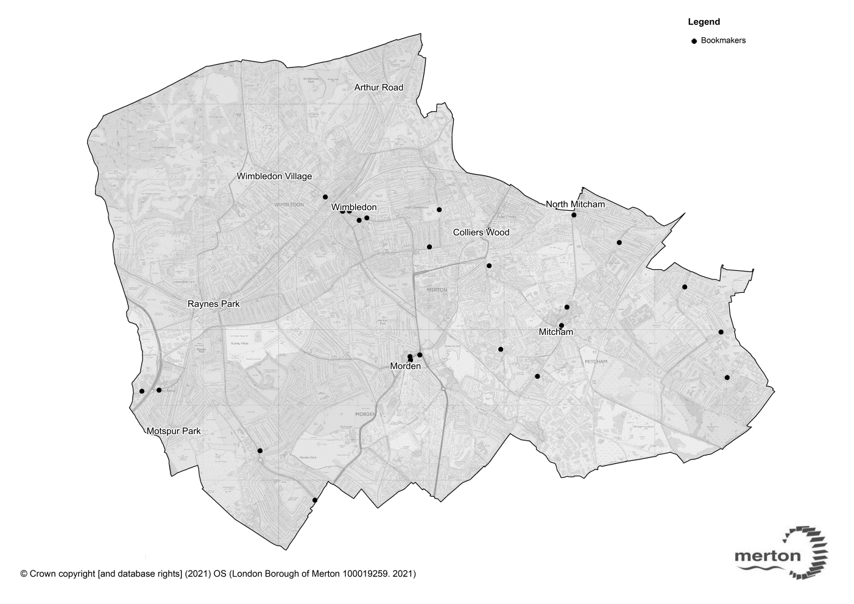

- Location of schools, colleges and youth centres

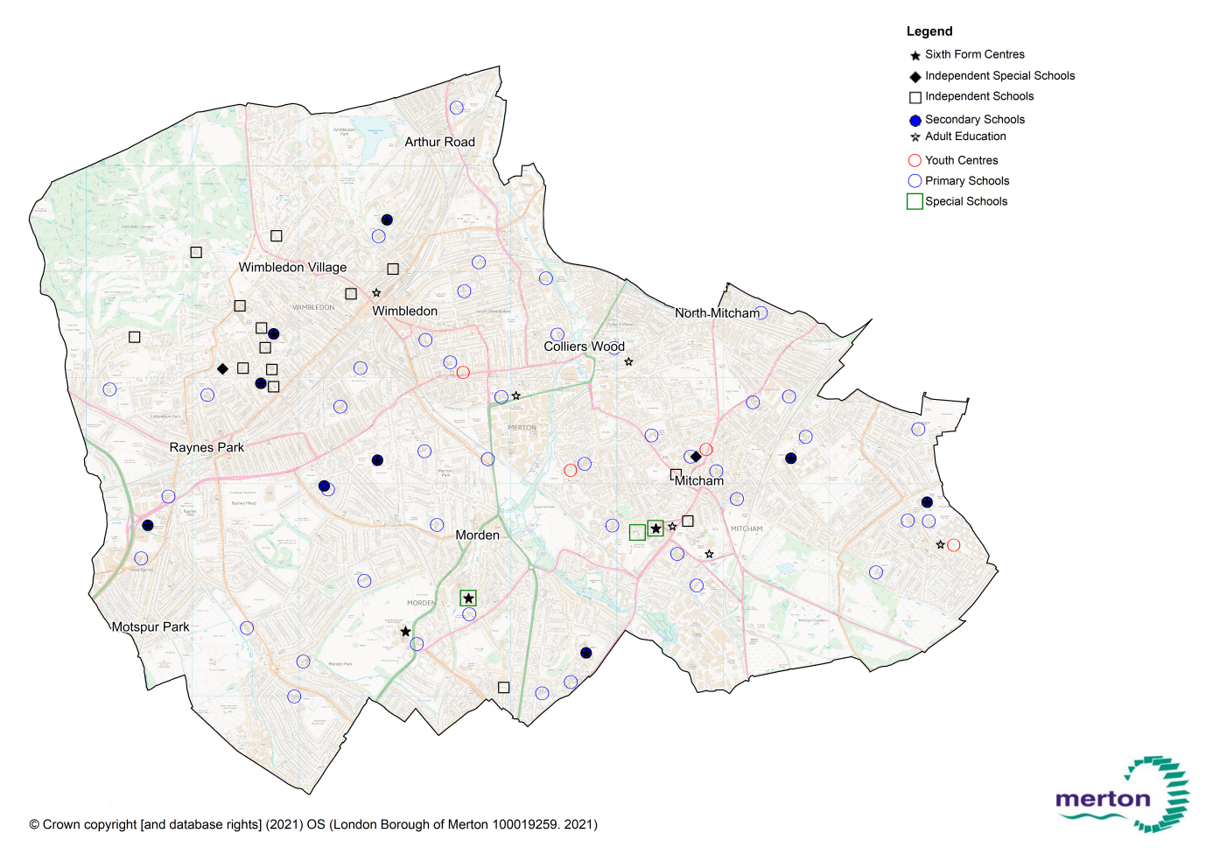

(iii) Location of community centres, libraries, leisure centres and places of worship

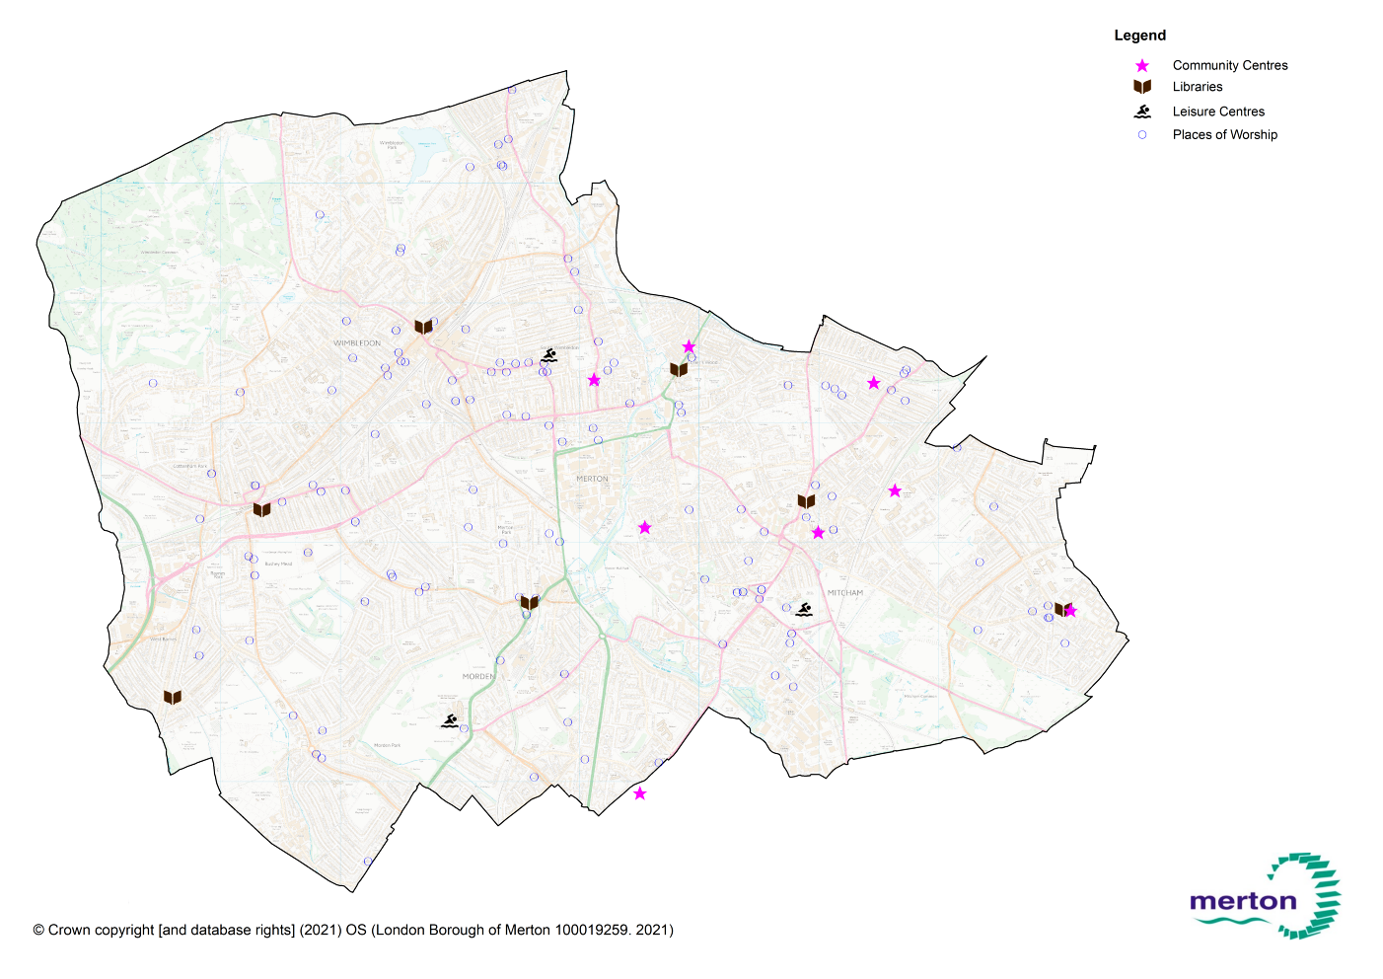

- Location of money loan stores and money transfer services

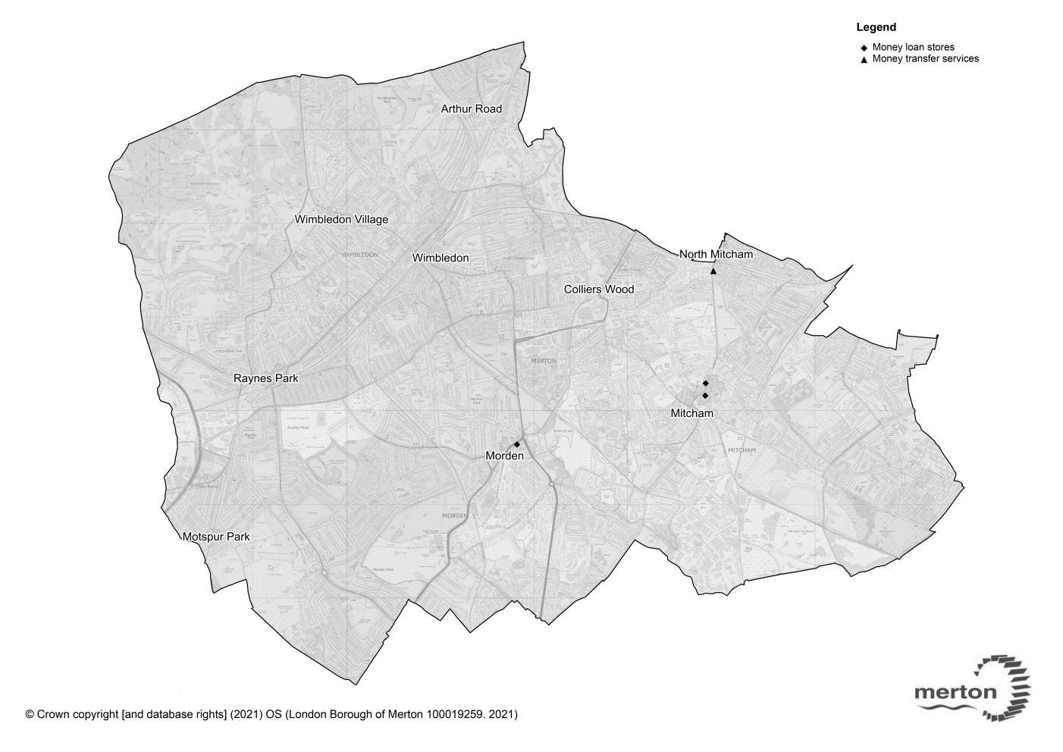

- Location of pawnbrokers

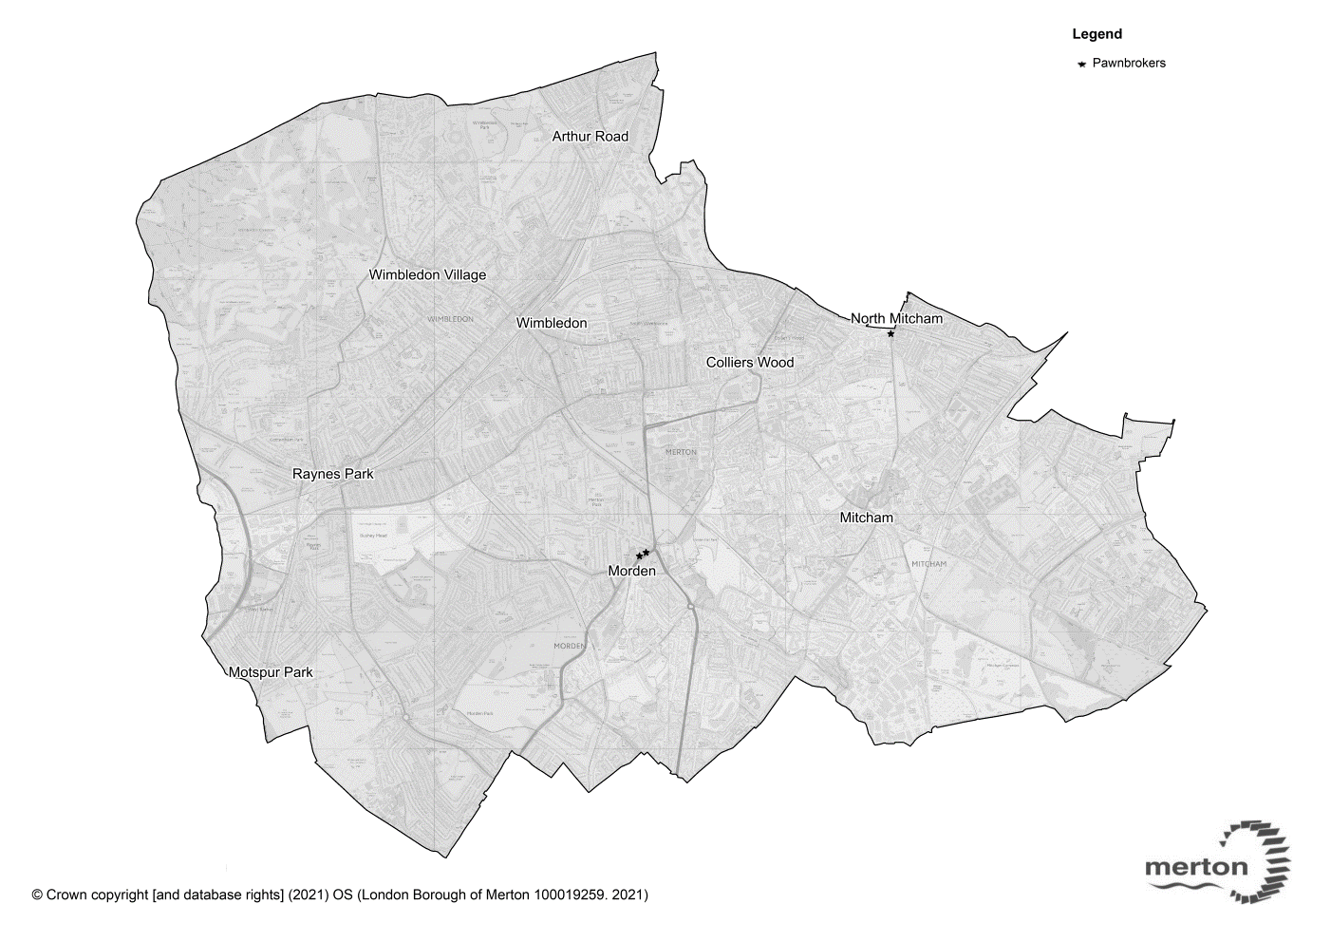

- Indices of Multiple deprivation
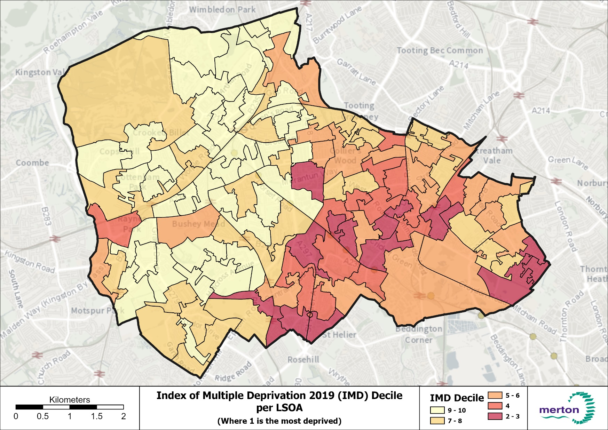

- recorded incidents of anti-social behaviour in the borough between April 2019 and March 2020

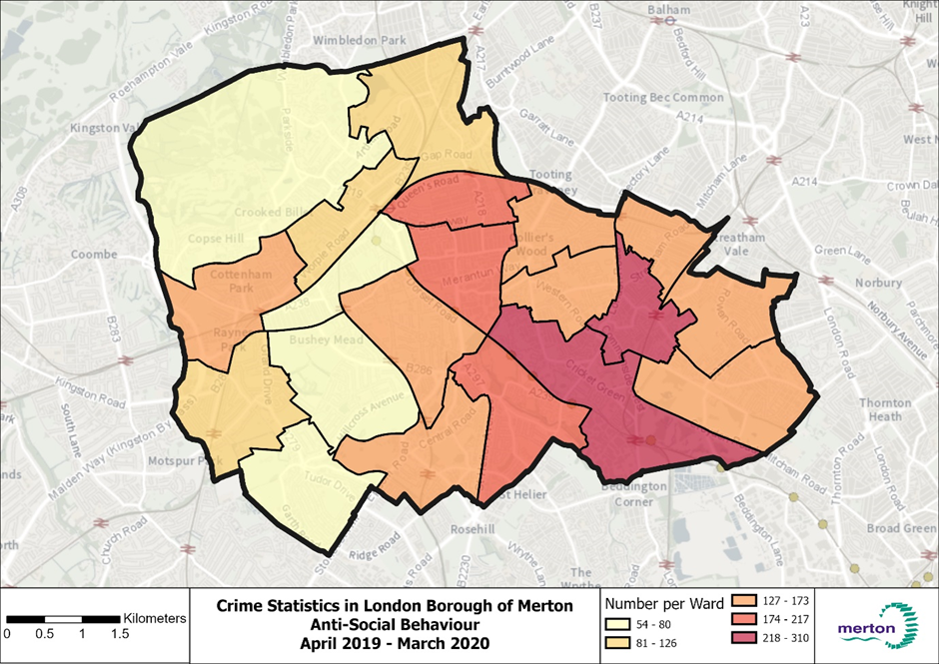

- Deprivation indices by Ward
Ward | Deprivation Score (IMD 2019)* | Income Rank  ** | Employment Rank  *** | Income Deprivation Affecting Children Index  **** | Income Deprivation Affecting Older People Index(60+) rank:
Abbey | 540 | 485 | 543 | 440 | 356
Cannons Hill | 585 | 548 | 570 | 547 | 514
Colliers Wood | 428 | 450 | 501 | 421 | 350
Cricket Green | 187 | 107 | 124 | 142 | 238
Dundonald | 621 | 627 | 630 | 623 | 556
Figge’s Marsh | 218 | 179 | 193 | 169 | 257
Graveney | 457 | 451 | 483 | 482 | 400
Hillside | 620 | 620 | 629 | 629 | 502
Lavender Fields | 340 | 254 | 323 | 241 | 200
Longthornton | 381 | 393 | 355 | 414 | 366
Lower Morden | 578 | 582 | 551 | 565 | 587
Merton Park | 602 | 587 | 604 | 588 | 570
Pollards Hill | 287 | 181 | 190 | 129 | 417
Ravensbury | 245 | 224 | 187 | 206 | 370
Raynes Park | 576 | 558 | 564 | 556 | 534
St. Helier | 269 | 253 | 198 | 277 | 316
Trinity | 563 | 519 | 506 | 501 | 459
Village | 631 | 628 | 631 | 627 | 614
West Barnes | 604 | 564 | 583 | 566 | 553
Wimbledon Park | 580 | 566 | 587 | 536 | 544

* Indices of Multiple Deprivation (IMD 2019) across Merton’s Wards with 1 being the most deprived and 644 least deprived.
** Income Rank scores across Merton’s Wards with 1 being the most deprived and 644 least deprived.
*** Employment Rank scores across Merton’s Wards with 1 being the most deprived and 644 least deprived.
**** Income Deprivation Affecting Children Index (IDACI) - Score across Merton's wards, with 1 being the most deprived and 644 being the least deprived.
***** Income Deprivation Affecting Older People Index(60+) rank (IDAOPI): Score across Merton's wards, with 1 being the most deprived and 644 being the least deprived)
Cells highlighted in red indicate, respectively, the worst 3 wards in each category.

(ix) Age Profile
Ward | Population (GLA Housing-led population projections 2018) | % of total borough population | Working age population (16-64) (GLA, Housing -led population projections 2018) | Child population (GLA, Housing -led population projections 2018) | 65+ population (GLA, Housing -led population projections 2018)
Abbey | 10770 | 5.3% | 7631 (70.8%) | 1916 (17.8%) | 1252 (11.6%)
Cannon Hill | 9370 | 4.5% | 5628 (60.1%) | 1710 (18.2%) | 2088 (22.3%)
Colliers Wood | 10910 | 5.3% | 7872 (72.2%) | 1640 (15%) | 1374 (12.6%)
Cricket Green | 12235 | 5.9% | 7335 (59.9%) | 2978 (24.3%) | 1855 (15.2%)
Dundonald | 9512 | 4.6% | 6377 (67.0%) | 1911 (20.1%) | 1265 (13.3%)
Figge's Marsh | 11809 | 5.7% | 7384 (62.5%) | 2806 (23.8%) | 1601 (13.6%)
Graveney | 10093 | 4.9% | 6729 (66.7%) | 1856 (18.4%) | 1491 (14.8%)
Hillside | 9115 | 4.4% | 5975 (65.6%) | 1501(16.5%) | 1696 (18.6%)
Lavender Fields | 10982 | 5.3% | 7368 (67.1%) | 2336 (21.3%) | 1187 (10.8%)
Longthornton | 10726 | 5.2% | 6645 (62%) | 2359 (22%) | 1643 (15.3%)
Lower Morden | 9136 | 4.4% | 5305 (58.1%) | 1794 (19.6%) | 2017 (22.1%)
Merton Park | 9710 | 4.7% | 5809 (59.8%) | 1904 (19.6%) | 2034 (20.9%)
Pollards Hill | 11039 | 5.4% | 6670 (60.4%) | 2621 (23.7%) | 1674 (15.2%)
Ravensbury | 10088 | 4.9% | 6182 (61.3%) | 2160 (21.4%) | 1712 (17%)
Raynes Park | 9962 | 4.8% | 6130 (61.5%) | 2020 (20.3%) | 1868 (18.8%)
St. Helier | 10856 | 5.3% | 6607 (60.9%) | 2420 (22.3%) | 1785 (16.4%)
Trinity | 10180 | 4.9% | 7062 (69.4%) | 1856 (18.2%) | 1271(12.5%)
Village | 8188 | 4.0% | 4449 (54.3%) | 1568 (19.1%) | 2235 (27.3%)
West Barnes | 10202 | 5.0% | 6067 (59.5%) | 2134 (20.9%) | 1977 (19.4%)
Wimbledon Park | 11082 | 5.4% | 7059 (63.7%) | 2633 (23.8%) | 1409 (12.7%)
TOTAL | 205965 | 100%

APPENDIX D – Definitions
Gaming machines
Gaming machines’ means ‘a machine which is designed or adapted for use by individuals to gamble (whether or not it can be used for other purposes)’ Regulations define four categories of gaming machine: categories A, B, C and D, with category B divided into a further five subcategories. The categories and sub-categories have been defined according to the maximum amount that can be paid for playing the machine and the maximum prize it can deliver as shown below.
There is a minimum age of 18 for all players of category A, B and C machines. There is no minimum age for players of category D machines.
Please note: This information is correct at the time of writing but for up to date information please go to The Gambling Commission website.

Category of machine | Maximum stake | Maximum prize
A-no category A gaming machines are currently permitted | Unlimited | Unlimited
B1 | £5 | £10,000  (with the option of a max £20,000 linked progressive jackpot on a premises basis only)
B2 (Fixed Odd Betting Terminals) | £2 | £500
B3 | £2 | £500
B3A | £2 | £500
B4 | £2 | £400
C | £1 | £100
D – money prize | 10p | £5
D – non-money prize (other than crane grab machine) | 30p | £8`
D – crane grab machine | £1 | £50
D combined money and non-money prize  (other than coin pusher or penny falls machines) | 10p | £8 (of which no more than £5 may be money prize)
D combined money and non-money prize  (coin pusher or penny falls machine) | 20p | £20 (of which no more than £10 may be money prize)

Casino
A ‘casino’ is an arrangement whereby people are given the opportunity to participate in one or more casino games. The permitted number of gaming machines in each category will depend on whether it is a large or small casino or a converted casino operating under preserved rights for operating prior to the 2005 Act

Bingo

‘Bingo’ means ‘any version of that game irrespective of by what name it is described’. The licence authorises a number of category B gaming machine not exceeding 20% of the total number of gaming machines which are available for use on the premises and any number of category C or D machines. Premises in existence before 13 July 2011 are entitled to make available eight category B gaming machines, or 20% of the total number of gaming machines, whichever is the greater. Regulations state that category B machines at bingo premises are restricted to sub-category B3 and B4 machines but not B3A machines.

Adult Gaming Centre
An ‘adult gaming centre’ (often called an amusement arcade) may make available for use a number of category B gaming machine not exceeding 20% of the total number of gaming machines which are available for use on the premises and any number of category C or D machines. Premises in existence before 13 July 2011 are entitled to make available four category B gaming machines, or 20% of the total number of gaming machines, whichever is the greater. Regulations state that category B machines at adult gaming centres are restricted to sub-category B3 and B4 machines but not B3A machines
Adult gaming centre’ s cannot admit those under 18.

Family entertainment centre
A family entertainment centre means ‘a premises (other than an adult gaming centre) wholly or mainly used for making gaming machines available for use’.
A licensed family entertainment centre may make available for use an unlimited number of category C or D machines. Family entertainment centres can admit those under 18 years of age, but they must not play Category C machines.
A family entertainment centre with a gaming machine permit may make available for use any number of category D machines.

Betting premises
The provision of facilities for betting, whether by making or accepting bets, by acting as a betting intermediary or by providing other facilities for making or accepting bets.
Betting means ‘the making or accepting a bet on the outcome of a race, competition or other event or process, the likelihood of anything occurring or not occurring or whether anything is, or is not, true.’
The machines available for use at betting premises are gaming machines and betting machines. The licence authorises a maximum of 4 gaming machines in categories B2, B3, B4, C and D (but not B3A). A betting machine is designed to bet on a future event or on a live event as a substitute for placing a bet over the counter
Persons under 18 will not be able to enter betting premises, although special rules apply to tracks.

Tracks
A ‘track’ means a ‘horse-race course, dog track or other premises on any part of which a race or other sporting event takes place or is intended to take place’.
Track operators do not need to have an operating licence (although they may have one), as the betting that is provided upon the tracks will not be provided by the track operator (a licence is required if the track operator wants to provide pool betting or general betting facilities himself). Individual operators who come onto the track on race days do not need to hold a premises licence but will require the necessary operating licences. Where there is no operating licence, the premises licence will need to contain requirements on the premises licence holder about their responsibilities in relation to the proper conduct of betting.

If the track operator who holds a premises licence also has a pool betting operating licence then up to 4 gaming machines of categories B2 to D (but not B3A) may be sited on the track. Betting machines may also be provided. Some tracks will also hold an alcohol licence and as such they will be automatically entitled to two gaming machines of category C or D. If a track premises licence holder has both an alcohol licence and a pool betting operating licence, then they will be entitled to a total of six gaming machines (two via the alcohol licence and four via the operating licence).

Persons under the age of 18 are excluded from any areas where facilities for betting are provided and any area where there are gaming machines, other than category D machines. However, persons under the age of 18 are not excluded from such areas where facilities for betting are provided in relation to dog tracks and horse racing courses on race days only (the exclusion still applied to areas where there are gaming machines other than category D). There is no exclusion of race days in relation to gaming machines, although persons under the age of 18 are not prohibited from playing category D gaming machines on a track.

Travelling fair
A ‘fair’ means ‘fair consisting wholly or principally of the provision of amusements’ and a fair held on a day in a calendar year is a travelling fair if provided ‘wholly or principally by persons who travel from place to place for the purpose of providing fairs and at a place no part of which has been used for the provision of a fair on more than 27 days in that calendar year’. There is no limit on category D machines and persons under 18 may use those machines.

Alcohol licensed premises gaming machine permits
Operators of premises with an on-premises alcohol licence have an automatic right to have 2 gaming machines of category C or D (following notification to the licensing authority). However, a permit is required if the applicant seeks to have more than two machines. A permit authorises the number of C or D machines. Persons under 18 may not play category C machines but may play category D machines.

Prize Gaming
‘Gaming is prize gaming if neither the nature nor the size of a prize played for is determined by reference to the number of persons playing or the amount paid for or raised by the gaming’. Persons under 18 may participate in equal chance prize gaming only. Gaming is equal chance gaming ‘ if it does not involve playing or staking against a bank and the chances are equally favourable to all participants’

Members Club
A members’ club is a club that is not established as a commercial enterprise and is conducted for the benefit of its members. Examples include working men’s' clubs, miners' welfare institutes, branches of the Royal British Legion and clubs with political affiliations. Members’ clubs may apply to their local licensing authority for club gaming permits and club machine permits.

Miners’ welfare institutes
Miners’ welfare institutes are associations established for recreational or social purposes. They are managed by representatives of miners or use premises regulated by a charitable trust which has received funds from one of a number of mining organisations. Miners’ welfare institutes may also apply for club gaming permits and club machine permits.

Commercial Club
A commercial club is a club established for commercial gain, whether or not they are actually making a commercial gain. Examples include commercial snooker clubs, clubs established as private companies and clubs established for personal profit. Commercial clubs may only apply for club machine permits.

Club gaming permit
A club gaming permit is available to members’ clubs or miners’ welfare institutes, but not commercial clubs. It allows the club to offer:
- equal chance gaming such as poker and bingo
- games of chance (pontoon and chemin de fer only)
- up to three gaming machines in total of categories B3A, B4, C or D, but by agreement, only one machine can be of category B3A.

Restrictions on the gaming (at the time of writing this Statement) are:
- no limits on stakes and prizes, except bingo where there is a stakes and prizes limit of £2,000 in any seven day period
- limit on participation fees per person per day - £20 for bridge and or whist (if played on a day on which no facilities of any kinds of gaming (other than bridge or whist) are provided by the relevant club on that day), £3 for other gaming (including poker) in any other circumstances

Club machine permit (CMP)
A club machine permit is available to members’ clubs, miners’ welfare institutes, and commercial clubs. It allows the club to offer:
- equal chance gaming such as poker and bingo
- up to three gaming machines in total of categories B3A, B4, C or D, but by agreement, only one machine can be of category B3A (B3A not permitted for commercial clubs).

Restrictions on the gaming are (at the time of writing this Statement):
- limit on stakes and prizes for bingo is £2,000 in any seven day period
- limit on stakes for poker - £10 per person per game, within a premises limit of £250 in stakes per day and £1,000 per week
- limit on prizes for poker - £250 per game
- limit on participation fees per person per day - £18 for bridge/whist (if played on a day on which no facilities of any kind of gaming (other than bridge or whist) are provided by the relevant club on that day), £1 for other gaming (including poker), £3 where it’s a commercial club.

Small Society Lotteries
Small society lotteries do not require a licence but must be registered with the local authority in the area where the principal office of the society is located.

Society lotteries are promoted for the benefit of a non-commercial society. A society is non-commercial if it is established and conducted for:
- charitable purposes
- enabling participation in sport or a cultural activity (for example theatre)
- any non-commercial purpose other than that of private gain.

A small society lottery:
- does not have proceeds that exceed £20,000 for a single draw
- does not have aggregated proceeds in excess of £250,000 in a calendar year.

APPENDIX E – Responsible Authorities
Authority | Contact Details
The Licensing Authority | Environmental Health (Licensing) Manager,  Merton Civic Centre,  London Road,  Morden, SM4 5DX  licensing@merton.gov.uk
Metropolitan Police | The Licensing Officer,  Wimbledon Police Station,  15 Queens Road,  London, SW19 8NN  southwestswmailbox-.licensinggeneral@met.police.uk
London Fire Authority | Fire Safety Regulation: South West Area 4,  London Fire Brigade,  169 Union Street,  London, SE1 0LL  fsr-adminsupport@london-fire.gov.uk
The Local Planning Authority | Planning Manager,  Merton Civic Centre,  London Road,  Morden, SM4 5DX
Responsible Authority for Noise and Environmental Pollution | Environmental Health (Pollution) Manager,  Merton Civic Centre,  London Road,  Morden, SM4 5DX  noiseandnuisance@merton.gov.uk
Protection of Children from Harm | Merton Local Safeguarding Children Board,  Merton Civic Centre,  London Road,  Morden, SM4 5DX
The Gambling Commission | Gambling Commission  4th Floor  Victoria Square House  Birmingham  B2 4BPhttps://www.gamblingcommission.gov.uk/home.aspx
HM Revenue and Customs | HM Revenue and Customs  Excise Processing Teams  BX9 1GL  United Kingdom  email: NRUBetting&Gaming@hmrc.gsi.gov.uk  https://www.gov.uk/government/organisations/hm-revenue-customs

