 | COSHH Risk Assessment No:
Name of Premises / School: |  |  |  |  |  |  |  |  | Section/Area:
Describe the activity or work process.
(Include how long and how often this is carried out and the quantity of substance used)
Location of process being carried out?
Identify the persons at risk: |  |  |  |  | Employees  (including trainees) |  |  |  |  | Contractors |  |  |  | Public  (including students)
Name the substance involved in the process and its manufacturer.
(A copy of a current safety data sheet for this substance should be attached to this assessment)
Classification (state the category of danger)
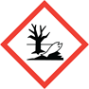
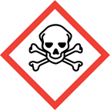
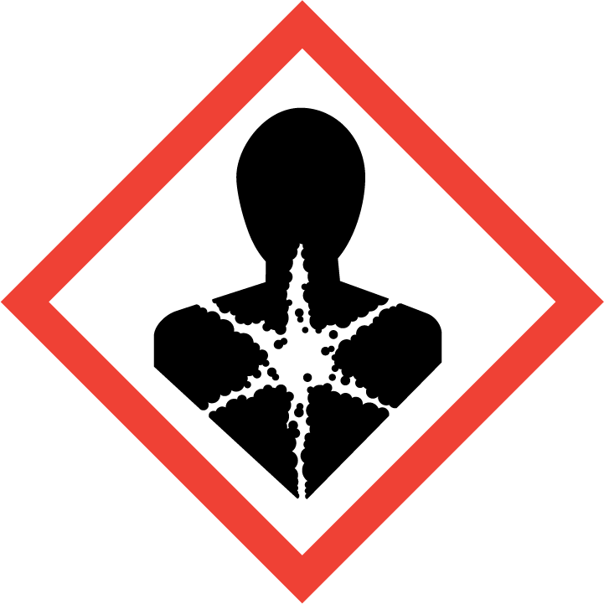

Aquatic Environment

Serious health hazard

Acute toxicity Cat 1-3

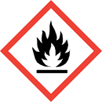

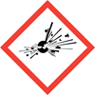
Flammable
Acute toxicity (cat 4)
Toxic

Explosive

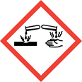
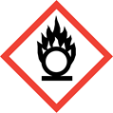


Oxidising
Gas under pressure

Corrosive

Hazard Type
Gas Vapour Mist Fume Dust Liquid Solid Other (State)
Route of Exposure

Inhalation Skin Eyes Ingestion Other (State)
Workplace Exposure Limits (WELs) please indicate n/a where not applicable
Long-term exposure level (8hrTWA): |  |  |  |  |  |  |  | Short-term exposure level (15 mins):
State the Risks to Health from Identified Hazards
Control Measures: (for example extraction, ventilation, training, supervision). Include special measures for vulnerable groups, such as disabled people and pregnant workers
Is health surveillance or monitoring required?

Yes No
Personal Protective Equipment (state type and standard)
Dust mask |  |  |  |  |  |  | Visor
Respirator |  |  |  |  |  |  | Goggles
Gloves |  |  |  |  |  |  | Overalls
Footwear |  |  |  |  |  |  | Other
First Aid Measures
Storage
Disposal of Substances & Contaminated Containers
Hazardous Waste Skip Return to Depot Return to Supplier Other

(If Other Please State):
Is exposure adequately controlled? |  |  |  |  |  | Yes No
What further action needs to be taken
Action |  |  |  | By Who |  |  |  |  |  |  |  | By what date

Assessed by:

Date: Review Date:
New and old CLP symbols

New Pictogram | Number | Hazard Class (CLP) | Old “CHIP” Symbol
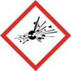 | GHS-01 | Explosives; Self-reactive substances and mixtures, types A, B; Organic peroxides, types A,B |   Explosive
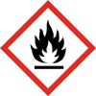 | GHS-02 | Flammable gases, aerosols, liquids or solids; Self-reactive substances and mixtures; Pyrophoric liquids and solids; self-heating substances and mixtures; Substances and mixtures which in contact with water emit flammable gases; Organic peroxides |   Highly/extremely flammable
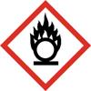 | GHS-03 | Oxidising gases, liquids and solids |   Oxidising
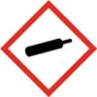 | GHS-04 | Compressed gases, liquids and solids; Liquefied gases; Refrigerated liquefied gases; Dissolved gases | No current symbol
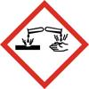 | GHS-05 | Corrosive to metals; Skin corrosion; Severe eye damage | 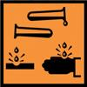  Corrosive
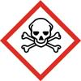 | GHS-06 | Acute toxicity (Cat 1-3) |   Toxic/ Harmful  Very Toxic
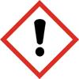 | GHS-07 | Acute toxicity (Cat 4)  Skin and eye irritation; Skin sensitisation; Specific target organ toxicity; Respiratory tract irritation; Narcotic effects | Harmful/Irritant
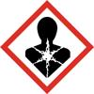 | GHS-08 | Respiratory sensitisation; Germ cell mutagenicity; Carcinogenicity; Reproductive toxicity; Specific target organ toxicity; Aspiration hazard | No current specific symbol  Use either
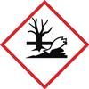 | GHS-09 | Hazardous to the aquatic environment |   Dangerous for the environment

