MERTON COUNCIL

Local Housing Allowance:

The complete guide

London Borough of Merton Housing Benefit

April 2017



Index Page

Merton LHA rates from 1st April 2017 to 31st March 2018 3

Points to note on LHA rates from April 2017 4

Background to LHA 4

Broad Rental Market Areas (BRMAs) 5

Merton’s Broad Rental Market Areas (BRMAs) 5

Working out how much your LHA will be 6

How many bedrooms am I entitled to? 6

LHA for single people under 35 7

LHA for severely disabled single people under 35 7

LHA for care leavers under 22 8

LHA rate for approved foster carers single people under 35 8

LHA for former hostel dwellers aged 25 to 34 8

LHA for ex-offenders aged 25 to 34 8

Working out your LHA if you are aged 35 or over 9

LHA for joint tenants in a separate household 9

LHA for joint tenants within the same household 9

LHA for a couple with no children 10

LHA for couples who cannot share a bedroom due to disability 10

LHA for single people under 35 11

LHA for severely disabled single people under 35 11

Working out your LHA if you are aged 35 or over 12

LHA rate for approved foster parent or carers 13

LHA for children 13

LHA for disabled children or non dependants with overnight carers 14

LHA for children who cannot share a bedroom due to disability 14

When your rent is more than your LHA rate and protection 15

When your rent is less than your LHA rate 15

Rent increases and decreases under LHA rules 15 What can I do if I disagree with your decision? 15

2

### Merton LHA rates from 1st April 2017 to 31st March 2018

Local Housing Allowance (LHA) rules apply to existing claims for Housing Benefit (HB) made on or after 7th April 2008 and new and change of address claims for tenants renting accommodation from a private landlord. The tables below show the LHA rates for the Broad Rental Market Areas (BRMAs) for Merton. Four bedrooms is the maximum LHA rate. For more information see **Points to note on** **LHA rates from 1st April 2017** on page 4. They are based on rents for three in ten properties being affordable**.**

If your rent is weekly use this table.

|  |  |  |  |  |  |
| --- | --- | --- | --- | --- | --- |
| **BRMA and ID number** | LHA weekly standard rates **for 1 April 2017 to 31 March 2018 only** | | | | |
| **Shared room** | **One**  **Bedroom** | **Two**  **bedrooms** | **Three**  **bedrooms** | **Four**  **bedrooms** |
| Inner  South West London - 145 | £94.38 | £253.82 | £302.33 | £354.46 | £417.02 |
| Outer  South West London- 152 | £87.46 | £209.77 | £280.60 | £336.96 | £417.02 |
| Outer  South  London – 153 | £82.46 | £172.24 | £216.89 | £279.14 | £344.38 |

If your rent is calendar monthly use the table below. The weekly rate above is multiplied by 52 and divided by 12.

|  |  |  |  |  |  |
| --- | --- | --- | --- | --- | --- |
| **BRMA and ID number** | LHA monthly standard rates **for 1 April 2017 to 31 March 2018** | | | | |
| **Shared Room** | One  **Bedroom** | **Two**  **Bedrooms** | **Three**  **Bedrooms** | **Four**  **Bedrooms** |
| Inner South West  London - 145 | £408.98 | £1099.89 | £1310.10 | £1535.99 | £1807.09 |
| Outer South West  London – 152 | £378.99 | £909.00 | £1215.93 | £1460.16 | £1807.09 |
| Outer  South  London - 153 | £357.33 | £746.37 | £939.86 | £1209.61 | £1492.31 |

**Your maximum rent for HB will be the lowest of your rent or the LHA rate you are claiming HB on or after 1st April 2017.**

3

### Points to note on LHA rates from April 2017

Most LHA rates are frozen at the April 2015 levels for four years. LHA targeted affordability funding has increased certain bedroom sizes in two of our three Broad Rental Market Areas (BRMAs) by 3%. These are the shared room rate for Outer South West London and the one bedroom and two bedroom rates for Outer South London. The LHA rates are valid for the year published which runs from 1st April 2017 to 31st March 2018.

### Background to LHA

LHA is the main Housing Benefit (HB) scheme for tenants renting accommodation from a private landlord. It also affects tenants already getting HB in social housing, who move into accommodation rented from a private landlord. If you live in social housing, LHA will not affect you until 1st April 2019.

With LHA, your bedroom rate for HB is based on your age, where you live, the number of people living in your household, their ages and circumstances like disabilities and caring arrangements. The maximum LHA rate is the four bedroom level. Your maximum eligible rent for HB will be the lowest of your rent or the LHA rate you are entitled to.

**Simon and Amanda**

Simon and Amanda want to rent a one bedroom flat in Morden for £180.00 per week, but their eligible rent for HB is based on the LHA rate of £172.24 for Outer South London BRMA.

Your HB can be reduced by your level of income and benefits you receive, what savings and capital you have and other adults that live with you. You can use the benefit calculator to get an estimate of HB at www.gov.uk/benefits-calculators. In some cases your HB could be subject to the Benefit Cap, which is:

* £296.35 per week for single people and
* £442.31 per week for couples and lone parents.

You can find out more at www.gov.uk/benefit-cap

4

### Broad Rental Market Areas (BRMAs)

Always check go to the Gov.uk website www.gov.uk/housing-benefit/what-youll-get and click on Local Housing Allowance Limit. Type your current postcode or the postcode of the address you are thinking of moving to. The area that you live in will affect the level of LHA that you can get. LHA rates will vary greatly around London and the rest of England and Wales. If you are considering moving outside Merton always check the LHA rates for the area you are looking to move to.

The Valuation Office Agency (VOA) has decided that Merton has three areas, called Broad Rental Market Areas (BRMAs), which are different in terms of:

⚫ Health ⚫ Education ⚫ Recreation ⚫ Banking and ⚫ Shopping

In the main, the boarders between two different areas follow natural boundaries like the Wandle River and the Tooting Railway Line. They sometimes follow borough boundaries, like the north of Wimbledon Village and Wimbledon Park**.**

### Merton’s Broad Rental Market Areas (BRMAs)

**Outer South London**

This covers the eastern wards in Merton. These are: Cricket Green, Pollards Hill, Figges Marsh, Graveney (south of the Tooting Railway Line), Lavender Fields, Longthornton, Ravensbury and St. Helier.

**Outer South West London**

This covers the western wards in Merton. These are: Abbey, Cannon Hill, Dundonald, Hillside, Lower Morden, Merton Park, Trinity, Wimbledon Park and Wimbledon Village.

**Inner South West London**

This is the smallest area, north of the railway line from Tooting

Station. This is the Merton part of Tooting Graveney.

5

### Working out how much your LHA will be

To work out how much Housing Benefit you might get you need to:

1. Find out the LHA rate based on the number of bedrooms you are entitled to, for the area you live in or are moving to from page 3 **Merton LHA rates from 1st April 2017 to 31st March 2018**; and
2. Find out how many bedrooms you are entitled to – see **How many bedrooms am I entitled too?** below; or
3. Go to the Gov.uk website www.gov.uk/housing-benefit/what-youll-get and click on the link Local Housing Allowance Limit

### 

### How many bedrooms am I entitled to?

The number of people and their circumstances dictates how many bedrooms you are entitled to. You are entitled to **one** bedroom for:

* a single person or a lone parent (pages 7 to 9)
* a couple (page 10)
* any other adult aged 16 or over such as a non dependant, sub tenant or boarder (page 11)
* two children of the same gender aged 10 to 16 (page 13)
* two children of either gender aged under 10 (page 13)
* any other child (page 13); and an **extra** bedroom for:
* a couple who cannot share a bedroom due to disability (page 10)
* you or your partner being disabled with overnight care (page 11)
* an adult child who is deployed in the armed forces (page 11)
* an approved foster carer or foster parent (page 13)
* a disabled child or non dependant with overnight care ( page 14)
* children who cannot be expected to share bedroom due to disability (page 14)

If you are a single person under 35 you are normally only entitled to the shared room rate of LHA. There are exemptions from this which could mean you are entitled to the higher one bedroom self-contained rate. These rules and exemptions are explained on pages 7-8. The rules for joint tenants are on page 9.

6

### LHA for single people under 35

If you are aged under 35, are single, you can only get the LHA shared room rate, unless you are exempt.

**Marcus**

Marcus is single. He is aged 23. He has sole use of a one bedroom

flat. He is entitled to the shared room rate.

You can be exempt from the shared room rate of LHA if you are:

* severely disabled (see page 7)
* a care leaver aged under 22 (see page 8)
* an approved foster carer aged under 35 (see page 8)
* a former hostel dweller aged 25 to 34 (see page 8)
* an ex offender aged 25 to 34, subject to Multi Agency Public Protection Arrangements (see page 8)

### LHA for severely disabled single people under 35

If you are single aged under 35 years of age and severely disabled, you are exempt from the shared room rate of LHA. Your HB will be based on the one bedroom self-contained LHA rate, even if you have chosen to live in shared non self contained accommodation. To meet the conditions for severely disabled you have to be:

* in receipt of the severe disability premium for Housing Benefit, Income Support, Jobseekers Allowance or Employment and Support Allowance; or
* in receipt of the middle or higher care component of Disability Living Allowance; or
* in receipt of the standard or enhanced rate of Daily Living component of Personal Independence Payment; or
* registered blind.

**Abdul**

Abdul is single person aged 33. He lives in a house where he has his own bedroom and shares a kitchen, bathroom and toilet. He is registered blind. He is entitled to one bedroom self-contained rate.

7

### LHA for care leavers under 22

If you are:

* a care leaver under 22 years of age or
* live with a care leaver who is under 22, who is your partner,

and have no dependent children, your HB will be based on the one bedroom self-contained LHA rate.By care leaver we mean someone who was in council Social Services care after the age of 15.

**Ahmed**

Ahmed is a single care leaver aged 21. His 22nd birthday is 11 October 2017. He is entitled to the one bedroom self-contained rate until 10th October 2017. From 11th October 2017 he is entitled to the shared room rate of LHA.

### LHA rate for approved foster carers single people under 35

If you are single aged under 35 and an approved foster carer, you will be entitled to the one bedroom self- contained LHA rate, not the shared room rate.

### LHA for former hostel dwellers aged 25 to 34

If you are aged between 25 and 34 and have spent at least three months in homeless hostels, receiving support to recover and resettle you could get the one bedroom self- contained LHA rate at the home you move into. The support may have been for alcohol or drug dependence for example. We would need to see proof from your support or key worker.

### LHA for ex-offenders aged 25 to 34

If you are aged between 25 to 34 and an ex-offender you could get the one bedroom self-contained LHA rate at the home you move into. You would be subject to Multi Agency Public Protection Arrangements (MAPPA). We would need proof from your probation officer or support worker.

8

### Working out your LHA if you are aged 35 or over

If you are 35 or over, single and do not live with any dependants, your benefit will be based on the one bedroom LHA rate if you live in:

* a self-contained property
* shared accommodation but have two or more rooms (bedrooms or living rooms) that no-one else can use.

**Tracey**

Tracey is single and aged 40. She lives in house sharing with other tenants, but she has one bedroom and study room that no-one else can use. She is entitled to the one bedroom self-contained rate.

If you are 35 or over, single with no children, your HB will be based on the LHA shared room rate, if you live in shared accommodation, unless you have two or more rooms (bedrooms or living rooms) that no-one else can use.

**Ken**

Ken is single and aged 38. He lives in a house where he has his own bedroom and shares a kitchen, bathroom and toilet. He is entitled to

the shared room rate.

### 

### LHA for joint tenants in a separate household

Single joint tenants are entitled to the shared room rate.

**Gary**

Gary rents a three bedroom house as a joint tenant with two other

adult friends for a total of £240 per week. They each pay an equal

share of £80 per week. Gary’s HB is based on the shared room rate.

### LHA for joint tenants within the same household

You may have a joint tenant who is part of your household, but are not treated as members of your family for HB purposes. For example you may have a non dependant son or daughter who is a joint tenant, but they live as part of your household. In these rarer cases, the LHA bedroom rate can be more than the shared room rate.

9

### LHA for a couple with no children

If you are a member of a couple with no children, your HB will be based on the one bedroom self-contained LHA rate if you live in:

* a self-contained property; or
* shared accommodation but have two or more rooms (bedrooms or living rooms) that no-one else can use

**Abdul and Gita**

Abdul and Gita live as a couple with no children. They live in a self-contained one bedroom terraced house. They are entitled to a one bedroom self contained LHA rate.

But, if you live in shared accommodation, with one bedroom or living room that no-one else can use and you are a member of a couple with no children, your HB will be based on the LHA shared room rate.

**Michael and Jane**

Michael and Jane live as a couple, with no children. They live in a room, but share a kitchen, bathroom and toilet with other tenants. They are entitled to a shared accommodation rate of LHA.

### LHA for couples who cannot share a bedroom due to disability

If you or your partner is unable to share a bedroom due to either your disability or your partner’s, you are entitled to a two bedroom LHA rate. This could be room for a single bed because of medical equipment or the symptoms of the disability make sharing a bedroom impossible. The conditions to qualify are, **firstly**, you or your partner:

* has a clearly identifiable medical condition; and **secondly**
* are in receipt of the standard or enhanced rate of the daily living component of Personal Independence Payment; or
* are in receipt of the middle or higher rate of the care component of Disability Living Allowance; or
* are in receipt of Attendance Allowance; or
* are in receipt of an Armed Forces Independence Payment.

10

### LHA for disabled claimants or partners with overnight carers

You could be entitled to an extra bedroom if you or your partner is disabled and **firstly**:

* an overnight carer or carer team is providing regular care; and
* a separate bedroom for them, which is in addition to the bedrooms already occupied by the people who live in your household; and **secondly** you or your partner:
* is in receipt of the standard or enhanced rate of the daily living component of Personal Independence Payments; or
* is in receipt of the middle or higher rate of the care component of Disability Living Allowance; or
* is in receipt of Attendance Allowance; or
* meet the first conditions but do not meet any of the second conditions for the benefits, you may get the extra bedroom.

### LHA for non dependants, sub tenants and boarders

Each non dependant, non dependant couple, sub tenant or boarder would add one bedroom to the number of bedrooms you are entitled to under LHA. However, non dependant deductions can reduce your HB. The rent or boarder income you receive from a sub tenant or boarder can reduce your HB.

### LHA for students studying at college or university

If your son or daughter is studying away from home on a temporary basis, we can treat them as an occupier of your home for LHA. But, we can only do this, if they regularly return home during the winter, spring and summer breaks and the bedroom is left for them.

### LHA for adult children who are armed forces personnel

If you have an adult child in the armed forces deployed on operations, you are entitled to an extra bedroom. An adult child is a son, daughter, step-son or step daughter of you or your partner who was a non dependant. They must intend to return to your home.

11

### Working out your LHA if you are aged 35 or over

If you are 35 or over, single and do not live with any dependants, your benefit will be based on the one bedroom self-contained rate, if you live in:

* a self-contained property; or
* shared accommodation but have two or more rooms (bedrooms or living rooms) that no-one else can use.

**Tracey**

Tracey is single and aged 40. She lives in house sharing with other tenants, but she has one bedroom and study room that no-one else can use. She is entitled to the LHA one bedroom self-contained rate.

If you are 35 or over, single and do not live with any dependants, your HB will be based on the LHA shared accommodation rate, if you live in shared accommodation, unless you have two or more rooms (bedrooms or living rooms) that no-one else can use.

By a self-contained property we mean one where you have your own room plus your own:

* bathroom
* toilet, and
* kitchen (or facilities to cook with)

**Sandra**

Sandra is single and aged 38. She lives in a house where she has her own bedroom and shares a kitchen, bathroom and toilet. She is entitled to the shared room rate.

12

### LHA rate for approved foster parent or carers

If you are a foster parent or carer, you could be entitled to one extra bedroom, if you or your partner, if you are a member of a couple, is an approved foster carer or foster parent. If you are both approved you still are entitled to one additional bedroom. You may or may not have had a foster child placed yet to qualify.

### LHA for children

If you are a lone parent or a couple with children who normally live with you, you are entitled to one bedroom for:

* two children of the same gender aged between 10 and 16; and
* two children of either gender aged under 10; and for
* any other child.

**Maxine**

Maxine is a 3 year old daughter of a lone parent. One bedroom is added for Maxine to her mother’s bedroom allowance. Maxine’s mother is entitled to the two bedroom LHA.

**David and Susan**

David is 7 year son and Susan is a 9 year old daughter of a couple.

One bedroom is added for David and Susan to their parent’s bedroom allowance. David and Susan’s parents are entitled to the two bedroom LHA. When Susan reaches the age of 10, she will no longer be expected to share a bedroom with David. So David and Susan’s parents will then be entitled to a three bedroom LHA.

**Vijay, Seema and Selena**

Vijay is a 6 year son, Seema is a 4 year old daughter and Selena is a 2 year old daughter of a couple. Two bedrooms are added for Vijay and Seema and one for Selena to their parent’s bedroom allowance. Vijay and Seema’s parents are entitled to the three bedroom LHA.

13

### LHA for disabled children or non dependants with overnight carers

* You could be entitled to an **extra** bedroom if you or your partner is living with a disabled child or non dependant and **firstly**:
* they have an overnight carer or team providing regular care;
* a separate bedroom is made available for them; and **secondly**
* they are in receipt of the middle or higher rate of the care component of Disability Living Allowance; or
* they are in receipt of Attendance Allowance; or
* they are in receipt of the standard or enhanced rate of Daily Living component of Personal Independence Payments;
* they in receipt of an Armed Forces Independence Payment; or
* if they meet the first conditions but do not meet any of the second conditions for the benefits, you may get the extra bedroom.

**John**

John is a severe disabled child of a couple who rent a three bedroom flat. The couple receive the highest rate of the care component of DLA. John has a carer who stays overnight in the third bedroom. The couple are entitled to one bedroom themselves, plus one for John, plus one for the overnight carer. Their total LHA entitlement is for three bedrooms.

### LHA for children who cannot share a bedroom due to disability

Where the normal rules allow one bedroom for two children, but one of your children is disabled, you could get an extra bedroom if **firstly**:

* they could not be expected to share a bedroom; and
* your disabled child regularly receives overnight care; and
* the sleep of your non disabled child would be seriously disrupted, if they were to sleep in the same bedroom; and
* there is a risk of harm if they do not sleep separately; and **secondly:**
* your disabled child is entitled or in receipt of the middle or higher rate care component of Disability Living Allowance.

14

### When your rent is more than your LHA rate and protection

If your LHA rate is less than your rent, you have to pay the shortfall. You could:

* Search for cheaper accommodation
* Negotiate a reduced rent with your landlord or prospective landlord, who can then request direct payment of HB
* Speak to Housing Options on 020 8545 3636
* You can apply to us for a Discretionary Housing Payment

If you could previously afford your rent and you or your partner have not claimed HB in the last 52 weeks before you make a claim HB, you are protected from restriction by the LHA rate for the first 13 weeks. If there has been a death in your household you are protected from restriction by the LHA rate for 52 weeks from the date of death.

### 

### When your rent is less than your LHA rate

If your rent is less than the LHA rate applicable to your household, your maximum eligible rent for HB will be your rent.

### Rent increases and decreases under LHA rules

Rent increases or decreases must be notified promptly. An increase could mean your HB increases, if your new rent is still at or below your LHA rate. If the landlord decreases the rent to the LHA rate or below, we can decide to pay them HB direct.

### What can I do if I disagree with your decision?

If you disagree with a decision we have made in the assessment of your claim you can challenge our decision in these ways. You can:

* Request a statement of reasons as you either do not understand it or you dispute it; or
* Make a written request for us to review our decision, known as a reconsideration
* Make a written request for an independent appeal at tribunal giving the reasons you disagree with the decision.

15

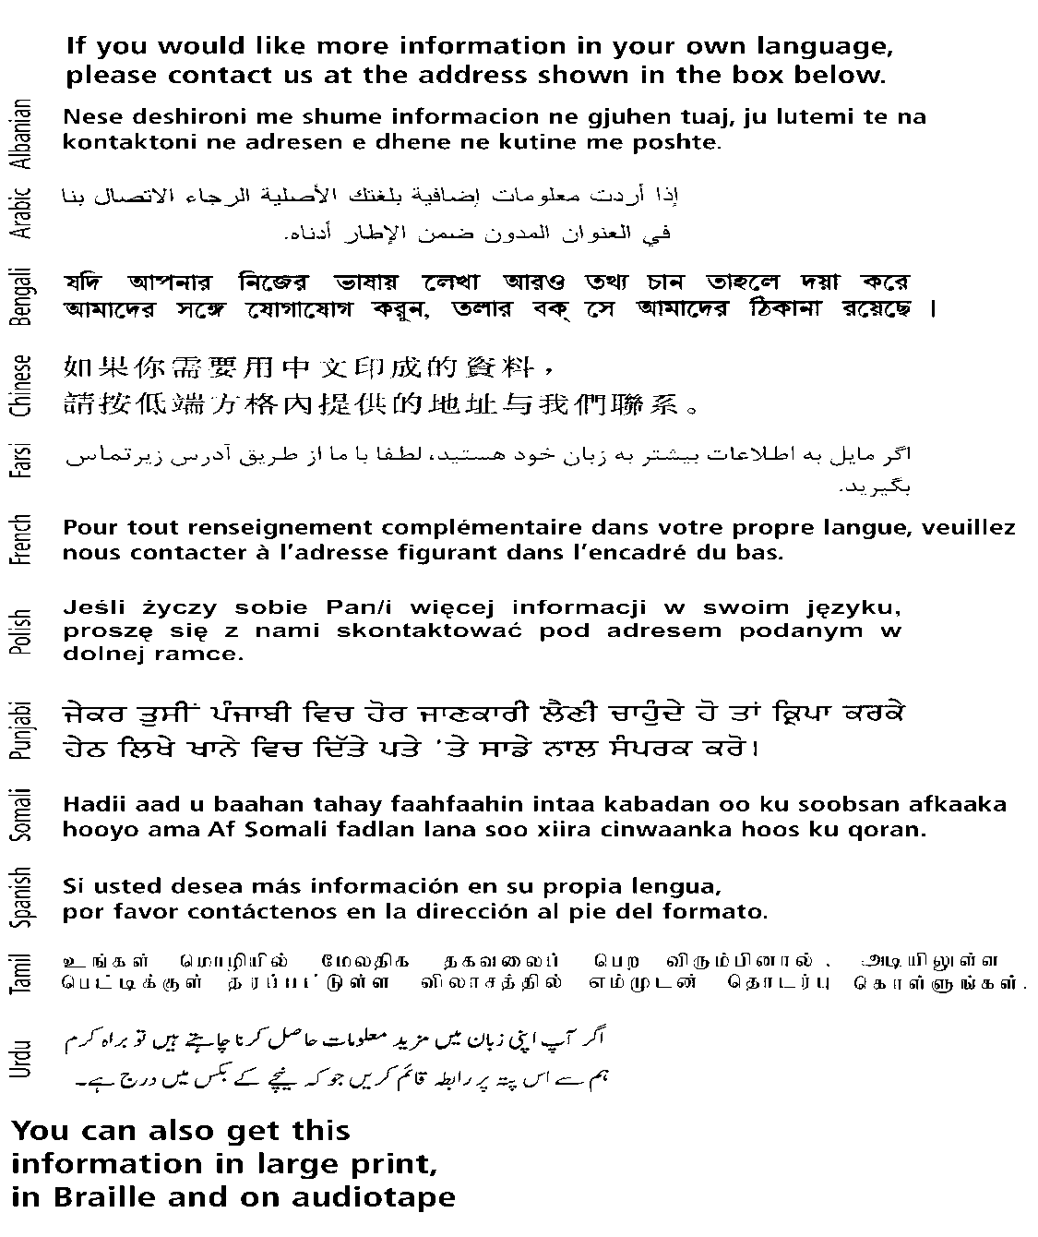

Merton Benefits Service, London Borough of Merton,

PO Box 610, Civic Centre, London Road, Morden, SM4 5ZT.

Tel No: 020 8274 4903

16