Expression of Interest Form to the Living Wandle Landscape Partnership Scheme (LW LPS)
Please let us know your project ideas. We are looking to fund projects that will deliver benefits within the LW scheme area before December 2017. It is likely that the total pot available will be £60,000. From this, a variety of smaller projects will be funded.
Your project idea should feed into at least one of the five main aims of the LW scheme:
Living Wandle Landscape Partnership Scheme Aims
To revitalise the River Wandle as an identifiable high quality asset to the communities of South London through engagement with the Natural and Built Heritage of the river
To provide a multi functional living landscape which is accessible to all and an open space resource that contributes to health and well-being
To strengthen the partnership of people who look after the river
To reintroduce the local diverse community to the river and to find ways in which this re-established relationship can enrich the lives of local people
To help make the river valley a clear, safer and much more sustainable environment

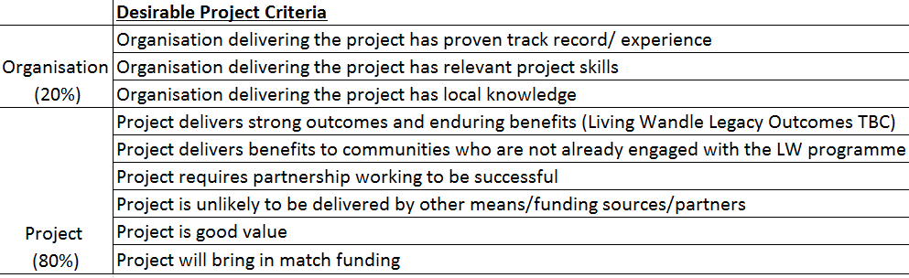
The following criteria will be considered during the selection process:

Timeframes:
Timeframe | Action
Deadline: 13th April 2016 | Contact with the Living Wandle team and submission of Expression of Interest forms
2nd March 2016 | Total funding pot available is decided
11th May 2016 | Projects considered by Living Wandle steering group and shortlist produced
June 2016 | Legacy outcomes of the LW LPS are decided
July 2016 | The project shortlist produced by the Steering Group is considered by the LW board with reference to the agreed LW legacy outcomes. Projects to receive funding are selected.
Your Project
Please try to keep the project description brief (ideally up to 2 pages). At this stage we require outline project information only. We will contact you if we need more information.
Please contact Rebecca Watts (LW LPS manager) if you would like to discuss and develop your project idea: rwatts@wandsworth.gov.uk, 07500 073073.
Contact Person and Details:
Name of Project:
Aim of Project:
Delivery Organisation(s):
Timeframe of Project:

Please provide a brief description of the project (including why you want to do this project, who you think the main beneficiaries will be, location where the project will be based, any partners you are looking to involve etc.)

Main Outputs
E.g. - 70 local people will be participants
- 10 events to be delivered
- Improvement to website information

Expected Outcomes
E.g. - Information is easier to access by the public
- People are more interested in Wandle heritage

Main Costs | Amount | Notes
VAT
Contingency
Total Cash Value:
Income/Budget | Amount | Notes
Match Funding anticipated (cash)
Living Wandle contribution (HLF cash)
Total Income:

Any Volunteer Value to be achieved? | Amount | Notes
Volunteer Value (please see p9 of the HLF guidance)

Thank you for your interest in the HLF Living Wandle Landscape Partnership Scheme.
More information about the programme can be found at:

www.wandlevalleypark.co.uk/the-living-wandle-partnership
Please send your completed Expression of Interest Form to: LivingWandle@wandsworth.gov.uk.

