Department for Culture, Media and Sport  www.culture.gov.uk  November 2005 | 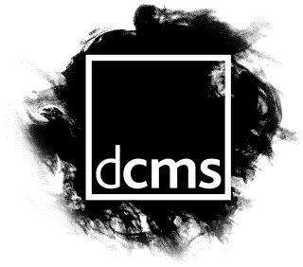

Cumulative Impact

The “Cumulative Impact” of licensed premises is not mentioned in the Act, but is covered in the Guidance issued under section 182 to Licensing Authorities (3.13 - 3.28). This Guidance can be viewed on the DCMS website:

www.culture.gov.uk/alcohol_and_entertainment/advice_and_guidance

The Guidance recognises that the saturation of licensed venues in a particular area can impact on public nuisance and disorder.

A licensing authority can state in its “licensing policy statement” whether it thinks that a concentration of licensed premises in a particular area is considered to be already causing a cumulative impact on one or more of the licensing objectives. Before finalising its policy, and deciding whether an area is nearing this point, the licensing authority has to consult a number of statutory consultees. These are set out in section 5(3) of the Act, and include local representatives of residents and businesses.

If, after consulting those individuals, a licensing authority is satisfied that it is appropriate and necessary to tackle cumulative impact in its policy statement, it should indicate in the statement that it has adopted a policy of refusing licences when it receives relevant representations about the cumulative impact on the licensing objectives, from responsible authorities and interested parties which it concludes, after hearing those representations, should lead to refusal.

Applicants should therefore be aware of the policy, and will need to address the issues in their operating schedules in order to show that they would not add to the “cumulative impact”.

Even where a cumulative impact policy exists, a licensing authority cannot impose conditions on or refuse to grant or vary a premises licence or club premises certificate unless it has received a representation from a responsible authority or an interested party.

For Guidance on making representations, talk to the licensing department at your local authority, or visit the DCMS website:

www.culture.gov.uk/alcohol_and_entertainment

Note that a cumulative impact policy should never be absolute, and licensing authorities should consider each application on a case-by-case basis and decide whether the circumstances of a case justify an exception.

