About the situation:
- Briefly describe the type of anti-social behaviour (e.g. noise nuisance, threatening behaviour, loitering):

- Please confirm if this issue of anti-social behaviour been reported before:
Yes, I have reported it before No, I have not reported it before
If the answer is ‘Yes’ go to No.3. If the answer is ‘No’ go to No.4

- State how many times the issue has been reported
Detail the dates and agencies who have received these reports, with contact details if available, and any reference numbers you have been given and provide copies of any relevant documents. Use extra space on page 4 if required. Then go to No.5:

- If the answer is no and this is your first report of anti-social behaviour please go no further with this form but contact the ASBU on 020827 4907 or asbunit@merton.gov.uk

- Please say if this issue affect more than one household or business premise:
Yes, it affects other premises No / I Don’t know
If answer is ‘Yes’ go to No.6
If the answer is ‘No /don’t know’ go to No.7
- Give as many details as possible of those affected, including names, addresses and contact details:

- Please say why you feel no action has been taken:

- Incident(s) details:
- Where did the incidents take place?

- When did the incidents take place?

- Has anyone else witnessed this?
Yes No
If ‘Yes’, please give contact names and details

- Can we contact the witnesses?
Yes No
- If ‘Yes’ which witnesses can we contact?

- How are the incidents affecting you?

Hate crimes are any crimes that are targeted at a person because of hostility or prejudice towards that person’s:
- disability
- race or ethnicity
- religion or belief
- sexual orientation
- transgender identity
  - This can be committed against a person or property.
  - A victim does not have to be a member of the group at which the hostility is targeted. In fact, anyone could be a victim of a hate crime.
Based on the above, do you feel this issue is:
a hate crime
or, not a hate crime

- Your contact Details:
Name:
Address:

Postcode:
Telephone:
Email:

In this situation, which option best describes your status in Merton?

Housing association tenant:
Private tenant;
Owner occupier:
Business owner:
Spokesperson for community group:
Other:
If ‘Other, please specify:

Additional information for No.3:

Equalities Monitoring Form
We ask these questions, below, to help us to improve our services to the community. You do not have to answer those you prefer not to, just leave those sections blank. The information is treated in confidence.

Are you: Male ☒ Female ☐

What age group are you in?

15yrs or less ☐ 30-34yrs ☐ 50-54yrs ☐ 70-74yrs ☐
16-19yrs ☐ 35-39yrs ☐ 55-59yrs ☐ 75yrs or over ☐
20-24yrs ☐ 40-44yrs ☐ 60-64yrs ☐
25-29yrs ☐ 45-49yrs ☒ 65-69yrs ☐

Do you consider yourself to have a disability? Yes ☐ No ☐

Which of the following groups do you consider you belong to? (Tick one box only)

White Mixed Ethnicity
White English ☐ White & Black African ☐
White Scottish ☐ White & Black Caribbean ☐
White Welsh ☐ White & Asian ☐
White Irish ☐ Other please specify ☐
Gypsy/Roma/Traveller ☐
Other please specify ☐

Asian/ Asian British Chinese and Other Ethnic Groups
Bangladeshi ☐ Chinese ☐
Indian ☐ Korean ☐
Pakistani ☐ Other please specify ☐
Tamil ☐
Other please specify ☐
Black/Black British
African ☐
Caribbean ☐
Other please specify ☐

Letter
If you need any part of this document explained in your language, please tick box and contact us either by writing or by phone using our details below.
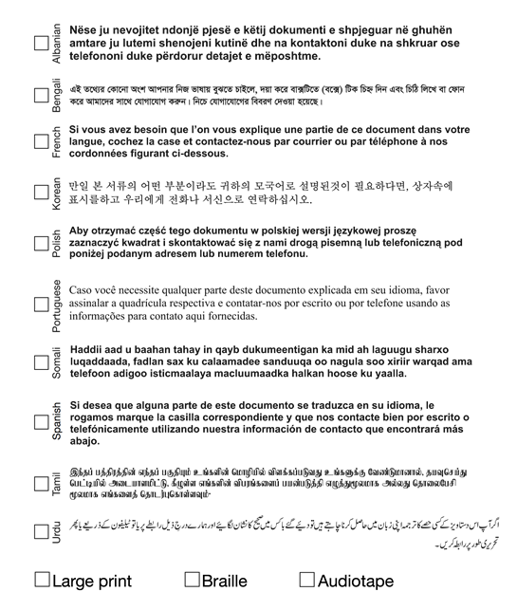
Our Address:
Anti-Social Behaviour Team (Community Trigger)
Safer Merton, Civic Centre SM4 5DX
Telephone: 020 8274 4907
Email: asbunit@merton.gov.uk

