

**Final Report and Recommendations arising from the Air Quality Task Group**

**January 2018**

**Task group membership**

Councillor Daniel Holden (Chair)  
Councillor Michael Bull   
Councillor David Chung  
Councillor Abigail Jones  
Councillor Abdul Latif

**Scrutiny support:**

Stella Akintan   
Scrutiny Officer

For further information relating to the review, please contact:

Democracy Services Team

Corporate Services Department

London Borough of Merton

Merton Civic Centre

London Road  
Morden

SM4 5DX

Tel: 020 8545 3390

Email: scrutiny@merton.gov.uk

**Acknowledgements**

The task group would particularly like to thank the officers who shared their experiences and thoughts with us;

* Jason Andrews, Environmental Health Pollution Manager
* Tara Butler, Programme Manager
* Andrew Gordon, Senior Environmental Health Practitioner
* Max Lawson, Graduate Management Trainee
* Paul McGarry, Head of Future Merton
* Neil Milligan, Development Control Manager
* Mike Webley ,Director - Enviro Technology.

|  |  |
| --- | --- |
| **Index** | **Page** |
|  |  |
| **introduction** | **4** |
|  |  |
| **Recommendations** | **5** |
|  |  |
| **Early success for the task group** | **6** |
|  |  |
| **Air quality in Merton** | **6** |
|  |  |
| **Task group comments on the Air Quality Action Plan** | **10** |
|  |  |
| **Funding for the Air Quality Action Plan** | **12** |
|  |  |
| **Electric Vehicle roll out** | **13** |
|  |  |
| **Improving air quality at construction sites** | **15** |

Introduction

Although air quality has improved in recent years, greater public awareness of the impact means that it has moved up the political and public agenda. There is greater urgency to tackle air pollution given it is the largest environmental risk to public health, particularly amongst vulnerable groups such as the elderly, young children and those with existing respiratory conditions. [1] Air pollution is the most significant factor impacting on public health after smoking. [2]

Poor air quality also damages the environment and contributes to climate change. No2 contributes to acidification of soil and water which impacts on animal and plants and biodiversity. [3]

The pollutants of concern are mainly from road transport; and include nitrogen oxides NO2 and particles PM10 and PM2.5. It is thought that these pollutants contribute to an additional 9,400 premature deaths in London alone. Reducing these emissions is one of the biggest environmental challenges the UK is facing, as many locations in the UK currently fail to meet the statutory targets. Merton along with almost all London Boroughs is also failing these national objectives.

Since there is both a national and local focus on reducing emissions and encouraging sustainable travel, this review decided to focus on improving air quality at construction sites which has a significant impact across the borough.

Merton also began refreshing its Air Quality Action Plan (AQAP). This task group used this opportunity to examine the future strategic direction to be taken to improve air quality in the borough. The AQAP was subject to a public consultation and the task group wanted to ensure that the views of local residents were at the centre of this updated approach.

**Recommendations**

1. The Sustainable Communities and Overview and Scrutiny Panel to conduct pre-decision scrutiny on the scope of any reviews to parking levies.
2. An Air Quality Officer to be appointed to help to implement the Air Quality Action Plan and provide expertise across the council. This will be appointed from existing resources, such as the diesel surcharge.
3. The task group supports the use of Local Implementation Plan funding to deliver the Air Quality Action Plan.
4. Better use should be made of 106 monies to support air quality measures.
5. That the Environmental Health team conduct a review of the impact of emissions from bonfires held in private gardens and on construction sites with a view to tighter restrictions, excluding cultural events..
6. The task group supports the rollout of electric charging points across the borough, including utilising additional funding where available.
7. Ensure that air quality measures are embedded in the Local Plan and that council adopts the Draft Air Quality Supplementary Planning Guidance for Merton.
8. In recognition for Merton’s work to coordinate a South London wide construction emission initiative, Merton should award certificates recognising good practice to developers that comply with the council’s standard.
9. The Environmental Health team to provide training for colleagues in planning team and Councillors on the planning committee on air quality issues, so that informed decisions on planning applications can be made where there is an air quality component.

**Early successes for the task group**

The task group was pleased that as it embarked upon this review it was able to raise the profile of air quality issues in the council. As a result of highlighting concerns, the following measures were implemented before this task group review was completed:

* A new air quality monitor was installed at the civic centre. This will ensure the council meets its statutory obligations to measure emissions across the borough; and
* The Environmental Health team has increased the number of ‘diffusion tubes and locations throughout the borough’. This will mean we are more effective at capturing the level of pollutants better across the borough

Diffusion tube locations in Merton 2017

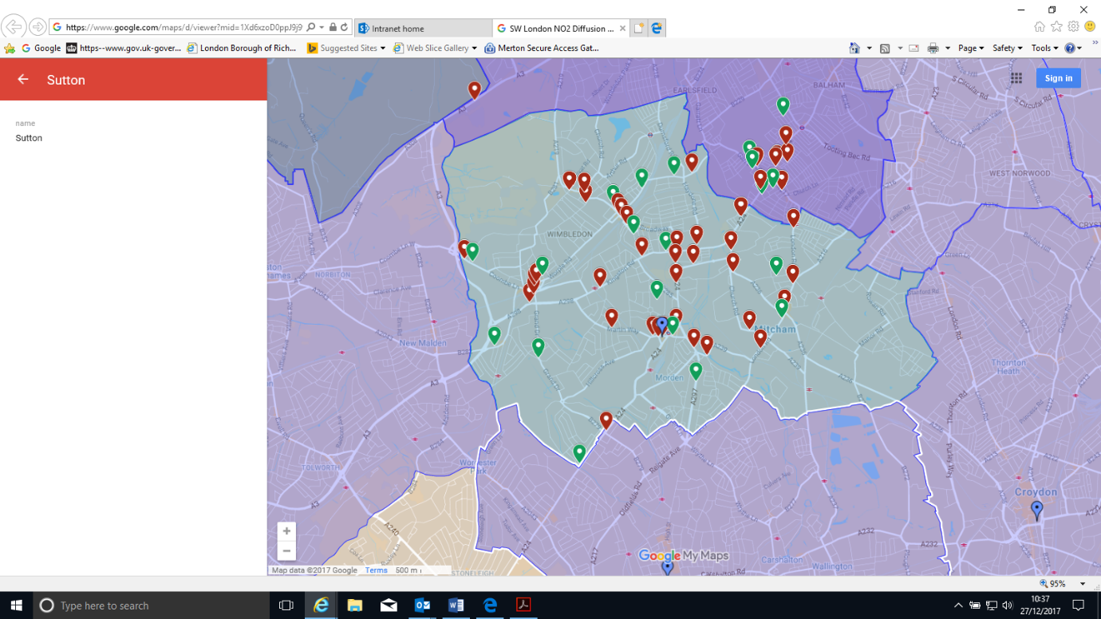

**Air Quality in Merton**

Pollution in Merton comes from a variety of sources. This includes pollution from sources outside the borough, and, in case of particulate matter, a significant proportion comes from outside of London and even the UK. Obviously for these sources the council has limited control; however, local sources are primarily from road transport and from buildings. [4]

In 2013, 6.4% of mortality was attributable to particular air pollution in Merton slightly lower than London (6.7%) as an outer London borough, but higher than England (5.3%). Current monitoring indicates that the annual mean nitrogen dioxide objective continues to be exceeded at roadside and nearby locations. [5]

All of Merton has been designated an air quality management area (AQMA) due to poor air quality. These AQMAs were declared in 2003 and 2000 respectively.

**Sources of NOx in Merton**



**Sources of PM10 in Merton**

**

**Sources of PM2.5 in Merton**

The Air Quality Strategy for England, Scotland, Wales and Northern Ireland

The Air Quality Strategy for England, Scotland, Wales and Northern Ireland (2007) sets out air quality objectives and policy options to improve air quality in the UK. The objectives are policy targets often expressed as a maximum ambient concentration not to be exceeded, either without exception or with a permitted number of exceedances, within a specified timescale. Local authorities have a legal duty to work towards achieving these air quality objectives.

National Air Quality Plan

The Government’s 2015 Air Quality Plan to achieve the EU limit values for nitrogen dioxide (NO2) introduced a programme of mandatory and voluntary Clean Air Zones (CAZs) outside London.

London Local Air Quality Management Framework

The air quality objectives, set out in the Air Quality (England) Regulations 2000 as amended by the Air Quality Regulations 2002, provide the statutory basis for the air quality objectives under the local air quality management (LAQM) system.

Air quality in London is devolved to the Mayor of London, who has powers to intervene and direct local authorities in Greater London. In support of these devolved powers, the Mayor established the London LAQM system (LLAQM) in 2016 for the coordinated discharge of the Mayor’s and Boroughs’ responsibilities.

Defra and the Greater London Authority require local authorities to report on the pollutants of greatest concern to the health of Londoners. These are NO2, particulate matter (PM10 and PM2.5) and sulphur dioxide (SO2).

The Greater London Authority (GLA) identified Air Quality Focus Areas in 2014. These are locations that not only exceed the EU annual mean limit value for NO2 but are also locations with high human exposure. The Focus Areas were defined to address concerns raised by boroughs within the Local Air Quality Management process and forecasted air pollution trends. This is not an exhaustive list of London’s hotspot locations, but where the GLA believe the problem to be most acute.

On the 11th August the Mayor of London, launched his [draft Environment Strategy](https://www.london.gov.uk/what-we-do/environment/draft-london-environment-strategy-have-your-say) for consultation

The Mayor’s office states that for the first time these plans combine strategies for each aspect of London’s environment, including air quality, into one holistic document. Alongside air quality, this draft strategy also addresses green infrastructure, climate change mitigation and energy, waste, adapting to climate change, and ambient noise.

When finalised, this strategy will replace the [2010 Mayor’s Air Quality Strategy](https://www.london.gov.uk/sites/default/files/Air_Quality_Strategy_v3.pdf) produced by Boris Johnson.:

**Merton’s Air Quality Focus areas**

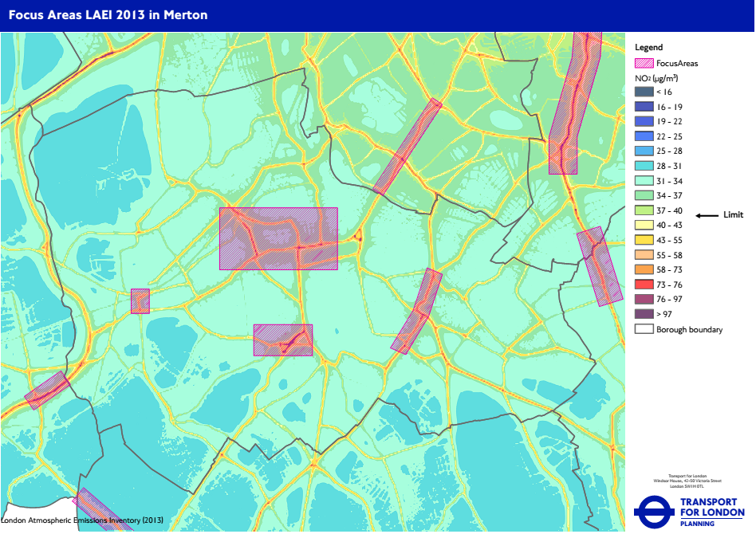

**Task group comments on the Air Quality Action Plan**

One of the main aims of this task group was to oversee the development of the new Air Quality Action Plan ( AQAP). This covers the period 20187-2023 and it aims to reduce concentrations and exposure to pollution. The task group met with officers to discuss the draft plan before it went to consultation. This was an opportunity to raise issues of concern and highlight additional measures that task group members wished to see in the AQAP. As a result of these early discussions task group members highlighted the importance of:

* New and innovative ways to tackle air pollution such as re-routing cars from pollution hotspots using phone apps and electronic signage
* Identifying opportunities to increase the numbers electric charging points especially within new developments
* Use of school travel plans to tackle air quality

The task group met with the Environmental Health Pollution Manager to discuss the results of the consultation. They were informed that the consultation ran for a period of six weeks and there were a total of 155 responses. Officers reported that although they had hoped for a higher response rate, some of the replies were from organisations rather than individuals therefore this reflects the views of a larger group.

Task group members were pleased to note that responders were overwhelmingly positive about the measures within the AQAP. Although a task group member highlighted that the question on “extending use of an emissions based parking levy for residential and business permits in Merton” attracted the highest number of people ‘strongly disagreeing’ .

The task group discussed each of the measures in turn and unanimously supported the majority of the actions. However, there were some concerns regarding action points 15, 19 and 20. These are set out in the table below:

AQAP – Specific actions to be considered

|  |  |  |
| --- | --- | --- |
| **Action ID** | **Description** | **Comments** |
| Action 15 | Mini Ultra-Low Emission Zone status for Air Quality Focus Areas and in pollution hotspots in Merton | This could follow from the above measure and will also be dependent on the Mayors project |
| Action 19 | Emissions based parking levy for residential and business parking permits in Merton. | There is a commitment to review parking in as many ways possible to reduce vehicle use and reduce emissions. The present parking surcharge and possibly extend the scheme to incorporate all vehicles parked in the borough |
| Action 20 | Provision of infrastructure to support walking and cycling across the borough | This is currently underway but needs to be publicised in the AQAP |

Action 15

Some task group members emphasised the importance of implementing measures that incentivise and encourage people to help reduce air pollution. There are already strategies in place to tackle pollution over the longer term. Any new emission zone could contribute to difficulties in driving around London.

Action 19

Some task group members welcomed a review of this policy to see how effective it had been and if it needed to be amended. It was highlighted that the Sustainable Communities Overview and Scrutiny Panel had called for a review of the diesel levy given that it had attracted some controversy and it was a new council policy.

Some task group members did not support this measure as they felt the wording of the comment suggested this could lead to additional charges for petrol cars. It was thought that increasing costs would be punitive and would not serve to reduce emissions from cars nor would it motivate people to buy new cars to avoid the permit charges. Task group members expressed concern about penalising car users as an approach but believe the emphasis should be on promoting new technologies such as electric cars. New measures are encouraging transition to emission friendly transport which, over time will have the desired impact. It was thought that the council should not put additional burdens on car users.

Other task group members felt that parking permit charges are one of the tools councils can use to influence behaviour change and inform decisions when buying their next car. The task group were able to come to a consensus on this issue and agreed that they wished to consider the scope of the review at the Sustainable Communities Panel.

|  |
| --- |
| **Recommendation**   1. The Sustainable Communities and Overview and Scrutiny Panel to conduct pre-decision scrutiny on the scope of any reviews to parking levies. |

Action 20

Some task group members expressed concerns about infrastructure to support walking and cycling as they felt there should be additional resource for extra cycle lanes rather than reduce the existing road infrastructure.

**Funding for the air quality action plan**

The task group wanted reassurance that there will be sufficient funding to deliver the projects within the AQAP. Therefore they supported the suggestions put forward by officers, such as making use of Local Implementation Funding and Section 106 monies. The task group also support proposals to recruit an air quality officer to carry out this work and provide advice and support on air quality across the council, particularly to help planning officers.

|  |
| --- |
| **Recommendations**   1. An Air Quality Officer to be appointed to help to implement the Air Quality Action Plan and provide expertise across the council. This will be appointed from existing resources, such as the diesel surcharge. 2. The task group supports the use of Local Implementation Plan funding to deliver the air quality action plan. 3. Better use should be made of 106 monies to support air quality measures. |

The task group supports concerns from the public outlined in the AQAP regarding the impact of bonfires and while they emphasised their support for the councils annual cultural events, they were concerned that there needs to be more guidance on the pollutants from bonfires as well as the impact of burning different fuel sources. The Environmental Health Pollution Manager said that a number of other councils in South London are conducting a review of bonfires and Merton could join this process as well as consider its own local issues.

|  |
| --- |
| **Recommendations**   1. That the Environmental Health team conduct a review of the impact of emissions from bonfires held in private gardens and on construction sites with a view to tighter restrictions excluding cultural events |

**Electric vehicle rollout**

Merton should be at the forefront of the electric vehicle roll out by increasing the number of charging points. The task group was pleased to be informed that the council will roll out twenty-five new points this year and twenty five points next year.

There are various funding pots that the council should seek to benefit from such as the £8 million Transport for London Source London charging point roll out scheme. In the recent budget the Chancellor announced funding for electric vehicle charging points, once the details become clearer the council should maximise these opportunities.

The task group is pleased the draft Supplementary Planning Guidance calls for all new developments to incorporate the electric vehicle charging requirements set out in the London Plan. This sets out percentages for charging facilities in residential developments, employee parking and shopping facilities.

|  |
| --- |
| Recommendation   1. The task group supports the rollout of electric charging points across the borough, including utilising additional funding where available. |

**Improving air quality at construction sites**

Construction activities which affect air pollution include preparation, demolition excavation, as well as tunnelling works building operations structural alteration and maintenance and transportation of materials from site to site. These activities produce dust, smoke and other pollutants, including those arising from diesel engines. The aim of air quality measures is to protect site workers as well as the local community from the impact[6].

The task group met with the Development Control Section Manager to discuss how planning regulations ensure measures are in place to improve air quality at construction sites. He reported that monitoring pollution requires expensive equipment as small particles are harmful but are barely visible and difficult to measure unlike other pollutants such as bonfire smoke. Responsibility for these costs should be made explicit in the planning documents.

Officers highlighted that the success of improving air quality in this area is dependent on joint collaboration between planning and environmental health teams. The task group believe that councillors on the planning committee, and in the planning team would benefit for training on air pollution issues.

The task group was told by the Environmental Health team they had received funding from the GLA to run an audit of pollution on construction sites across South London boroughs. The audit looks at the diesel engines of the heavy construction equipment, records emissions and makes recommendations about acceptable levels. The audit acts as a form of enforcement as well as providing advice and consultancy. Compliance levels varies between sites, some are defined as cold and are not adhering to air pollution regulations, while other sites are more aware and aim to comply.

The audit is aiming to encourage construction sites to become compliant before more stringent enforcement measures are introduced by the GLA in 2020. The audit is having an impact, environmental issues are rising up the agenda, compliance is currently at 80%. Audits are serving as a good way to educate people without using enforcement. The task group believes that good practice should be recognised and would like developers to be given a certificate of achievement if they meet the required standards.

The Environmental Health Pollution Manager reported that all the concerns regarding air pollution at constructions sites can be addressed through the Local Plan and the Air Quality Supplementary Planning Guidance (SPG).

The Local Plan sets out the priorities for the development of the borough and will be used for making decisions on planning applications. Merton is currently consulting on the development of a new Local Plan. This task group supports the approach taken by Richmond Council that ensured air quality measures are fully embedded in the Local Plan. Merton should take this approach and the council will then be able to incorporate the SPG within this document.

A task group member was concerned that the SPG it is not as influential as full planning guidance and can be challenged by a developer. It was reported that the guidance is in line with is the GLA and will not present an additional burden on developers.

|  |
| --- |
| Recommendations   1. Ensure that air quality measures are embedded in the Local Plan and that council adopts the Draft Supplementary Planning Guidance for Merton. 2. In recognition for Merton’s work to coordinate a South London Wide construction emission initiative, Merton should award certificates recognising good practice to developers that comply with the council’s standard. 3. The Environmental Health team to provide training for colleagues in the planning team and Councillors on the planning committee on air quality issue, so that informed decisions on planning applications can be made where there is an air quality component. |

1. Every breath we take: the lifelong impact of air pollution. Royal College of Physicians, February 2016.
2. Lethal and Illegal London’s Air Pollution Crisis, Institute of Public Policy Research, July 2016
3. Improving air quality in the UK: tackling nitrogen dioxide in our towns and cities, Department for Environment Food and Rural Affairs May 2017.
4. Merton Air Quality Action Plan 2017-2022
5. Merton Joint Strategic Needs Assessment 2015
6. Merton Code of Practice 2017