### PROCUREMENT STRATEGY _ DECEMBER 2020

### Section 1 – Introduction

The National Procurement Strategy defines Procurement as:

“The process of acquiring goods, works and services, covering both acquisitions from third parties and from in-house providers. The process spans the whole cycle from identification of need, through to the end of a service contract or the end of the useful life cycle of an asset. It involves options appraisal and the critical ‘make or buy’ decision which may result in the provision of services in house in appropriate circumstances”

Although the definition is primarily about procurement, it also about the need to secure sustainable services, products and outcomes that meet the needs of the community we serve. Strategic procurement also encompasses collaboration, including the need to develop partnerships, consider delivery options and ensure value for money for every pound spent.

Merton has taken the approach of investing in and using its procurement team more effectively. Procurement should be at the heart of the authority’s thinking because procurement is not solely about compliance, although it is required. More importantly, procurement is necessary to help deliver benefits to our communities through specifying additional social value and engaging with local companies and voluntary sector groups.

This document sets out the Council’s strategic approach to procurement for the next four years. It is not intended to be a procurement manual; however, the principles should be applied to all procurement and commissioning, recognising that procurement must work closely with our health and social care colleagues to deliver value for money from all commissioning and procurement.

Consideration of this strategy is not optional - it is to be read in conjunction with the Council’s Contract Standing Orders (CSO’s).

The Procurement Strategy emphasises the continuing importance of sustainable procurement being used to support wider social, economic and environmental objectives in ways that offer real long-term benefits to the residents of this borough.

Cost reduction and efficiency targets will not be achieved if the Council fails to approach competition positively, taking full account of the opportunities for innovation and genuine partnerships, which are available from working with others in the public, private and Voluntary, Community and Faith Sectors (“VCFS”).

This strategy provides a corporate focus for procurement. It embraces the Council’s commitment to strategic procurement and sets out the Council’s aspirations. It is not a ‘user manual’. More detail on procurement processes and procedures will be found within the Contract Standing Orders, the Procurement Toolkit, and the Social Value Toolkit all of which can be found on the procurement and Commercial Services team pages of the intranet.

The strategy will contribute to delivering the long-term goals of:

* + The Business Plan 2021-25
  + The MTFS
  + Divisional Service Plans
  + Community Plan
  + London’s Best Council

The principal means of disseminating detailed procurement guidance are Commercial Services (including the running of various monthly training sessions), quarterly procurement forums, the departmental Operational Procurement Groups (OPGs), the corporate Procurement Board (PrB) and the intranet.

### Section 2 – Objectives and Benefits

The overarching objectives of this strategy are:

* To evaluate and improve current procurement practices to achieve better value for money and to ensure customer/client needs are met
* To ensure best practice examples are identified and applied consistently across the organisation
* To align procurement activities with other strategies adopted and to ensure that corporate objectives are addressed
* To ensure that current and future procurement activities are planned, monitored, and reviewed effectively including identifying opportunities for collaboration with both private and public sector bodies as well as the VCFS
* To ensure the delivery of a category management approach to commissioning and procurement, across the entire organisation
* To strengthen the knowledge and skills of all officers involved in procurement and commercial activities

In taking this strategy forward, the Council expects to realise the following benefits:

* Demonstrate continuous improvement and achieve value for money through the efficient procurement of goods and services
* More efficient procurement processes
* Better risk management
* Strategic procurement planning
* Effective spend analysis and measurable cash savings
* Proactive contract management
* Greater use of standard processes and templates
* Compliance with appropriate legislation
* Compliance with the Council’s Contract Standing Orders
* Collaboration, including with other authorities, local businesses and the VCFS
* Greater use of the e-Tendering system
* Encourage communication and interaction with local and national suppliers to understand their views
* Develop relationships between the Council, the business community and the broader voluntary sector which create mutually advantageous, flexible and long term relations

Our vision for procurement is to provide a first class service for our residents whilst we build on best practice to ensure value for money in all our procurement exercises.

### Section 3 - Overview of Procurement

The London Borough of Merton spends approximately £200m each year on goods and services on behalf of Merton’s residents. Of that £200m, the Council was able to influence approximately £120m for financial year 2019/20.

The range of goods and services is varied but includes services for schools; waste collection; care services for children and adults; maintaining the highways, parks and services; encouraging business growth; and major construction works.

***Updated expenditure 1 April 2019 – 31 March 2020***

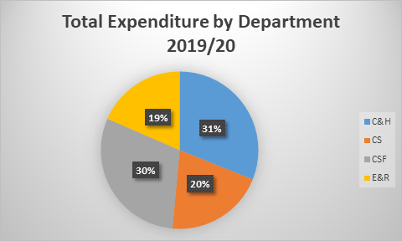

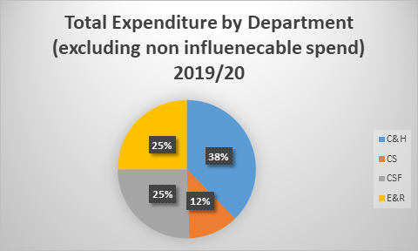

Commercial Services is part of the Infrastructure & Technology division of the Corporate Services department. It was set up specifically to provide professional procurement and commercial advice, guidance and support to the departments and responsible officers. Procurement in the Council takes place across all departments and is undertaken in what is called a ‘devolved’ model. This means that responsible officers in the departments undertake day-to-day operational procurement.

Following a review in 2017, it was agreed to pursue a centre-led approach.

The consolidated category management approach for high value, high risk expenditure with devolved responsibility for low risk, low value expenditure ensures a common strategic approach to sourcing and supplier management, driving much needed Value for Money and savings.

The revised approach provides Departments with a level of local control and influence with respect to commissioning, brokerage and contract management, whilst providing specialist support through a professional central resource able to assist in the development and implementation of sourcing strategies.

Commercial Services underwent a restructure in late 2017 to better support the agreed delivery model for procurement.

The main objectives of Commercial Services are to:

* + provide professional procurement resources to support and advise internal and external partners such that all Merton’s procurement decisions deliver:
    - Council objectives by demonstrating value for money
    - Synergies with the Council's MTFS
    - The effective use of resources
    - Expenditure that is managed strategically to achieve social and community benefits
    - Continuous improvement in service delivery
    - Deliver efficiency savings over a three-year period through the implementation of category management
  + lead the implementation of the Council’s Category Management approach and its Make or Buy agenda by providing a professional procurement service to all clients across the Council.
  + be responsible for the development and delivery of robust, overarching Category Management plans, working alongside clients to profile and deliver the service areas procurement and commissioning strategies.
  + provide strategic commercial advice as and when required
  + provide specific advice on EU Regulations, UK Public Contracts Regulations, and associated areas, including latest case law
  + drive best practice in procurement
  + provide spend data and analysis and to assist in the Identification of potential savings opportunities, fraud, areas of collusion and areas of collaboration
  + ensure the Council’s contracts register is kept up to date by working closely with colleagues via departmental OPGs. Responsibility for entering information onto the contracts register and ensuring that the information is up to date and accurate, rests with the departments
  + engage with partners and potential partners with the objective of streamlining the procurement process, i.e. making the Council an easier organisation with which to deal
  + ensure that officers involved in procurement hold the correct level of knowledge, and to provide skills training where appropriate
  + provide up to date support via the intranet, toolkits, procurement guidance and advice.

Procurement is not simply about lowest price; rather it is a strategic tool to ensure that we receive best value whilst putting the needs of Merton’s residents first.

Effective procurement is about managing the whole life cycle of the goods and services we procure, and ensuring that specifications are right and fit for purpose with clear outcomes and purposes.

The Council adopted a Procurement Governance and Gateway process that comprises four key elements: the Procurement Board; the Procurement Gateways; Departmental Operational Procurement Groups (OPGs); and the Risk Assessment Tool. These four elements are designed to work together to enable the Procurement Board to exercise effective oversight, control and to provide direction to procurement activity Council wide.

In 2019/20, the Council launched its Contract Management Toolkit. The toolkit provides an overview of recognised Contract Management principles; and includes information, guidance and templates needed to enable Merton’s Contract Managers to build on existing good practice and implement an effective and consistent approach to contract management.

Since 2017/18, the use of the Council’s e-tendering portal for all procurements, has been reinforced; departmental OPGs have been revived; and the implementation of category management commenced. 2019/20 saw the re-introduction of Procurement Forums. 2021/22 will see the continued implementation of category management across the entire organisation (somewhat delayed due to the Covid-19 pandemic and its impact on business as usual for both Merton and its supply chain), as well as a more robust approach to contract management.

### Section 4 – Key Themes

##### Value for Money (VFM)

Now, more than ever, the Council will need to make substantial year on year savings for the ongoing future. Every pound spent must deliver true value to the community, whether that is by better management of our existing contracts, proactive spend analysis, being more commercially aware, or through reviewing current services and potential delivery models.

Knowing how, where and on what our money is spent will be used to drive a supplier review to maximise savings. It is the Council’s intension, during 2021, to invest in additional functionality of its e-financial system with the specific aim to provide more robust spend data and analytics. Furthermore, we intend to review the supply base and drive additional efficiencies by reducing the overall number of suppliers and to utilise the additional advantage obtained. This exercise will also help us to develop and shape supply markets, define the skills to develop the market and to negotiate better outcomes for the Council and service users.



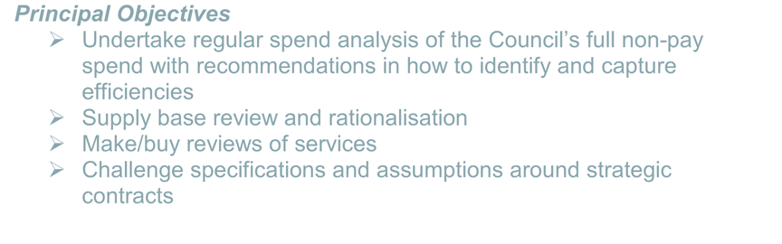





***Principal Objectives***

* Undertake regular spend analysis of the Council’s full non-pay spend with recommendations in how to identify and capture efficiencies
* Supply base review and rationalisation
* Make/buy reviews of services
* Challenge specifications and assumptions around strategic contracts

##### Category Management

By grouping together products and services according to their function (e.g. care, construction, transport, professional services etc.) the Council can better manage the overall spend, whilst maximising our buying power and achieving economies of scale.

A ‘Category’ is an area of spend determined by known market boundaries separating different products or services. Category Management recognises that suppliers within a certain market are likely to have similarities that enable a tailored approach to procurement.

We continue to develop our capacity and capability in Category Management to support the major commercial decisions the Council is facing. We will add value to projects we support, bringing commercial insight and support throughout the commissioning lifecycle. Recognising this challenge, we will also develop our staff through a revised professional training programme. It will also enhance their relationship and partnership building skills. This means they will spend less time involved in the administrative task of running tenders and spend more time with customers, commissioners and our major suppliers.



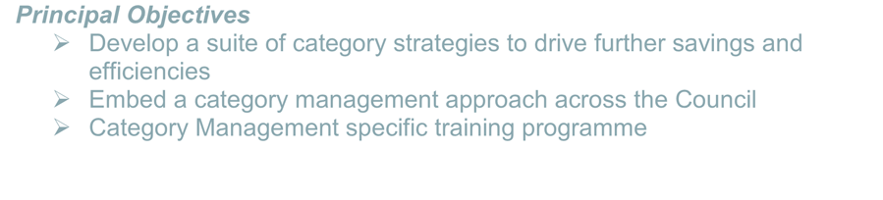





***Principal Objectives***

* Develop a suite of category strategies to drive further savings and efficiencies
* Embed a category management approach across the Council
* Category Management specific training programme

##### *c.* Contract Management

We will manage our major contracts more actively to drive continuous improvement in performance and efficiency and further develop contract management across the Council. We will provide greater visibility of the performance of our top contracts to help to improve the management of major suppliers and ensure they are delivering against the agreed performance standards.

By reviewing strategic contracts and adopting a more commercial approach to the management of our key contracts, we will ensure that improvements and efficiencies are delivered.

We will also work with operational contract managers in departments to build on best practice and provide training in contract management techniques.

The outcome of this change will be measured by the monitoring of contract performance and by the identification of improvements in performance levels and additional efficiencies during the life of a contract. Furthermore, as we develop stronger relationships with our key suppliers, we will be recognised as their ‘customer of choice’ that may lead to increased market intelligence and therefore improve our opportunities for innovation in the marketplace.

Through a clear commercially led approach to contract management, we will ensure a greater focus is directed towards obtaining the required outcomes. This will include increased monitoring, management of supplier performance through robust SLA’s and KPI’s (including the delivery of community benefits), and where performance is not being achieved, an action and improvement plan will be implemented.



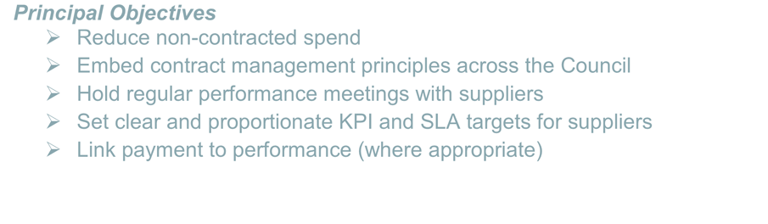





***Principal Objectives***

* Reduce non-contracted spend
* Embed contract management principles across the Council
* Hold regular performance meetings with suppliers
* Set clear and proportionate KPI and SLA targets for suppliers
* Link payment to performance (where appropriate)

##### Partnering and Collaboration

Partnering means the creation of sustainable, collaborative relationships with suppliers in the public, private, social enterprise and voluntary sectors to deliver services; carry out major projects; or acquire supplies and equipment.

Partnerships can be beneficial and integrated in service delivery, but it needs to be recognised that this is not necessarily an easier contract style - indeed, partnering agreements are likely to be more challenging than traditional contracts. A partnership agreement will therefore require careful preparation and procurement. Partnering should be considered when engaging in best value reviews of services as a potential alternative to established methods of service delivery.

When formulating our procurement strategies, we will ensure that we take account of potential opportunities afforded by partnering and collaborating. We will also look at existing framework agreements when considering any future options for procurement and where appropriate the use of any national, regional or pan London procurement arrangements that fit with the Council’s strategy.

Collaboration describes the various ways in which councils and other public bodies come together to combine their buying power, to procure or commission goods, works or services jointly or to create shared services.

Collaboration is a form of public partnership; its major benefits are economies of scale and accelerated learning.

We will ensure that contractors and partners have priorities that align with those of the Council. We will also ensure that they understand how these contribute to the Council’s performance.

The Council will actively participate with other authorities and organisations where appropriate and feasible, to seek economies through joint procurement, joint commissioning, framework agreements and shared services.







***Principal Objectives***

* Work with other public bodies to seek joint partnering and collaboration opportunities
* Investigate the greater use of collaborative contracts
* Look to use existing framework agreements where appropriate

##### Market Management

The Council will continue to work with a more diverse group of providers. In some areas there are strong markets but in others, they are either small or not yet developed. The Council will make full use of all the different methods of delivery available, including joint ventures, public, private and VCFS options. Through procurement, we will support the growth of local businesses and other organisations by encouraging the use of local suppliers. Whilst staying within the legal constraints of public sector procurement, the Council will encourage local suppliers to work with us, recognising and exploiting the ability to create a positive climate for firms based in Merton. The Council will endeavour to support a thriving local business sector, providing opportunities for suppliers to develop the capacity to win future contracts from the Council and other public sector partners.

This approach recognises that by encouraging sustainable high quality local employment, the Council is reducing the demand and thus cost of other public services. The Council will seek to encourage innovation, improve skill levels in Merton, create jobs and retain money in the local economy.







***Principal Objectives***

* Identify where market capacity may be weak and where new markets may need to be developed
* Encourage suppliers to develop innovative approaches
* Foster a collaborative approach to procurement
* Work to increase the proportion of spend with SME’s and VCFS
* Take steps to promote and encourage local economic growth e.g. reducing the barriers to SME and VCFS participation
* Hold regular supplier engagement events

##### Supplier Relationship Management

The Council will build strong, long term, positive relationships with suppliers across all sectors, not just when actively procuring goods and services but also when considering alternative delivery models e.g. social enterprises.

The Council will establish strategic relationships with suppliers to ensure that both parties are delivering against the commitments within the contract and build upon mutual experience and knowledge to embed continuous improvement practices throughout the contracted period. Effective engagement with suppliers will also inform future specifications. This will ensure that the Council is approaching the market place with requirements that meet clearly defined needs and are commercially attractive to potential bidders.

The Council commits to making all procurement activity fair and transparent as well as encouraging a diverse range of potential bidders to participate.

A suite of standardised documents and contracts will be developed for use across the Council to ensure consistency and to make the procurement process more accessible to suppliers.



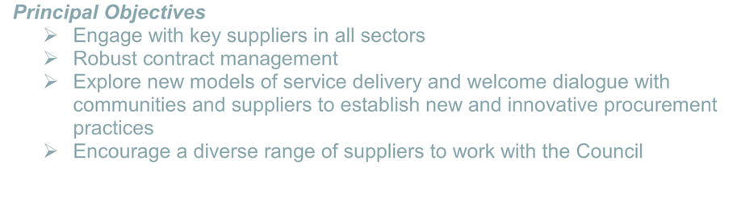





***Principal Objectives***

* Engage with key suppliers in all sectors
* Robust contract management
* Explore new models of service delivery and welcome dialogue with communities and suppliers to establish new and innovative procurement practices
* Encourage a diverse range of suppliers to work with the Council

##### Developing People and Improving Skills

Procurement is a key activity in sourcing the skills, services and supplies required by the Council to deliver community outcomes. The officers who undertake procurement and contract management activity are vital to the successful delivery of the Councils strategic procurement objectives. The required capacity and skills will continue to be developed in departments with support and guidance from Commercial Services.

Commercial Services will develop other ideas to encourage officer participation. These will include the offering of regular ‘drop-in’ sessions, which will allow any topic of interest to be discussed informally. In addition, specific targeted training will be developed and made available to officers/teams and divisions as required.

Regular procurement forums for all Merton responsible officers will continue to be offered. Active participation will be encouraged by the use of focus and working groups on specific topics of interest such as: toolkits, market engagement and benchmarking.

The forums will:

* + Bring together all professionals across the Council working on procurement activity into a single forum
  + Provide a platform for evidence sharing and best practice (both internal and external)
  + Introduce and embed a co-ordinated and consistent Merton approach to procurement
  + Identify savings and efficiencies opportunities

The forum is a reference group, accountable to the Procurement Board, with recommendations and updates to be fed bilaterally.







***Principal Objectives***

* Provide a career path for practitioners of procurement with clear roles and responsibilities
* Provide skills and training and learning & development opportunities for officers
* Ensure that procurement best practice advice is available via the Procurement Toolkit

##### Systems and Processes

Continued use of the e-Tendering system has improved compliance and at the same time, it has streamlined the tendering processes.

The contracts register is part of the e-Tendering suite that is in the public domain so that any interested parties may view it. This has led to greater visibility of Council spend which will be fed into procurement and resource planning and should lead to greater opportunities for efficiency savings.

It will also make it easier for members of the public to have their requests under the Freedom of Information Act 2000 (FoI’s) answered quickly and efficiently.

Ensure council and departmental rolling 1-3-year procurement plans are produced each financial year and kept up to date.







***Principal Objectives***

* Maintain an up to date contracts register
* Increased use of the e-Tendering system
* Investigating the strategic use of e-Auctions
* Training in the use of the procurement toolkit
* Develop a comprehensive rolling 1-3-year procurement plan

##### Sustainable and Ethical Procurement

Sustainability is an important consideration when making procurement decisions. It ensures that we consider impact of environmental, economic and social factors of procurement decisions along with price and quality.

Merton is committed to making its spending decisions in a way that delivers both value for money on a whole life cycle basis, and achieving wider economic, social and environmental benefits. It is important to be aware of, and look for signs of unacceptable practices, such as modern slavery, fraud and corruption, in the supply chain

The Council has set targets, for its operations, to become carbon neutral by 2030, including procured services. Merton will actively consider how services are provided that are in keeping with the targets we have committed to, working with companies who are willing to take an active role in reducing the carbon footprint of their activities in Merton and for their company as a whole.

|  |
| --- |
| ***Principle Objectives***   * Ensure all Commercial Services staff undertake the Chartered Institute of Procurement and Supply’s (CIPS) online course on Ethical Procurement and Supply * Require suppliers and contractors to reduce the negative environmental impact of goods, works and services by considering whole life costs; ending our use of single use plastics; and reducing the carbon impacts associated with goods works and services. * Require information from potential suppliers on how they will help us to progress our environmental objectives as part of the delivery of a contract. * Require contractors to comply fully with the Modern Slavery Charter 2015, wherever it applies, with contract termination as a potential sanction for non-compliance. * Challenge any abnormally low-cost tenders to ensure they do not rely upon any potential contractor practising modern slavery. |

### Section 5 - Governance Framework

Merton’s procurement is governed both by UK Law and by Merton’s Contract Standing Orders. These are mandatory for officers of Merton to follow.

##### The Corporate Management Team

The Corporate Management Team (CMT) will continue to initiate and lead all procurement activity and endorse and support adherence to the procurement strategy across the Council. CMT will set the strategic direction of the Council, empower officers and hold officers to account in the delivery of the strategy.

##### Contract Standing Orders

The Council will comply with the wide range of legislation, regulation and guidance, which governs procurement. The Council’s Contract Standing Orders are currently being reviewed and updated to take into account the impact of the UK leaving the EU, lessons learnt over the past years as well as emerging best practice principles. The revisions to the Council’s CSOs are currently scheduled to be reviewed by Full Council in April 2021, after which they will become effective immediately.

Adherence to the Contract Standing Orders will be enforced to ensure the highest standards of probity and compliance, one of Merton’s principles underpinning procurement activity.

##### The Procurement Board

The Procurement Board is the primary strategic agent through which procurement activity is governed. The Procurement Board is made up of senior management officers and procurement professionals and is chaired by a Director.

The main functions of the Procurement Board are:

* + Oversee the production and management of the procurement strategy
  + Assure that procurement is managed competently and legally
  + Ensure changes in legislation e.g. The Social Value Act (2012) and best practice are embedded in the Councils procurement practices
  + Assessing whether procurement is achieving best value for the Council
  + Ensuring that staff engaged in procurement have the required skills
  + To be responsible for the Operational Procurement Groups (OPG)

##### Departmental Management Teams

Departmental Management Teams will receive regular reports from their Operational Procurement Group representatives and ensure that the Procurement Strategy is being delivered effectively within their respective departments.

##### Operational Procurement Group

The OPG’s are the operational arm of the Procurement Board, and are the means through which departmental procurement activity is planned and coordinated. One OPG exists for each department and the Groups co-ordinate, risk assess and manage the flow of all procurement activity. Each group is championed by a departmental procurement lead who also attends the Procurement Board.

##### Procurement Gateway process

A risk-based approach uses a series of minimum criteria and risk triggers to determine which procurement activities will come to the Procurement Board.

Currently projects need to be brought to the Procurement Board for review where:

* the total value is over £2m (or annual value over £750k)
* or the decision to award the contract is to be made by Cabinet or
* three or more risk triggers are assessed at amber level or greater. These include: political or reputational risk; impact of failure on service user; and maturity or volatility of the market.
* The contract is for a concession

##### Financial Regulations and Procedures

The Financial Regulations and Procedures are the internal rules applicable to Merton’s financial processes and these have also been reviewed to take account of current and recent changes in procurement practice e.g. use of Framework Agreements. Within the options appraisal carried out for each procurement project there will be included due consideration to the methods of financing the project available i.e. capital borrowing, leasing, and other alternatives.

##### Procurement Plans

These plans identify the required strategic procurement activities for a period extending 1-3 years into the future. The departmental procurement plans inform the Corporate Procurement Plan, which will encompass all major procurements due in the following 1-3 years. This will allow for enhanced planning and scheduling, improved visibility and improved risk management for the Council’s major procurement activities. The Procurement Board oversees procurement plans.

##### Procurement Templates, Toolkits and Training

The ‘Procurement Toolkit’ is available to officers via the Procurement section of the Intranet. It provides specific procedural guidance and templates for procurement activity.

The Council continually reviews and updates its procurement toolkit and associated guidance. It is against this procedural guidance that individual compliance will be measured to ensure best practice, legal compliance and whether there is any off contract spend.

The Commercial Services continually works with departments to improve the toolkit and templates. The last revision was published in December 2020.

Officers are advised to book on one of the many training sessions aimed at assisting them navigate their way through the CSOs, the use of the e-Tendering portal and the Public Procurement Regulations.

##### The Contracts Register

The Contracts Register is a Council-wide record of all contracts that the Council has entered into above the value of £5,000.

The Contracts Register is currently part-hosted via the London Tenders Portal as part of the Council’s e-Tendering system. Responsible Officers must ensure that all contracts are entered onto it and that they are kept up to date.

The Contracts Register will continue to be a key component to co-ordinate and risk manage procurement activity at the corporate level and will assist with FoIs.

##### e-Procurement

During 2019, the Council again re-let its contract for Pro-Contract. The system provides officers and suppliers with an effective and efficient way to electronically manage tender and quote processes. The system is designed to allow staff to conduct requests for quotations and tenders online, much more quickly and to allow potential suppliers to respond without the need to complete numerous paper forms.

We will ensure that the benefits of e-Tendering continue by the promotion and monitoring of the system. The use of the e-Tendering system was made mandatory as of 1 April 2012.

Improved use of the e-Tendering system will provide corporate visibility on spend and prevent duplication of processes. Improved corporate visibility will in turn allow greater scrutiny of the management of spend across the Council.

##### Looking to the Future

We continue to investigate greater use of e-Auctions and Dynamic Purchasing Systems as a way of saving additional monies.

### Section 6 – Key Actions

A procurement action plan will cover the principal objectives detailed in this strategy document.

To help us achieve our vision, we are taking six key actions:

1. Implement our people development plan, putting in place a new programme of training, coaching and mentoring
2. Roll out stronger contract and supplier management across the Council for key contracts, identifying clear roles and responsibilities and providing professional support for service teams
3. Develop a rolling three-year corporate procurement plan, incorporating robust departmental plans
4. Continue to update the procurement toolkit and templates for responsible officers
5. Increased use of partnerships and collaboration with other organisations to drive greater efficiencies
6. Implementing a category management approach to commissioning and procurement across the Council.

By 2023, we will have:

Delivered substantial cost savings through strategic contracting, to help meet the Council’s budget targets

Developed a best-in-class service which is highly responsive to the needs of customers, and is valued by them as a strategic partner in developing their own plans

Encouraged greater levels of spend with local suppliers and have thriving relationships with local businesses and VCFS communities

Established strong partnerships with other public sector bodies to leverage best value for money

##### Contract Activity

List of key tenders planned for calendar year 2021 include:

| **Contract Title** | **Department** |
| --- | --- |
| Supported Living for people with Mental Health Difficulties | Community & Housing |
| Community Services (CCG Led Contract) | Community & Housing |
| Educational Occupational Therapy | Children, Schools and Families |
| Capital Condition Works Programme 2021 | Children, Schools and Families |
| School Meals | Children, Schools and Families |
| Combined Heat and Power (CHP) plant for the civic centre | Corporate Services |
| Maintenance contract for public space CCTV and traffic enforcement ANPR cameras - ongoing | Environment & Regeneration |

##### Contacting Us

Please contact us if you have any questions, comments or feedback about the Procurement Strategy:

E-mail: [commercial.services@merton.gov.uk](mailto:commercial.services@merton.gov.uk)

**Other useful links:**

* Procurement section of the Council’s intranet: <https://mertonhub.merton.gov.uk/councilwide/policyproceduresandguidance/procurement/Pages/procurement.aspx>
* National Procurement Strategy https://www.local.gov.uk/national-procurement-strategy
* Local Government Transparency Code <https://www.gov.uk/government/publications/local-government-transparency-code-2015>
* Audit Commission [http://www.audit-commission.gov.uk](http://www.audit-commission.gov.uk/)
* Department for Communities and Local Government [http://www.communities.gov.uk](http://www.communities.gov.uk/)
* Local Government Association [http://www.lga.gov.uk](http://www.lga.gov.uk/)