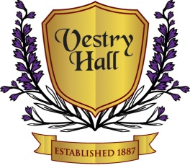

Vestry Hall Function Hire

Gold £995.00

Public Hall, Training Hall, Committee Room, main kitchen, kitchenette with serving hatch, cloakroom, disco lights & sound system, 14 round tables and chairs to seat 125, with maximum accommodation of 150 guests.
Set up from 2pm until 1am.
Use of Training hall accommodating an additional 75 guests, available from 6pm until 1am

Silver £750.00

Public Hall, Training Hall, Committee Room, main kitchen, kitchenette with serving hatch, cloakroom, disco lights & sound system, 14 round tables and chairs to seat 125, with maximum accommodation of 150 guests.
Set up from 2pm until 1am.

336 – 338 London Road, Mitcham, Surrey, CR4 3UD
Tel: 020 8274 5200 Email: vestryhall@merton.gov.uk

