MERTON COUNCIL
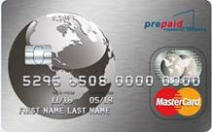
www.merton.gov.uk
Direct payments
and pre-paid cards

Your pre-paid card
Your new pre-paid card, provided by Merton Council and Prepaid Financial Services, will be loaded with your direct payments for community care services, so you can use it to purchase the services you would like to meet your needs as set out in your support plan.
Using your pre-paid card
How can I spend the funds loaded onto my card?
You can only use the pre-paid card in a variety of ways to make payments for services which you receive to meet your assessed support needs:
- The card is MasterCard enabled, which means you can use it anywhere that accepts MasterCard.
- The card is similar to a debit card, so you can use it to pay for goods and services up to the value that is loaded onto it.
- You can make BACS transfers to other bank accounts online.
- Make payments over the telephone to places that accept card payments.
- Set up direct debits.
How will I know how much I have to spend on my pre-paid card?
Merton Council will load your card with the amount that was agreed to be paid to you as a direct payment from your personal budget. If you have been asked to pay a contribution towards your services, the amount we pay to you will be the amount less your assessed financial contribution. You will be required to pay your assessed financial contribution onto the card at least at four weekly intervals.

You will be able to check the balance of your account online at: https://Clients.prepaidfinancialservices.com/merton 24 hours a day, 7 days a week or alternatively, you can phone Customer Services on 020 3953 5589.
Please note calls may be recorded. If you would like a statement and cannot print one yourself, you can contact us using the methods on back of this leaflet.

I have been financially assessed and I need to make a contribution towards my services. How do I pay this onto my pre-paid card?
If you have been financially assessed as needing to make a contribution towards your services, your direct payment will be paid to you less your contribution amount. You will then be able to pay your contribution on to your card by setting up a standing order or as a bill payment. If you don’t have your own bank account there may be ways around this, so please contact the London Borough of Merton’s Direct Payment Team using the contact details on the back of this leaflet to discuss other options or if you have any other queries regarding making your assessed financial contribution.
If you do not pay your contribution onto your pre-paid card there may not be enough funds in the account to pay for your care services and your direct payment may be at risk.
Mrs. Adams a Merton resident explains how she uses her pre-paid card:
“Merton Council agreed that I needed £25.00 per week to meet my social care needs. Following my financial assessment, the council calculated that I needed to contribute £5.00 per week towards my care needs.
Receiving this money is really straight forward. Merton Council pays £20.00 straight onto my pre-paid card, whilst I pay £5.00 onto the card, making a total of £25.00, the amount needed to meet my social care services.”

What happens if I spend more than is loaded on the card?
You can only spend up to the amount that is loaded onto the card, so you cannot go overdrawn.
How can I pay my Personal Assistant?
You can make a BACS payment or transfer straight into a bank account online. You can also make regular payments by setting up a standing order, telephone banking or direct debit online.
Can I withdraw cash?
No, you cannot withdraw cash from the pre-paid card.
Will I be charged for using the card?
You won’t be charged for having a pre-paid card. You will incur charges if you pay bills by direct debit, standing order or individual payments direct to other bank accounts - this is currently 35p for every direct debit or standing order transaction and 45p per online transaction, and this will come out of your direct payments on costs.

Receiving payments
How often will I be paid?
Your initial direct payment will be made approximately eight to ten working days after you have signed your agreement. The initial payment will cover any startup costs, such as payroll and insurance. After this, Merton Council Direct Payments Team will make payments every 28 days, in advance.
I have started receiving my payments, what do I need to do next?
If your service is provided by an agency, please check the invoice the agency sends you to make sure that you have been charged the correct amount and only charged for services received. If correct, please pay the bill as soon as possible from the funds in your pre-paid card account. You can arrange with your chosen agency how to pay.
If you employ your own personal assistant or carer, we advise that you register with a payroll company who will work out the tax and insurance you will need to pay. They will send you a pay slip that tells you how much to pay your personal assistant or carer.
A list of payroll agencies can be found in your information pack that was provided to you.

Lost or stolen cards
If your card is lost or stolen, you can report it by contacting PFS Customer Services, the suppliers of Merton’s pre-paid cards. A new card will be sent out to you within five working days.
To report a lost or stolen card:

Telephone PFS Customer Services on 020 3953 5589. Open from 8.00am to 9.00pm Monday to Friday.

What should I do if I suspect fraud or my card has been misused?
You should contact the Direct Payments Team at Merton Council or PFS Customer Services as soon as possible using the contact details on the back of this leaflet.
Monitoring your direct payment

As part of the Council’s commitment to support you with the effective management of their direct payment to meet your assessed support needs, the Council will continue to regularly review their pre-paid card account to ensure that you do not have more than eight weeks direct payments in the direct payment account at any one time as well as ensuring that the direct payment is being managed in line with the direct payments agreement. Through regular review, if the Council identify any issues we will contact you to support you to help customers manage their direct payment effectively.

Merton Council will need to monitor the money paid to you as a direct payment. This is so that we can ensure your personal budget is being used effectively to meet your needs as outlined in your support plan.

You should keep your own financial information, including invoices for services, for at least seven years to show during your full audit. Other records may need to be kept for longer for tax purposes. See page eight for more information.
What records should I be keeping?
It is very important that you keep the correct records for monitoring purposes and for certain requirements from Her Majesty’s Revenue and Customs (HMRC).
You will need to keep the following paperwork to send to us when requested, and for tax purposes:
- Bank statements
- Invoices from agencies
- Pay slips
- Receipts.

HMRC advises you to keep your records for six years. This is particularly important if you are employing a personal assistant.
Payroll and tax
When should I pay my personal assistant?
We recommend you pay your personal assistant every four weeks in line with our payments. Your payroll company, if you are using one, should provide a four weekly Pay Slip showing how much the personal assistant has earned. This amount should be less any tax and National Insurance contributions.
Agencies will send invoices at regular intervals and request payment, normally within seven to ten days. We also suggest you pay invoices every four weeks in line with your payments.
Why do I need a payroll?
If your personal assistant is a UK taxpayer, you will be responsible for making sure their tax and insurance is paid to the correct authority on time. The London Borough of Merton will pay for a payroll company to do this for you as part of your direct payment. It is an offence to avoid paying tax and national insurance contributions. HMRC will contact both you and your personal assistant if you do not do this.
Who pays the tax?
Tax and National Insurance contributions must be deducted from your personal assistant’s earnings and sent to the tax office. The payroll company will work this out for you and tell you exactly how much to pay your personal assistant, and where and when to send their tax and National Insurance deductions. As an employer, you may also have to pay National Insurance contributions.

When to contact the council
There are certain times when you should contact the council to discuss your support plan and direct payment. These could be:
- If your support network has broken down and you are struggling to cope.
- If your needs have considerably changed.
- If you are unsure of anything or have any questions or concerns that you would like advice on.
Merton Council’s Direct Payments Team contact details are at the end of this booklet.
Managing your money
What if I can’t manage or do not understand anything to do with my direct payment?
You are welcome to call or email the Direct Payments Team with any questions or concerns about your payments.

What happens if I mismanage my money?
We provide you with as much support as possible to ensure the money you receive through direct payments is spent on effectively meeting your needs, and is properly accounted for.
If we feel you are struggling to cope with your payments, or not spending them on services that are meeting your needs, we will contact you. We may set up a meeting to discuss any problems you are having.
If we feel that it is not appropriate for you to continue receiving direct payments, we will discuss other methods of meeting your assessed social care needs.
What happens to money left over in the account?
The money paid to you as a direct payment is public money, which the council has a duty to account for.
We will review your account from time to time and calculate how much you need to keep in the account and tell you how much we need to collect back if there is more than eight weeks direct payment in your direct payment account.

Contact us:
If you have any questions do not hesitate to contact us:
Merton Council Direct Payments Team:
- Email: directpaymentsduty@merton.gov.uk
- Telephone: 020 8545 3928 or 3109 or 3605.
Further information is also available on our website, visit www.merton.gov.uk/directpayments
Prepaid Financial Services:
- Telephone: 020 3953 5589 numbers are charged at your network’s local rate.
- Website: http://prepaidfinancialservices.com/en/

Request for document translation
Direct payments finance and pre-paid cards
If you need any part of this document explained in your language, please tick box and contact us either by writing or by phone using our contact details below.
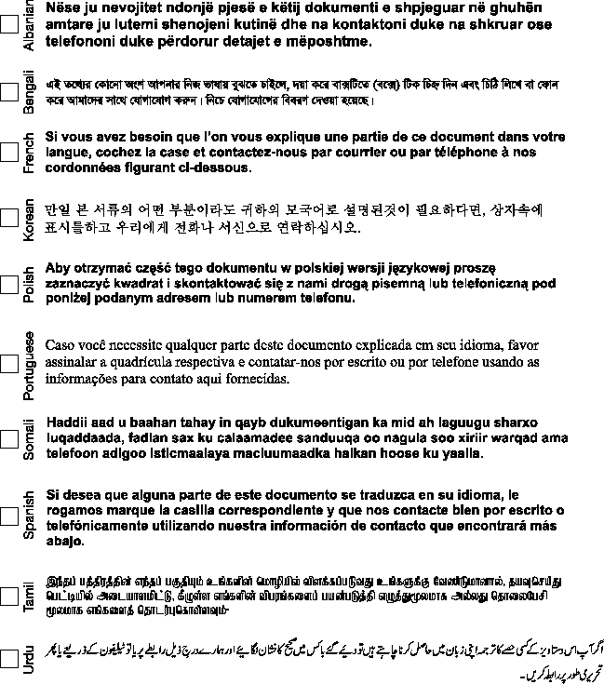
Large print Braille Audiotape

Your contact:
Name
Address
Telephone
Direct Payments Team Merton Council
Civic Centre
Morden
Surrey SM4 5DX

