|  |  |
| --- | --- |
| **Schools Forum 24th June 2021** | Item 3 |

**SUBJECT: DSG outturn report for financial year 2020/21**

**LEAD OFFICER: Pat Harvey**, Interim Principal Accountant, Children, Schools and Families Finance

**RECOMMENDATION**

**That the Forum:**

1. **Notes the outturn position of the Dedicated Schools Grant (DSG) as at 31st March 2021, and**
2. **Notes the cumulative DSG deficit position as at 31st March 2021.**
3. **Purpose of report and executive summary**

1.1 Detailed analysis of Dedicated Schools Grant (DSG) budgets as at the end of March 2021 reports over and underspends within the four blocks of DSG that combine to an overall overspend of £12.231m as per table1 below and cumulative DSG deficit of £24.981m. Appendix A details previous years DSG deficits.



* 1. The DSG is a ring-fenced specific grant and it must be used in support of the schools budget as defined in the School and Early Years Finance (England) Regulations 2020; it can be used for no other council purposes.

1. **DSG Detail** 
   1. Merton’s Schools, Central Schools Services, and Early Years blocks underspent during 2020/21 while the High Needs Block (HNB) overspent. Some of these underspends were as a result of management action to reduce the overall overspend expected in the DSG as a whole.
   2. The main reason for the overspend in the HNB is increased numbers of Education Health and Care Plans (EHCPs) over the past years which have not been met with corresponding increases in grant funding. This has resulted in the HNB overspend becoming progressively larger each year and growth in demand for specialist SEN placements.
   3. In the past, Merton was able to put plans in place to fund smaller levels of increases. The sheer volume of increase in recent years has just been too large for the borough to cover due to the limited availability of local maintained provision and the time it takes to increase this through expansion and new build.
   4. In the three years from January 2013 to January 2016, the total number of statements and EHCPs increased from 888 to 1,075 (increase of 187 cases, 21%). In the six years from January 2016 to January 2021, the total number of statements and EHCPs increased from 1,075 to 2,252 (increase of 1,177 cases, 109%).
   5. The National government statistics report[1]:

* 3.3% of all pupils in schools in England have an Education, health and

Care (EHC) plan, a rise from 3.1% in 2019;

* A further 12.1% of all pupils have SEN support, without an EHC plan, up from 11.9% in 2019;
* The most common type of need for pupils with an EHC plan is autistic spectrum disorders (ASD) and for pupils with SEN support is speech, communication and language needs;
* SEN is more prevalent in boys than girls, with boys representing 73.1% of all pupils with an EHC plan and 64.6% of pupils with SEN support.

2.6 The extract below reports Merton’s increases in EHCP’s as 9th in the country (DfE Statistics 2019)[2] with an average increase of 2.12% from previous year and Merton reporting 2.80%. *(Torquay was the highest 3.85%)*

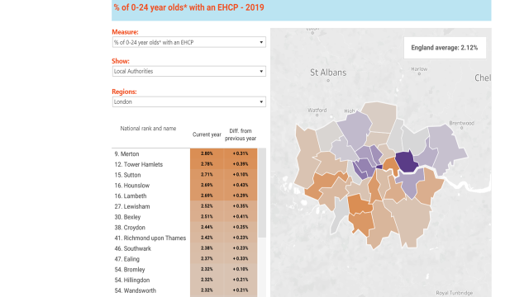

* 1. Table 2 below reports the four DSG blocks and split of retained budgets and delegated budgets and impact of the increase on the various types of provision over the past year of DSG over and (under) spends identified to the end of March 2021:



* 1. Table 3 below details the impact of the increase on the various types of provision over the past year of DSG over and (under) spends identified to the end of March 2021:



* 1. School funding is updated for business rate adjustments undertaken by the valuation office during the year. Additional funding is provided for increases and deductions made for reductions. This year we expected a net reduction resulting in an under spend of £6k (Note: NNDR is funded on a one year lagged basis through the DSG schools’ formula).
  2. Bulge class funding was set aside for possible secondary/primary expansions. We were able to place all children in 2020/21 in existing schools or planned bulge classes which resulted in an under spend of £89k.
  3. SEN EHCP payments to Merton maintained schools was over spent by £2.496m. At the end of January 21 the number of approved EHCPs was at 2,252, this is expected to increase further in 2021/22.
  4. The SMART Centre funding allocated was £29k over HNB budget set and this was due to demand.
  5. Special school allocations was over budget of £303k due to SEN children being placed within the settings and top up payments in support. Place funding for Special school places is lagged funded from the DfE via the HN block.
  6. The ARP budget this year was under spent by £88k. This budget was kept at the same level as 2019/20 and there is likely to be a prospect of an ARP expanding in 2021/22 which may require for this budget to be increased.
  7. Early Years formula is reporting an under spend of £1.392m primarily due to COVID-19 and census changes in data collections by the DfE. We are waiting for a possible clawback of funding with regards to expenditure not exceeding 85% of funding on the 2 year old grant, but await further guidance from the DfE with regards to this change in light of COVID-19.
  8. Within the school block budget setting an allocation of £576k was earmarked for any formula changes made by the Education Skills and Funding Agency (ESFA) with the formula validation checks that are undertaken January before schools receive their individual budget allocation notifications. This was not required to support any formula changes via the Authority Proforma Tool (APT).
  9. The independent day school provision has over spent by £9.611m. The number of students placed in this type of provision has steadily increased over the past few years due to demand for specialist SEN provision.
  10. Out of borough maintained school and academy placements have over spent by £2.260m. The number of places funded `out of borough’ has increased due to the increased number of EHCPs Merton had to statutory support.
  11. Further Education and post 16 Independent Specialist Provision was over spent by £577k. This is linked to the legislation changes requiring local authorities to fund the education of SEND pupils up to the age of 25.
  12. The sensory team reported a saving of £25k due to staff vacancies.
  13. Early Years back office reported an over spend of £94k due to COVID-19 administration of the Early Years formula to schools and settings.
  14. The parenting cover budget has under spent by £9k at the end of March.
  15. Schools causing concern has reported an under spend of £20k at the end of March 2021.
  16. Prudential borrowing costs reported a saving of £177k against central services budget.
  17. School admissions expenditure supported from central services block reported a saving of £22k.
  18. School meals equipment de-delegation budget of £40k reported a saving of £3k.
  19. The de-delegation budget for Behaviour support reported a saving of £17k.
  20. Attain de-delegated budget reported a saving as in previous years of £39k.
  21. De-delegated budget for schools environmental support for Tree maintenance reported a saving of £11k.
  22. School improvement budget reported a small pressure of £6k.
  23. Education Welfare reported a saving within the HNB of £26k due to a reduced demand in schools during COVID-19.
  24. Independent Hospital provision overspent by £14K due to in year demand.
  25. Independent Residential EHCP budget was underspent by £521k due to an increase in budget in support of the over spend in the previous financial year.
  26. SEN early years 0-5 budget within the HNB was underspent by £138k due to COVID-19 and low take up.
  27. The combined four blocks of under and over spends for 2020/21 reports an outturn of £12.231m and cumulative DSG deficit in total of £24.981m. This cumulative DSG is held as an unusable reserve.

1. **Future pressure**
2. 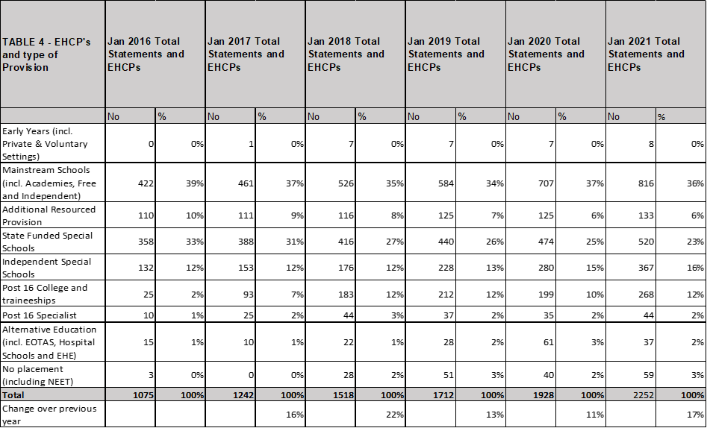The overall cost for SEN has increased significantly over the past five years as a result of increased numbers of pupils being supported. The following table 4 details the impact of the increase in EHCPs.
3. Table 5 below details numbers of EHCPs and ages of children[3]



1. EHCP’s within Merton have grown an average of 16% over the 5 years yet the HNB funding growth has seen an average growth of 4% increase since 2018/19, since the reporting deficit. This lack of funding has been a contributing factor to the DSG deficit as well as huge growth and demand for SEN provision within Merton.



1. Further analysis of National Government data for 2019/20 reports the category of first need as Speech Language and Communication needs (SLC) on school census as the highest number of EHCPs in Merton as table 6 below and Autistic Spectrum Disorder (ASD) as the second recorded level of need:



1. Merton has moved £656k from the schools block to the high needs block for 2021/22 to provide support for this increase and this was approved by School Forum. This represents 0.49% of the maximum allowable 0.5% above which Secretary of State Approval is required. Any other movement of funding between DSG blocks has to be approved by School Forum, then approved by the Secretary of State.
2. The reported DSG deficit is a `net total’ of all four blocks of the DSG, and each block is monitored separately for audit purposes. The net DSG outturn will be reported as an unusable reserve within the financial accounts.
3. Merton has not requested a higher amount to be transferred as schools are also struggling. This was evident in the number of schools requesting to set deficit budgets for 2021/22 of 11 schools.
4. School balances have increased £2.892m due to COVID-19 and the semi-closure of schools during the lock down periods. This year has been an unprecedented year and table 7 below details the movement of school balances, as reported within the financial accounts.



1. The current in-year deficit will increase the DSG reserves into a negative position. Due to the size of the deficit Merton has already met with representatives from the ESFA and has to produce a DSG Deficit Recovery Plan by mid July 2021.
2. There are already some councils in this position and the directors of Children, Schools and Families as well as Corporate Services both continue to work with their professional counterparts to lobby nationally for government to address the pressures.
3. We have also been working closely with other south west London authorities to identify value for money practice and joint commissioning initiatives aimed at reducing costs.

1. **Covid19 funding for Schools**
   1. Government’s response to COVID-19 is fast-moving and the accompanying guidance is being regularly updated. £302m COVID-19 Recovery Premium Fund was announced in February 2021.

4.2 A new one-off Recovery Premium for state primary and secondary schools, building on the Pupil Premium, will be provided to schools to use as they see best to support disadvantaged students. The average primary school will receive around £6,000 extra, and the average secondary school around £22,000 extra. This will help schools to bolster summer provision for their students, for example laying on additional clubs and activities, or for evidence-based approaches for supporting the most disadvantaged pupils from September. Please refer to the link for further details.

<https://www.gov.uk/government/news/new-education-recovery-package-for-children-and-young-people>

1. **Financial, resource and property implications**

5.1 The financial implications are detailed in the main body of this report.

1. **Legal and statutory implications**
   1. No legal implications at this stage.
2. **Human rights, equalities and community cohesion implications**
   1. None at this stage.
3. **Appendices**
   1. Appendix A – 2018/19 DSG outturn and 2019/20 DSG outturn

1. **Background Papers – the following documents have been relied on in drawing up this report but do not form part of the report:** 
   1. Centrally held financial information and other papers held by the Children Schools and Families Finance Team.
2. **Report author**

Pat Harvey, Interim Principal Accountant, CSF

0208 545 3939

[Patricia.harvey@merton.gov.uk](mailto:Patricia.harvey@merton.gov.uk)

Further information about Merton Council can be obtained from its web site [www.merton.gov.uk](http://www.merton.gov.uk)

**Appendix A**

**2018/19 and 2019/20 DSG blocks outturn**

1. [Education, health and care plans, Reporting Year 2021 – Explore education statistics – GOV.UK (explore-education-statistics.service.gov.uk)](https://explore-education-statistics.service.gov.uk/find-statistics/education-health-and-care-plans#dataBlock-90caccb8-5c11-46c2-805c-bff8465614d2-tables)
2. [DfE Data Release Breakdown: EHCPs in England - Mime (mimeconsulting.co.uk)](https://www.mimeconsulting.co.uk/dfe-data-release-breakdown-ehcps-in-england/)
3. [Statements of SEN and EHC Plans: England 2019 - GOV.UK (www.gov.uk)](https://www.gov.uk/government/statistics/statements-of-sen-and-ehc-plans-england-2019)