MERTON COUNCIL
Served by:
The Regulatory Services Partnership
Environment & Regeneration
Licensing Team
London Borough of Merton
Civic Centre, London Road,
Morden, SM4 5DX
Telephone: 020 8545 3969
E-mail: licensing@merton.gov.uk

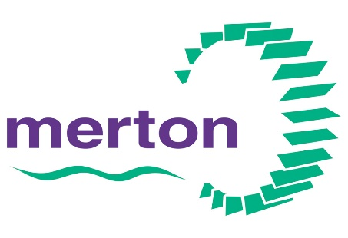

To make a request for pre-application advice please complete the enquiry form below providing as much information as possible

Regulatory Services Partnership serving Merton, Richmond and Wandsworth  Licensing Section  Pre-Application Advice Request Form |  |  |  | Flare Ref No:  M3 Ref No:  (office use only)
About the Premises/ Proposed Development Site
- Address of Premises/Site
- Post Code
- Current use of premises/Site
- Description of Proposal (Please provide an accurate and detailed description of your proposal)
- Please provide as much relevant information as possible and specify plans/details that you are submitting with your request. This information may include as appropriate:
- Draft Licence application
- Plans showing the existing and proposed development - where possible drawn to metric scale with an illustrative layout, floor plans and elevations.
- Existing and proposed uses within the building
- Have you contacted the Council previously about this (or a similar) proposal? |  | YES/ NO/ DON’T KNOW (delete as necessary)
- If yes, please provide details if known e.g. dates, reference numbers and the names of the officers involved.
- Your Details:
Name:
Company (if applicable)
Address:
Post Code:
Phone Number:
Email address:
What is your interest in the building? E.g. proprietor, Lease Holder, Agent, Solicitor.
Fee submitted for advice (Please note that we will not deal with your request for advice until we receive telephone payment) |  |  | £
- Personal Information Policy
The Council will use your details, the information about your dealings with the Council and the information about you available to the Council (“your information”) to:

- deal with your requests and administer its departmental functions in the processing of your application
- meet its statutory obligations
- Prevent and detect fraud
- Conduct surveys and research

The Council may share your information (but only the minimum amount of information necessary to do the above and only where it is lawful to do so) with other Departments within the Council (including the elected members), central government law enforcement agencies, statutory and judicial bodies, community services providers and contractors that process data on its behalf.
Note: Applications submitted under the Licensing Act 2003
Once your application under the Licensing Act 2003 has been received and accepted as duly made by the Licensing Section, it will be subject to consultation as required under the Act. During the consultation period, responsible authorities and any other persons can make relevant representations to your application. If the representations cannot be resolved between parties, the matter will be referred to the Licensing Sub Committee of Council members to make a final decision. You should therefore be aware that Licensing officers are unable to give any guarantees about the decision that will be made on an application.

Completed form should be submitted by email to licensing@merton.gov.uk
Please call the Council’s payment line on 020 8545 3969 to make a payment for the pre-application advice. Upon receipt of both the form and payment, your request will be allocated to our next available Licensing Officer.

